Topic | Learning objective | Teaching points /teachers voice | Task to complete
Grammar | L.O to be able to use dashes to show parenthesis. | This week we are staying with the learning objective of punctuating Parenthesis, but this time we are looking at how dashes are used instead of brackets. As we learnt last week, parenthesis is the grammatical word used for when extra information is added to a sentence. It can be used to give more context to a sentence, such as time, how something is done (manner), or place, or it can be used to give extra emphasis or importance to a sentence to really draw the reader’s attention to something.  The one key difference is that brackets always come in pairs, whereas dashes can sometimes be used just once if the parenthesis comes at the end of the sentence e.g.  That was the best meal of my life – I’ve never eaten so much!  The first part That was the best meal of my life makes perfect sense on its own, the parenthesis after the dash gives the extra information - I’ve never eaten so much!  Note there is no second dash after much.  Please go through the attached PowerPoint called ‘Using Dashes to indicate Parenthesis’ – read each slide carefully, and then have a go at the quiz (in the same Powerpoint).  Remember the key to knowing which part is the extra information, i.e. the parenthesis, is if you took the extra information out of the sentence, the sentence would still make sense. And it’s useful to use dashes to draw the reader to an important piece of information. | Please choose the activity that you feel challenges you form the Consolidating Dashes Activity Sheet. If you can print the worksheets then you just need to mark where you think the dashes should go, otherwise write the sentences on paper and insert the dashes.  You can check your work with answers on the last page – no sneaking a peak until you’re finished please.  Challenge: create your own sentences using dashes for parenthesis.  Finally have a go at the Dashes for Parenthesis Quiz and see how you get on.
Maths | Arithmetic paper | These are slightly different in appearance to the ones we do in class but the questions are essentially the same.  When you’ve finished have a break and then go on Doodle maths or Hit the Button for a maths ‘cool down’.  Last week some of you did the extra activity sheet (well done) and there was some confusion on what a rectilinear shape was, I hope this helps:  A rectilinear shape is a shape that has straight sides and right angles. It can look like two rectangles that have been joined together e.g.  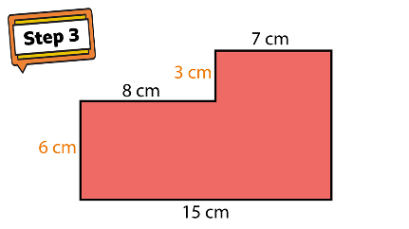 | The booklets are marked Group D or E so please do the one appropriate for what you would have been given in class. Group D you have a full booklet this week.  Please show as much working as possible.  The answers are included – if you need to do any corrections, please try do them in a different colour so I can see your new working.
ICT | Scratch | Please go onto https://scratch.mit.edu/projects/editor/?tutorial=getStarted  This week I would like you either go back to the tutorial you did last week and improve it or try something different within the same tutorial, or go on to a whole new tutorial. If you would like to send me a screenshot or video of what you have done that would be great, but no problem if it’s not possible.
Spellings |  | Please note as of today your new spellings are available on Spelling Frame. | Have a go at the activities and when you feel confident that you have learnt them please do the test – good luck!

If you have any questions about today’s learning activities set then please email the class email these are viewed from 9.00 until 3.30 daily.

