Maths Herald Issue 8 page 2
Remember to show your working!
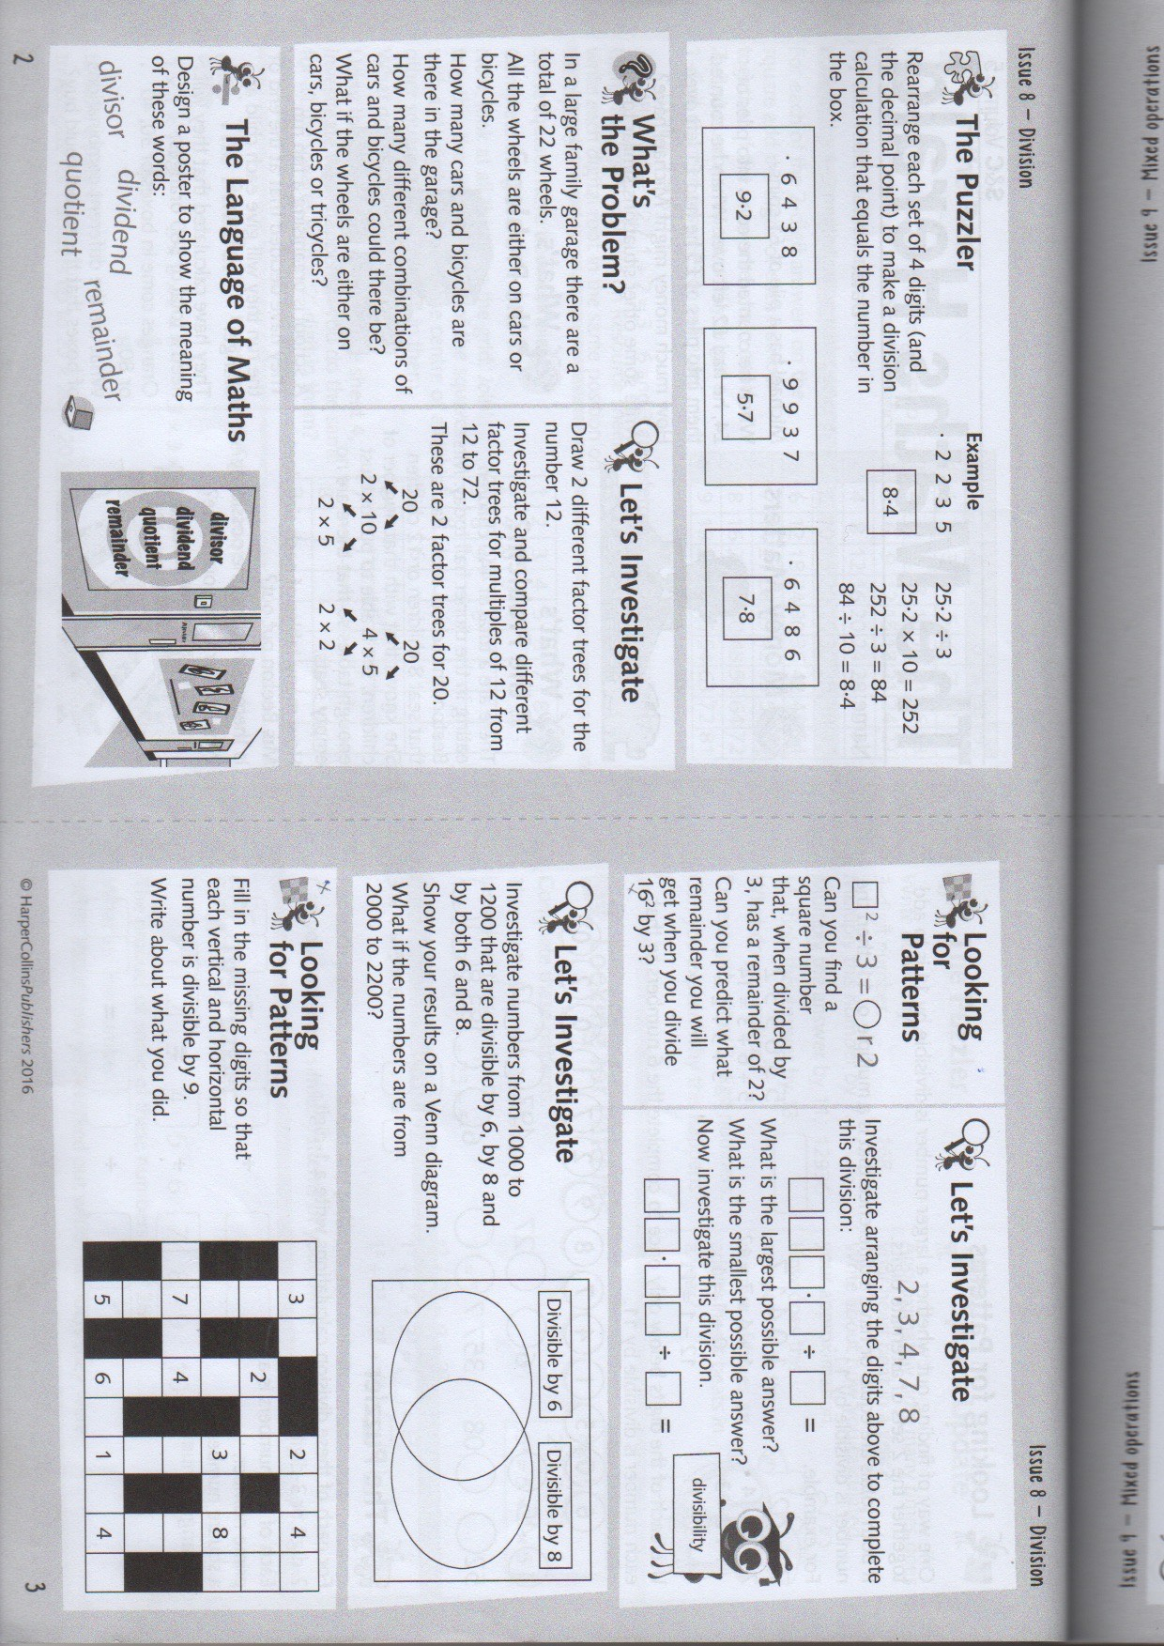
Maths Herald Issue 8 page 1
Remember to show your working!


