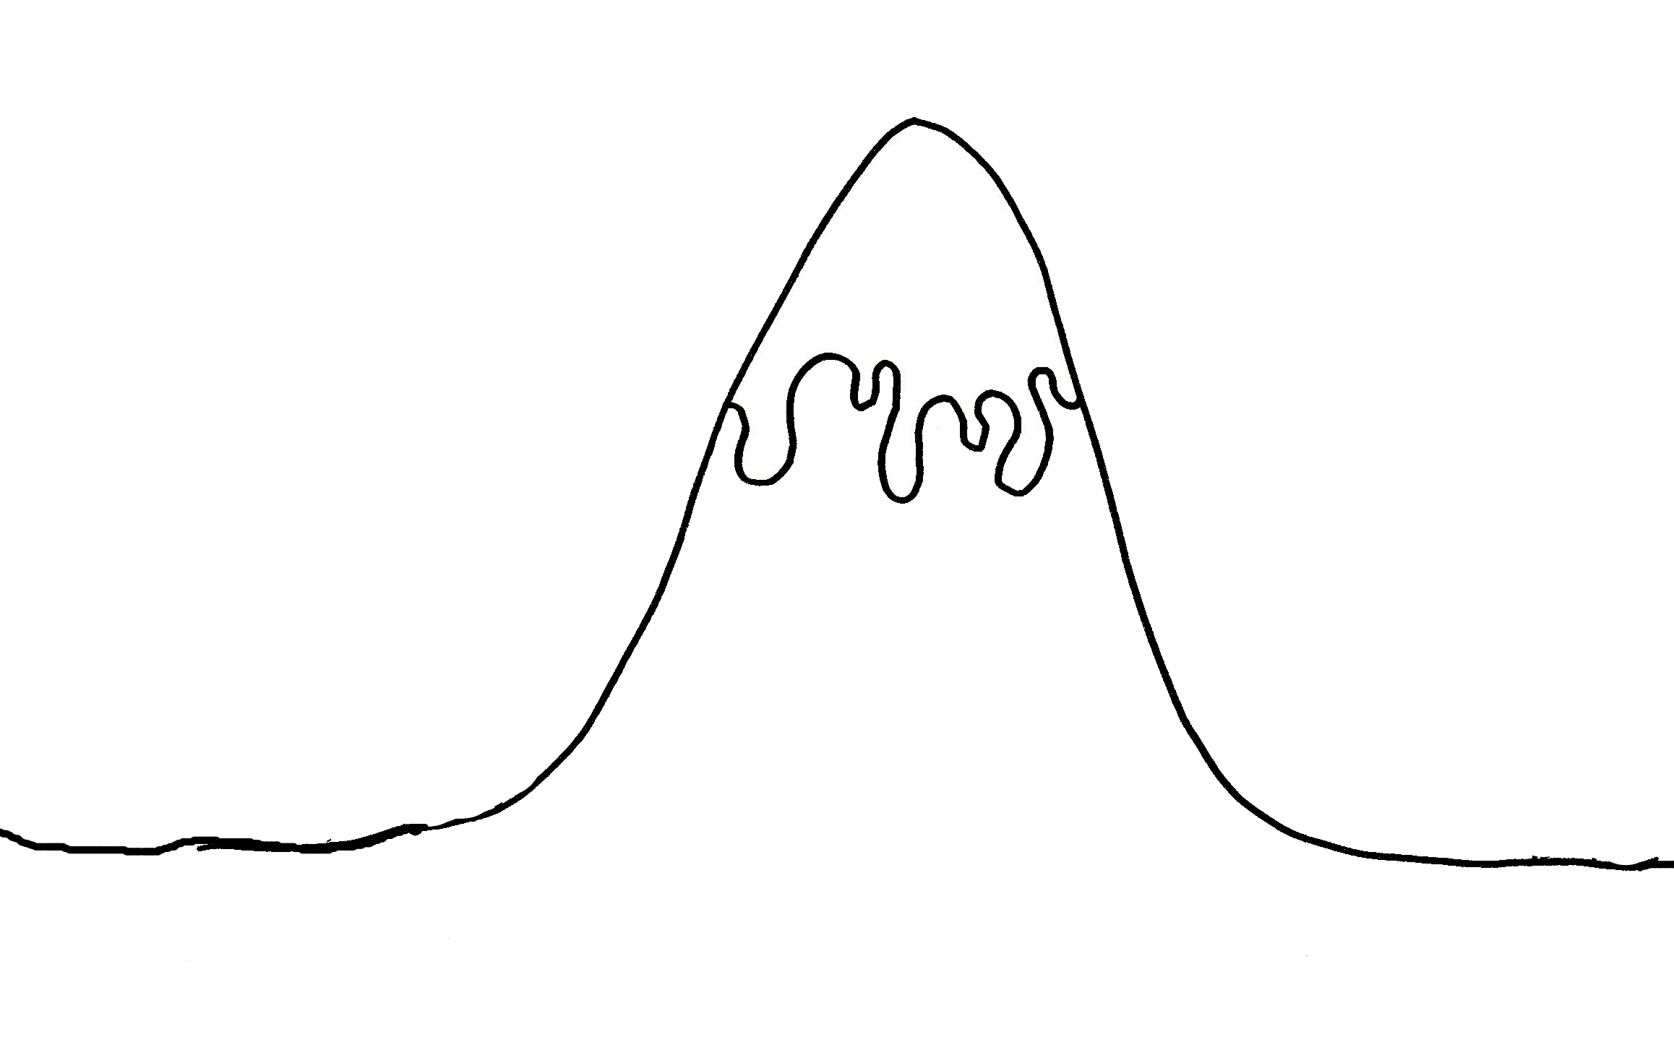
L.O:I can match the story mountain structure to a story from another culture.

Ending
____________________________________________________________
Fix problem
______________________________________________________________________________________________________
Problem!!
_______________________________________________________________
Introduction
Who:____________________Where:___________________________________________________-
Build up
____________________________________________________________________________________________________________________________________________
The Story Mountain
Ending
____________________________________________________________
Fix problem
______________________________________________________________________________________________________
Problem!!
_______________________________________________________________
Introduction
Who:____________________Where:___________________________________________________-
Build up
____________________________________________________________________________________________________________________________________________
The Story Mountain

