Topic | Learning objective | Teaching points /teachers voice | Task to complete
English | LO: I can design and advertisement for a healthy snack.  LO: I can use subordinate clauses to write complex sentences. | Today, we are finishing our topic of ‘Food, Glorious Food’ and our work on advertisements for a healthy snack.  Please use the following link to the lesson at the Oak Academy: https://classroom.thenational.academy/lessons/to-design-and-write-an-advertisement-for-a-healthy-snack-6cv34t?activity=video&step=1 Work through the lesson which should take 25-35 minutes. You will need some paper for written to write down your answers throughout the video and a sheet of plain paper for the advertisement design task.  *Success Criteria*  To design an advertisement for a healthy snack with:  - A question with a superlative in it  - A slogan using rhyme, a pun or alliteration  - A picture of the snack  - A complex sentence containing scientific vocabulary to persuade the reader  - At least one comparative sentence  - A sentence with adjectives  To be able to recognise a subordinate clause and write complex sentences | Task 1: Design an advertisement for your own healthy snack. (Note: This is the task set during the Oak Academy lesson).  Check your advertisement for correct punctuation and spelling as well as the success criteria.  Task 2:  Complete the ‘Subordinate clause’ worksheet provided to write complex sentences. NB: In part 3, remember that subordinate clauses must contain a verb and a subordinating conjunction e.g. because, as, after, if, when, which, although.  Task 3:  Continue to practice the new spellings for your group either on Spellingframe or with pencil and paper.  NB: Please try to read with an adult daily.
Maths | LO: I can use column subtraction to subtract two 3-digit numbers (with exchange). | Please use the White Rose video at https://vimeo.com/466609834 and the White Rose worksheet (Subtract 3-digit numbers from  3-digit numbers – exchange). Optional further practice and challenge questions are also provided for those who complete the main worksheet with time to spare.  *Success Criteria*  I have completed the worksheet to show that:  - I can use formal written methods to subtract two 3-digit numbers with exchange.  - I can solve problems involving subtracting two 3-digit numbers.  - I can reason about subtraction with two 3-digit numbers. | Complete the White Rose Maths worksheet provided.  You may choose to also complete the optional further practice and/ or the challenge questions (2 separate worksheets).
DT | LO: To show what you have learned about eating seasonal food as part of a healthy, varied diet. | *Success Criteria*  - I know some reasons why some foods are only in season for a short time.  - I can explain why it is a good thing to eat seasonal food.  - I can recall and apply what they have learned about seasonal food in Britain.  Seasonal Food Lesson 6 DT  Weird and Wonderful Seasonal Food Calendar and Menu Template Lesson 6 – a resource. | 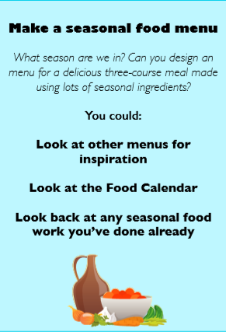

If you have any questions about today’s learning activities set then please email the class email these are viewed from 9.00 until 3.30 daily.

