Topic | Learning objective | Teaching points /teachers voice | Task to complete
Assembly |  | Please find the link to our weekly assembly, as a church of England school we would normally meeting for whole school assemblies and felt it would be good to continue with a weekly assembly whilst we are in lockdown. https://datchet-st-marys-cofe-primary-school.primarysite.media/media/week-commencing-1st-march-2021
English | LO: I can write complex sentences about a healthy snack.  LO: I can recognise subordinate clauses and complex sentences. | Today, we are continuing our new topic of ‘Food, Glorious Food’ and our work on advertisements for a healthy snack.  Please use the following link to the lesson at the Oak Academy: https://classroom.thenational.academy/lessons/to-write-complex-sentences-about-our-healthy-snack-60upct?activity=video&step=1 Work through the lesson which should take 25-35 minutes. You will need some paper for written to write down your answers throughout the video and for the written task.  *Success Criteria*  To know what is meant by a complex sentence.  To be able to recognise a subordinate clause and subordinate conjunctions.  To write complex sentences about a healthy snack. | Task 1: Write at least two complex sentences about your healthy snack using comparatives, superlatives and scientific vocabulary. (Note: This is the task set at the end of the Oak Academy lesson).  Check your punctuation and spelling!  Task 2:  Complete the ‘Spot the complex sentences’ worksheet provided.  Task 3:  Continue to practice the new spellings for your group either on Spellingframe or with pencil and paper.  NB: Please try to read with an adult daily.
Maths | LO: I can use column subtraction to subtract two 3-digit numbers (without exchange). | Please use the White Rose video at https://vimeo.com/466580214 and the White Rose worksheet (Subtract 3-digit numbers from  3-digit numbers – no exchange). Optional further practice and challenge questions are also provided for those who complete the main worksheet with time to spare.  *Success Criteria*  I have completed the worksheet to show that:  - I can use formal written methods to subtract two 3-digit numbers without exchange.  - I can solve problems involving subtracting two 3-digit numbers.  - I can reason about subtraction with two 3-digit numbers. | Complete the White Rose Maths worksheet provided.  You may choose to also complete the optional further practice and/ or the challenge questions (2 separate worksheets).
DT | LO: To know how fish are caught or reared, processed and used in healthy meals. | *Success Criteria*  - I know some ways in which fish are caught or reared and processed in Britain.  - I know some of the nutrients in fish.  Seasonal Food Lesson 5 DT Part 1  Seasonal Food Lesson 5 DT Part 2  My teaching voice  Fish and Seafood Seasonal Calendar Lesson 5 – for reference | 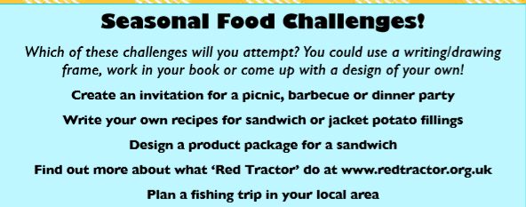  Please choose one of the challenges.

If you have any questions about today’s learning activities set then please email the class email these are viewed from 9.00 until 3.30 daily.

