Challenge questions – Adding lengths 11/02/21

Q1

Q2
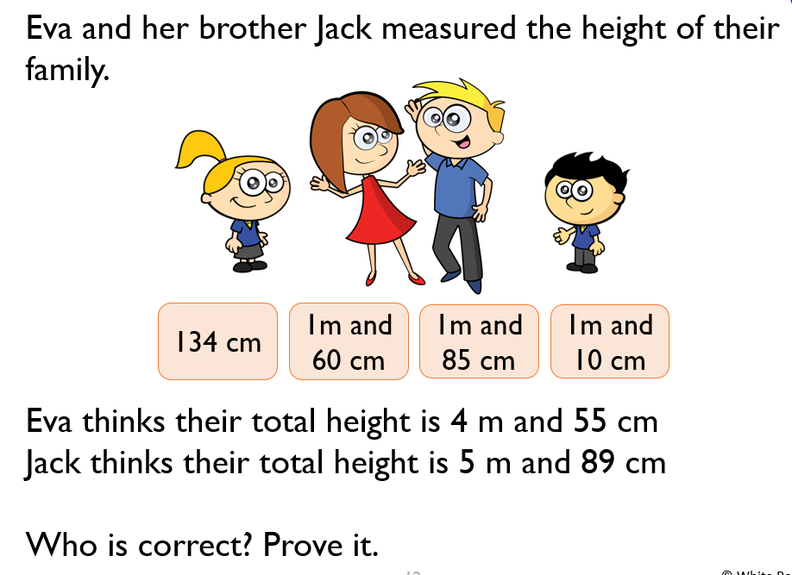

Q3


