Spruce Summer 2 Term Newsletter
Welcome back to the Summer 2 term, this term we have an exciting new topic we are covering.

Topic: Journeys


Upcoming Events
Friday 14th June. Marvelous Men into school morning
Friday 22nd June. Mufti Day- bring a bottle
Wednesday 26th June. School trip Look out Discovery Centre
Friday 28th June. School summer fair
Thursday 4th July Sports Day
Wednesday 10th July. Transition morning
Friday 13th July. School Reports
Monday 22nd July 2.30pm EYFS Graduation
Tuesday 23rd July End of Term. 1.30 Finish.
Activities to do at home:
- Discuss the transition to year 1 and encourage your child to discuss any questions or concerns they have.
- Listen to your child read every night
- Encourage independent writing
- Complete doodle maths daily
This Term PE will be on a Friday morning.

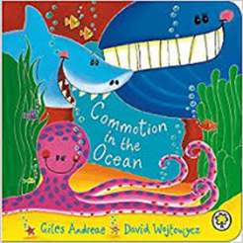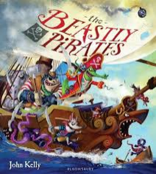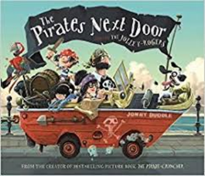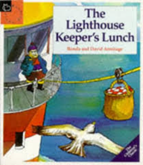
This term we will be exploring the topic Journeys. Each week the children will go on a different journey… to the bottom of the sea, the seaside, a pirate island, the jungle and anywhere else they would like to visit.
Literacy:
This term we will be using our phonic knowledge and SWAG to write postcards, fact files and wanted posters. Children will be exploring describing words to make their writing more descriptive.
Maths:
This term we will be consolidating all our previous maths knowledge and reinforcing maths skills and knowledge in preparation for Year 1. Children will be using their maths skills to explore, shape, pattern, time, money and measures as well as counting in twos, fives, tens, adding and subtracting numbers, ordering different numbers up to 20 and also from the two, five and ten timetables and continuing to learn doubles and halves of numbers and amounts and apply these to practical problems.

