YEAR 5
EASTER REVISION BOOKLET

Name:
Answer the following questions:
- Draw in the lines of symmetry in the following shapes:

  - c) e)

  - d) f)

- List the 1st five prime numbers:

List all the factors of 10:

List the first five multiples of 5:

- Fill in the table square

x | 1 | 5 | 9 | 3 | 7 | 10 | 2 | 8 | 6 | 4
3
6
10
4
9
2
8
1
7
5

Write in figures:

- One hundred and sixty seven thousand, three hundred and one

- Two million, twelve thousand and four

Remember when writing numbers in figures:

M | Space | 100  Th | 10  Th | Th | Space | 100  H | 10  T | U

6) |  |  | 7 1 2 3 | 7) | 4 0 0 0 |  | 8) | 2 1 8 6
 |  |  | + 4 1 8 6 |  | —3 1 2 7 |  |  | — 1 2 1 4
9) |  |  |  | 10) |  |  | 11) | 4 7 1 2  x 9
 | 4 | 4 | 6 6 8 |  | 3 3 1 6 8
12) |  |  | 1 7 1 6  x 4 2 | 13) | 13 + 7.02 + 14.3 = |  |  | l

- Answer the following:
a) 58 x 10=
b) 680 x 100=

c) 42 x 2000=
d) 8910 ÷ 10=

e) 50000 ÷ 1000= f) 800 ÷ 20=

Find the area and perimeter of the following shapes:

- 4m area
=
6m = m²

perimeter

= m

- 3cm area of shape A = cm² B = cm²
Total = cm²
5cm
3cm

8cm

perimeter =
= cm

- Simplify to the simplest form

3
  - 6
= b)
15
20 = c)
25
30 = d)
11
33 =

- Write these times as 24 hour times
a) 6:17pm = b) 4:26am

- List the factors of 30 (8)

- List the first 5 multiples of 12

- Find the volume of a cube that has the sides of 3cm

Volume = cm³

- Share 456 marbles evenly between 3 boys

Each boy will get marbles.

- Betty buys a coat for £97 and trainers for £58. How much does she spend altogether?

£

1
- Our school raises£150 for six charities. Each charity gets 6 of the
amount raised. How much did each charity get?

£

- For a school party Mrs Swain buys six boxes of 125 straws each. How many straws did she buy altogether?

straws

26) Find:
a) 50% of 82cm  = cm  c) 25% of 44cm  = cm | b)  d) | 10% of £30  = £ 40% of £2  = £

- Plot the following coordinates and join them up to make a picture:

(5,9) (1,6) (2,6) (2,1) (4,1) (4,3) (6,3) (6,1) (8,1) (8,6) (9,6) (5,9)
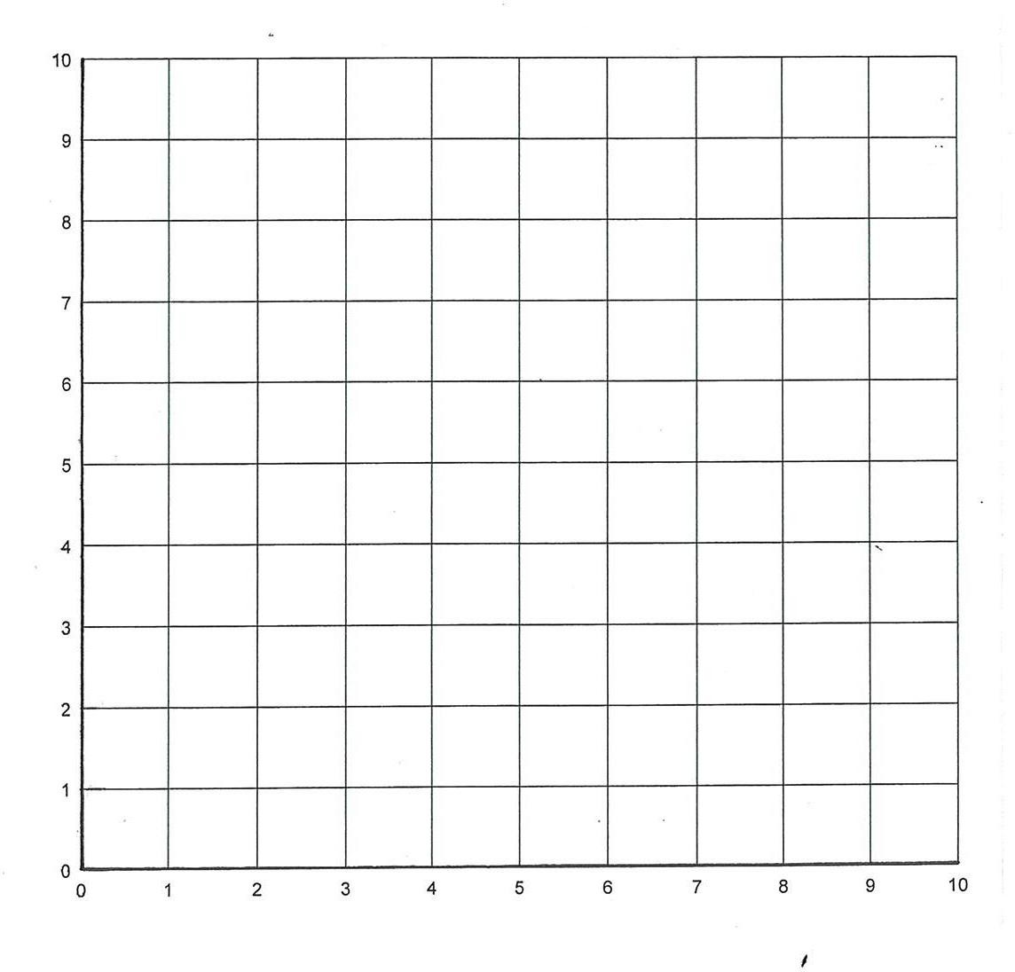

- Fill in the following table using the number machine:

IN OUT

x 3

+ 4

IN | OUT
4 | 16
10
7
 | 22
 | 10

- Measure the following angles with a protractor.

Answer Answer

Find the area and perimeter of the following shapes:
- 7cm area of shape A = cm² B = cm²
Total = cm²

9cm

12cm

4cm

perimeter =
= cm

Write in figures:

- Twenty two thousand, four hundred and seventy six.

Remember when writing numbers in figures:

M | Space | 100  Th | 10  Th | Th | Space | 100  H | 10  T | U

32) |  |  | 7 3 3 3  + 4 2 1 6 | 33) | 4 1 6 8  — 1 2 1 4 | 34) | — | 6 0 0 0  4 7 2 6
35) |  |  |  | 36) |  | 37) 7 8 1 5  x 6
 | 6 | 6 | 5 8 2 |  | 4 4 2 6 4
38) |  |  | 1 5 2 1  x 4 8 | 39) | 15 + 1.68 + 12.1 = |  | l

- Answer the following:
a) 56 x 10=
b) 720 x 100=
c) 24 x 2000=

d) 4510 ÷ 10=
e) 80000 ÷ 1000=
f) 600 ÷ 30=

- Find the area and perimeter of the following shapes:

10cm
8cm area of shape A = cm²
B = cm²
Total = cm²

4cm

14cm

perimeter =
= cm

- Simplify to the simplest form

16
  - 20
= b)
25
45 = c)
42
60 = d)
11
44 =

- Write these times as 24 hour times
a) 2:27 am = b) 2:27 pm

- List the factors of 20 (6)

- List the first 5 multiples of 6

- Find the volume of a cube that has the sides of 2cm

Volume = cm³

- Mrs Hotel buys 4 ice-creams costing 75p each and 3 cokes costing
£1.50 each. Work out the total cost.

£

- What is 10% of £80?

£

- What is 20% of £80?

£

- What is 30% of £80?

£

- What is 25% of £80?

£

- What is the mean of the following numbers? 4 , 3 , 6 , 1 , 8 , 6 , 2 , 9 , 6

- What is 1 hr 20 mins before 6.20pm

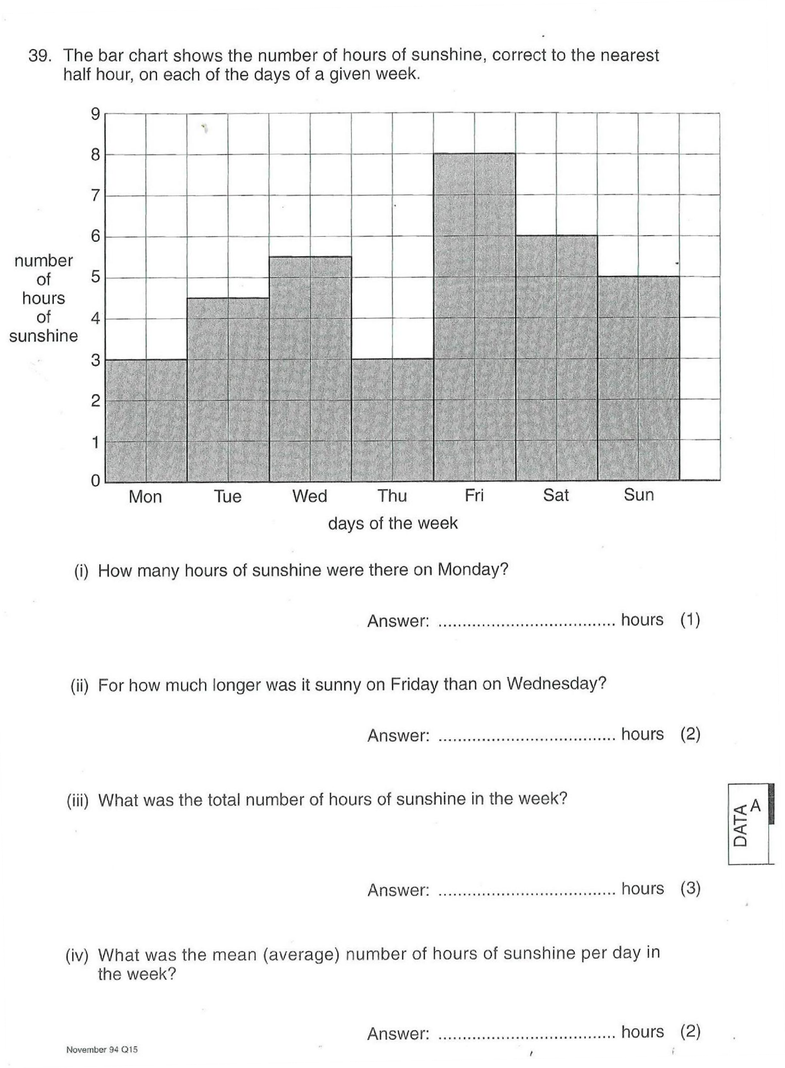

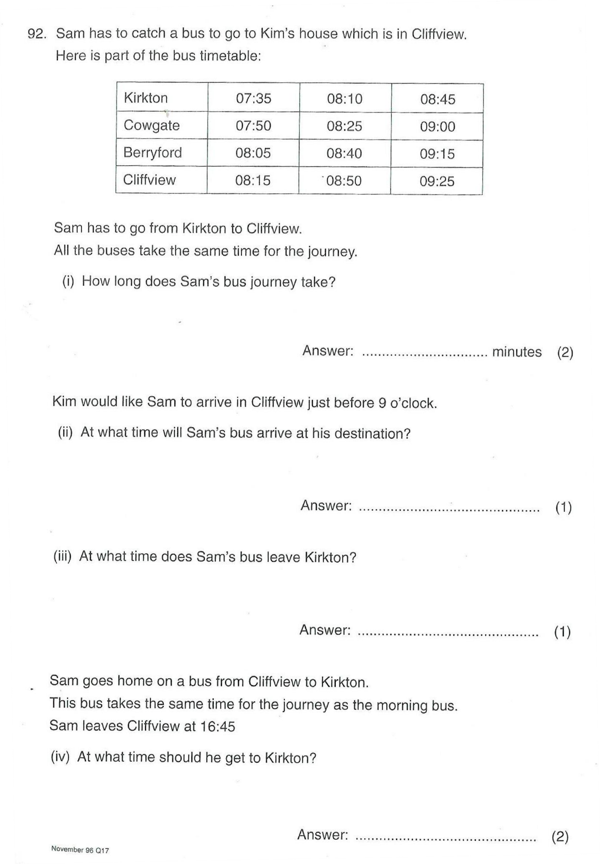

- Write in figures:
  - Seven million, two hundred and six thousand, four hundred and ninety six.
  - Seven hundred thousand, two hundred and five.

57) | 7 8 1 6 | 8 2 6 9 | 6 0 0 0
 | + 4 2 1 5 | — 2 1 7 3 | — 3 4 7 1

5 3
9 1 6 5
7 3 5 6
4 7 1 3 4 8

8 1 1 6
X 4
9 4 1 1
X 6
4 7 8 4
X 3

2 4 1 6
X 2 4

5 1 8 7
X 3 5
20 x 30 =

40 x 300 =

32 x 200 =

- Write the following numbers in words:
a) 354

b) 1 032

c) 23 067

- What is the value of each of the following underlined digits in words:
a) 364

b) 14 236

c) 2 320 064

- Complete the number sequence below: a) 23, 37, , 65, 93

b) -2, -4, -6, , -10, ,

c) 6, 3, , -3, , , -12

- Complete the table below so that the fractions, decimals and percentages are equivalent.

Fractions | Decimals | Percentages
1  10 | 0.1
 | 0.5
1

4
3  4 |  | 75%
 | 0.6
 | 0.2
1

100

- Write down any three factors of 24 , ,

- Write down any three multiples of 8 , ,

- Circle the number which is not a multiple of 6: 6 24 3 36 42 54
- Complete the table below

53 | + |  | = | 100
100 | — | 73 | =
22 | + |  | = | 100
100 | — | 59 | =
67 | + |  | = | 100
100 | — | 83 | =

- Solve the following problems. You may use the middle box for workings and write you answer in the answer box.

Problem | Workings | Answer
3.4 + 2.63
4.65 + 0.04
34.98 — 23.75
56.12 — 5.05

- Circle the 2 numbers below which added together make 0.12
0.04 0.8 0.02 0.08 0.1 0.4

- Solve the following multiplication and division problems

a) 34 x 10 = f) 543.09 x 10 =

b) 45.6 x 10 = g) 972.95 ÷ 10 =

c) 340 ÷ 10 = h) 5.008 x 10 =

d) 65.7 ÷ 10 = i) 345.8 x 1000 =

e) 56.78 ÷ 100 = j) 15 ÷ 10 =

- Solve the following problems by showing all your workings: a) 456 — 179

b) £34.76 — £8.98

c) 1078 — 786

d) 10 765 — 8 435

- Colour all the 2d shape names in blue coloured pencil and the 3d shape names in red coloured pencil.

cone | heptagon | hexagon | tetrahedron
circle | cube | decagon | nonagon
pentagon | square | sphere | cylinder
cuboid | hemisphere | dodecahedron | rectangle
square based  pyramid | triangle | triangular  based prism | pentagonal  pyramid

- Choose the correct word that fit in the following sentences:

equilateral triangle right angled triangle
isosceles triangle scalene triangle

  - A has one angle that is exactly 90 degrees.

  - has no equal sides or angles.

  - An has 3 equal sides and 3 equal angles.

  - A has 2 equal sides and 2 equal angles.

- Read the following carefully
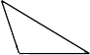
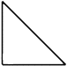
- Colour in the right triangle:

- Colour in the scalene triangle:

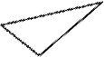
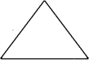

- Colour in the equilateral triangle:

- Colour in the isosceles triangle:
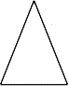

- Draw a circle around the following quadrilaterals: Rhombus
 |  |  | 

Trapezium
 |  |  | 
Rectangle
Parallelogram
Square

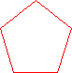
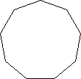
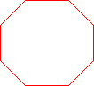
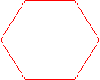
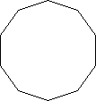
- Match up the following shapes:

Pentagon
Hexagon
Heptagon
Octagon
Nonagon
Decagon

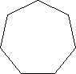
- Label the 3D shapes
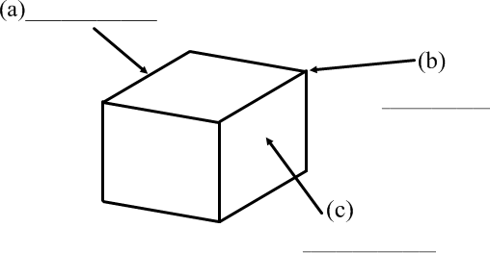

- Name the 3D shapes

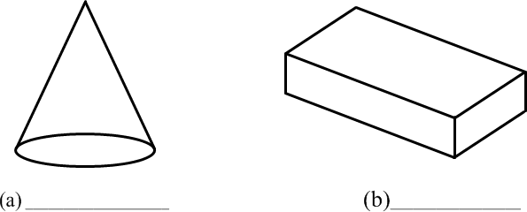

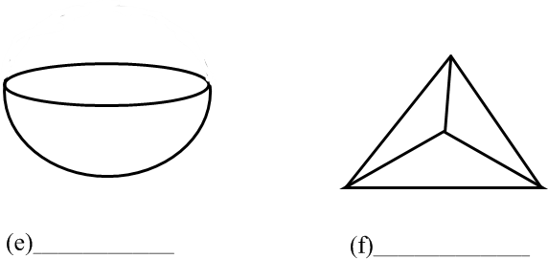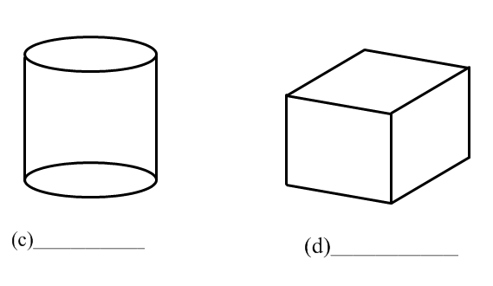

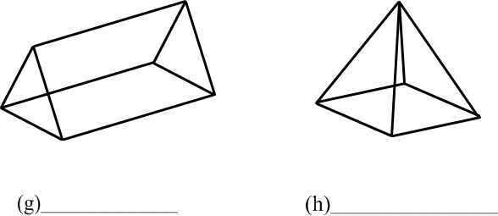

- Answer the following averages questions using these numbers

3 2 8 4 3 12 5
7 15 3 10 2 4

  - What is the range

Answer:

  - Find the median

Answer:

  - What is the mode

Answer:

  - Find the mean

Answer:

- Draw in lines of symmetry in the word below:



- Add these numbers

+ | 0.5 | 0.6 | 0.7 | 0.8
0.7
0.8
0.9
1

- Simplify to the simplest form

3
  - 6
= b)
2
8 = c)
9
12 = d)
22
66 =

14
e) 16
= f)
12 10
20 = g) 25
= h)
15
20 =

20
i) 25
= j)
20 24
35 = k) 30
= l)
18
24 =

36
m) 42
= n)
18 14
42 = o) 28
= p)
42
49 =

7
q) 49
= r)
35
49 = s)
16
64 = t)
16
48 =

8
u) 64
= v)
32 9
48 = w) 81
= x)
27
63 =

- List all the factors of 20:

List the first five multiples of 4:

- Write these times as 24 hour times
a) 10:22pm = b) 6:45am

- Find:

a) 50% of 74cm b) 75% of £30

= cm = £

c) 25% of 204cm d) 10% of £5

= cm = £

- Fill in the following table using the number machine:

IN OUT

+ 2

x 3

IN | OUT
4 | 18
10
7
 | 21

- What is 1 hr 40 mins before 8.15pm

- What is 10% of £60?

£

- What is 60% of £60?

£

- What is 40% of £60?

£

- What is the mean of the following numbers? 11 9 6 11 8

- Measure the following angles with a protractor.

Answer Answer

- Complete the number sequence below: a) 14, 17, , 23, 29

b) -3, -6, -9, , -15, ,

c) 21, 19, , 15, , , 9

- What does BIDMAS stand for?

B

I

D

M

A

S

For the following, ensure you show your step by step workings!
91) 4 x ( 2 + 5 x 2 )

92) 7 + (3 x 2) – (8 ÷ 2)

93) (5 – 4) ÷ 2 + (7 x 2)

94) (4 x 2) – (6 ÷ 3) + (3 x 2)

95) (6 x 8) – 18 ÷ ( 2 + 4 )

96) 5 + ( 2 x 10 – 5 ) – 6

97) ( 5 + 3 ) x 2 + 10 ÷ ( 8 – 3 )

98) √25 + 2 x 3

99) √16 x √100 + ( 102 ÷ 10 )

100) ³√8 + √36 ÷ 22

  - Construct a triangle with sides 11cm, 3cm and 9cm

  - Construct a triangle with side AB 8cm, angle ABC 34˚ and angle BAC 55˚.

  - Construct a triangle with side 9cm, angle 100˚ and side 10cm.

  - Construct a triangle with sides 3cm, 6cm and 7cm.

Draw the following triangles accurately, some are only sketches! Remember to work out what information you already have: (over page)



