Tie Dye 3

Bulls eye Tie Dye Technique 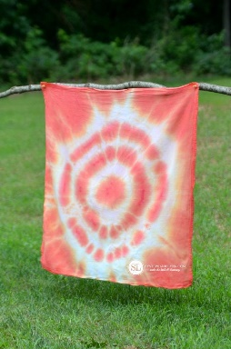

Lay the fabric flat.

Pinch the centre of the fabric.

Pull the fabric upward into a cone shape.

Secure with rubber bands. 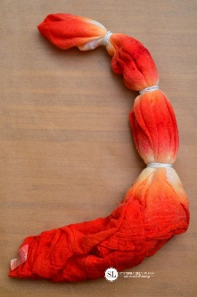

Apply the dye in sections.

Flip over the fabric and ensure dye is on all sections.

Do not try to get the dye near or under the rubber bands.

Tie Dye 1

One Colour Spiral Tie Dye Technique

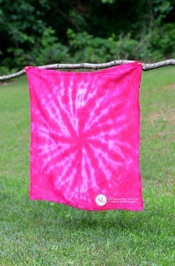

Lay the fabric flat

Pinch the centre
Begin twisting the fabric in a circular motion and continue until all of the fabric is in a spiral shape

Tightly secure the spiral with rubber bands. 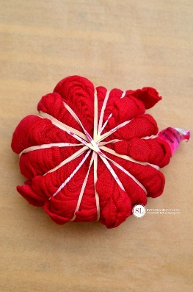

Apply the dye to the fabric.

Flip the fabric over and repeat on the other side.

Tie Dye 2

Sunburst Tie Dye Technique

Lay the fabric flat.
Fold fabric in half.
Fold fabric in half, again, leghtwise,

To create the sunbursts pinch the fabric and pull upwards, 1 to 2 inches. Secure fabric with a rubber band and repeat for the desired number of sunbursts.
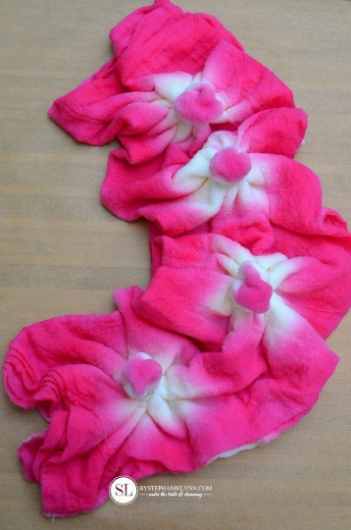

Apply the dye to the outer edges of the fabric, the fabric between each sunburst and the centre of each sunburst.



