 |  | Teaching points /teachers voice | Task to complete


Since it is World Book Day, we will not be providing formal feedback in the form of the ‘home school learning feedback sheet’, however we will comment on the activities the children partake in.
We have set up ‘The Masked Teacher’ game where teachers have chosen to discuss their favourite books but their faces have been hidden. Can you guess who each teacher is? Click on the link to play. The masked teacher | Datchet St Mary's CofE Primary Academy (primarysite.media)
We hope you enjoy the day!

Activity 1 |  | For today’s activities, I have chosen to work from the book ‘The Day the Crayons Quit’. It is a story that some of the Year 1’s may be familiar with but it isn’t a story that we have used in class which is why I chose it. There is a lot of humour in the story and I am sure that the children will enjoy it.  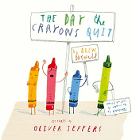  Please click on the link to read the story: https://www.youtube.com/watch?v=489micE6eHU&t=200s | I would like the children to complete the blank letter by choosing which colour crayon they are writing to and then to write about the items they would need to use that specific crayon for e.g.  Dear Red,  Please do no quit. I need you when I want to draw a fire engine, a heart, a flower and a ladybird.  From Miss Weerasekera  The children can then draw pictures of the things they have written about in their letter.
Activity 2 |  | This activity just requires the YouTube link to the story. | I would like the children to read the clues and colour in each crayon accordingly.
Activity 3 |  | There is no presentation for this activity.  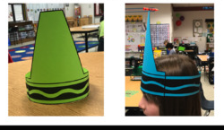 | I would like the children to create a crayon hat using the template provided. I would like the children to colour in their hat, their favourite crayon colour.

If you have any questions about today’s learning activities set then please email the class email these are viewed from 9.00 until 3.30 daily.
willow@datchetstmarysacademy.co.uk

