Spruce Spring 2 Term Newsletter
Welcome back to the Spring 2 term, this term we have an exciting new topic we are covering.
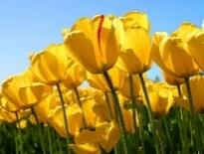
Topic: All Around the World
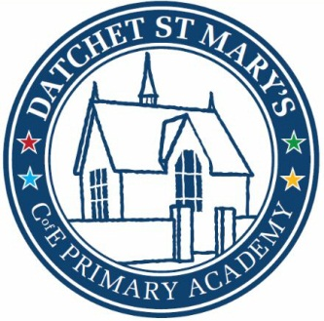

Upcoming Events
Thursday 5th March World Book day
Tuesday 10th March School trip to Pizza Express
Wednesday 11th March Science Day
Friday 20th March wonderful women day
Thursday 2nd April Ester church service 9.30
Friday 3rd April Easter Bonnet Parade
Friday 3rd April Last day of term 1.30 finish
Activities to do at home:
- Talk about where their families are from and things that make them unique
- Look at different coins
- Play shops at home encourage children to add coins or give change
- Listen to your child read everyday
- Read and discuss stories at bedtime
- Encourage writing using Fred Fingers i.e. shopping lists, labels.

This Term PE will be on a Wednesday afternoon.

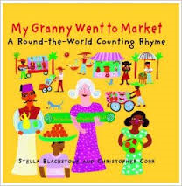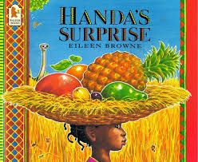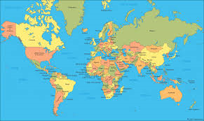
This term we will be exploring the topic All Around the World. The children will be learning about different countries and cultures from around the world including how to say hello in different languages. They will be making friendship bracelets, making different food from around the world and looking at art techniques from a different country.
Literacy:
This term we will be using our phonic knowledge and SWAG to write information about ourselves, facts about different countries, instructions on how to make a pizza using time words, and a letter to a character in a different country.
Maths:
This term we will be learning about money. We will be learning to identify different coins, and using these coins to add and subtract different amounts. Children will be challenged to use their knowledge of counting in twos, fives and tens to add higher value coins as well as using this knowledge when playing in the role play restaurants and shops.

