Learning From Home
Year 3
Week 2 (week beginning 27th April)

Please find below details of your child’s learning from home tasks for this week.

 | Learning Focus | Links to useful websites, resources and videos to support with the learning focus | Tasks to complete
Phonics/ Spelling | We are learning to spell words in which the /ɪ/ sound is spelt y. | https://spellingframe.co.uk/  Click on year 3/4  Rule 2: View words  Then do spelling tiles  Then test when ready.
Reading | We are learning to retrieve information from a text and to infer from our reading. | Use Twinkl Home Learning Hub.  Click on 7-9 age range. Choose the activities for 6/4/20. Then go down to Guided Reading session [Reading with Puffin and the Pawsome Gang] and watch and read on Youtube ‘Stig of the Dump’. Answering questions asked by the Pawsome Gang will help to develop comprehension skills. Further chapters are explored in subsequent guided reading sessions for that week.  Alternatively, read a suitable book using Oxford Owls on the school VLE.
Writing | We are learning to write non-chronological texts. | Greek myths are full of monsters which are often creatures made up of a mix of different animals. Look online for pictures or descriptions of the Minotaur, Medusa, a sphinx, the Sirens and the Harpies.  Now, draw your own creature, made up of two or more animals, and give it a name. Think about:  - Why does that name suit it?  - Where does it live?  - What does it look like and why? E.g. Why does it need fur or three eyes?  - What skills does it have?  - What are its strengths and weaknesses? | Write down your ideas as a short, non-chronological report. Use the monster’s name as the title and each prompt question as a sub-heading.  Remember to use describing words to make your text interesting. Check that your text makes sense to others and tht you have used all the capital letters and full stops you need.
Maths | We are learning to read and write 12-hour digital times.  Doodle Maths daily | Websites which you may find useful are:  https://www.math-aids.com/Time/  https://www.topmarks.co.uk/Search.aspx?q=digital%20clock  http://www.maths-games.org/time-games.html  https://www.helpfulgames.com/subjects/mathematics/match-clocks.html  https://worksheetgenius.com/clock_worksheets.php  NB: You must understand how to use am and pm. | Using online games and worksheets, practise reading and writing the time to the nearest 5 minutes on a 12-hour digital clock. Once you can read 5 minute interval times, move on to reading time to the nearest minute.
Project linked to foundation subject(s) | Groovy Greeks  History: | https://www.bbc.co.uk/bitesize/topics/z87tn39  The BBC bitsize website is brilliant tool for researching about the Ancient Greeks it is interactice and has a few video clips.  You will need a piece of paper and turn it landscape. Draw a long line across the middle of the page-this is your timeline. On the next page, there is the key events from the Ancient Greeks.You can cut and stick them or copy them onto your timeline.  Top tip when ordering on a timeline-  Remember because it is BC (Before Christ) the numbers are ordered the oppsiote to how we do it now (AD). Therefore, you start with biggest number first. Below is an example of what a timeline can look like. | To understand the order of the Ancient Greeks timeline.  Draw a timeline and add the key events.

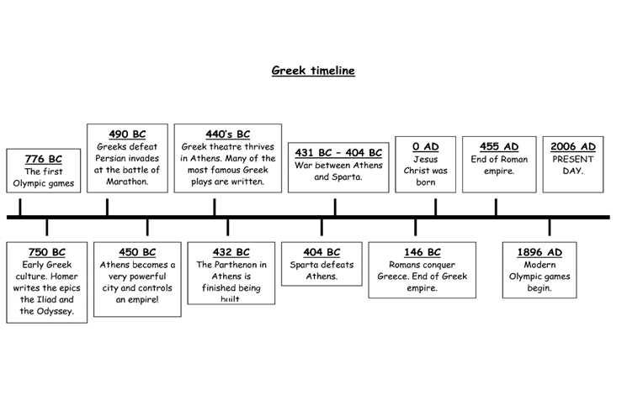

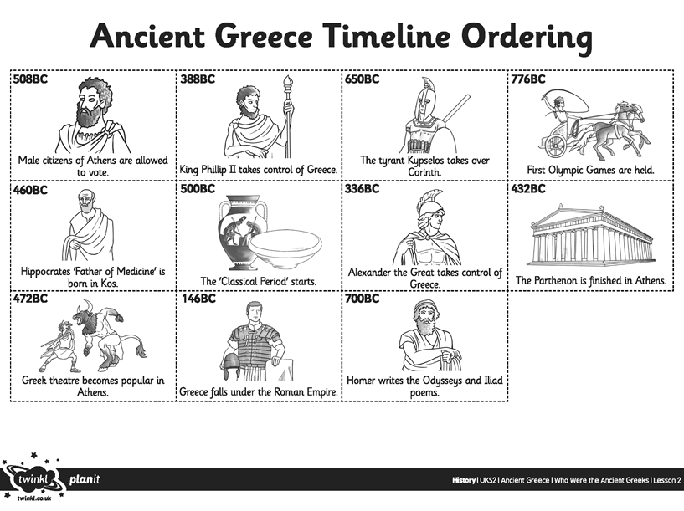

Other useful websites, games, resources and videos:

If you have any questions regarding your child’s learning, please send an email to:
learning2@datchetstmarysacademy.co.uk we will look into your query and respond as soon as possible.

