Learning From Home
Year 3
Week 3 (week beginning 4th May)

Please find below details of your child’s learning from home tasks for this week.

 | Learning Focus | Links to useful websites, resources and videos to support with the learning focus | Tasks to complete
Phonics/ Spelling | We are learning to spell words in which the /ʌ/ sound is spelt ou. | Spellingframe.co.uk  Click on year 3/4  Rule 3: View words  Then do spelling tiles  Then test when ready.
Reading | We are learning to identify words which capture our interest in our reading, and use strategies to work the meanings of new words. | Use Twinkl Home Learning Hub.  Click on 7-9 age range. Choose activities for 13/4/20. Then go down to Guided Reading session [Sabryna and the River Spirit] and watch and read on Youtube. Do the comprehension activities as you go. Further chapters are available on each of the following days of that week (e.g. 14/4, 15/4)  Alternatively, read a suitable book using Oxford Owls on the school VLE.
Writing | We are learning to write play scripts. | At the bottom of this sheet is the start of a playscript for a famous Greek myth about a great inventor and designer called Daedalus and his son, Icarus.  A playscript should have:  - A list of characters (at the very beginning).  - It may be split into scenes which take place in different places (settings).  - Each scene will have a description of the setting at the start and then the characters' dialogue.  - Dialogue is set out with the character's name on the left, then a colon then the dialogue (without speech marks).  - Stage directions for the actors are written every now and again in brackets.  - Greek plays also have a chorus which acts as a narrator to explain things and fill in missing information. | Have a go at turning the start of your favourite Greek myth into a playscript.  You may wish to do only the start or the whole story. You might want to act out your script with your family to check that it makes sense. You could even record it on an ipad and send it to us in school.
Maths | We are learning to find unit and non-unit fractions of a quantity or shape. Count up and down in tenths.  Doodle Maths daily | Use the website: https://whiterosemaths.com/homelearning/  Other websites which you may find useful are:  https://www.math-aids.com/Fractions/  https://primarymathsresources.com/free-fractions-worksheets.html | Go to the White Rose website and choose Year 3. Select Week 1. Use the daily video lessons to revise, or learn more about, fractions. Complete the worksheet provided. There is one lesson for every day or the week. Answers are provided. If you need more practice or more challenge, look at the other websites for some more worksheets.
Project linked to foundation subject(s) | Groovy Greeks.  Now you should know where Greece is and have a basic understanding of the key events that took place.  Now we will look at the history of the Ancient Greek Democracy. | Resources can be found in folder underneath this home schooling sheet. Inside you will find:  *Lesson Presentaion Ancient Greek Democracy.  *Ancient Greek Democracy cards.  *Activity sheets comparing Ancient Greek democracy.  When looking through the PowerPoint answer the questions perhaps have a discussion with your family.  Have a look at the democracy cards sort the cards into two piles those that are included in democracy and those that are not.  Next, you can fill in the table on the activity sheet found in the file. There are 3 different activity sheets to choose from 3 stars being the challenge. There are statements that can be sorted onto the table. You can cut and stick or copy the table and statements onto your own piece of paper.  If you would like to find out about democracy in UK please go on BBC Bitesize.  https://www.bbc.co.uk/bitesize/guides/zwvqtfr/revision/1  Further knowledge can be found on BBC bitsize ‘How did the Ancient Greeks change the world?’  https://www.bbc.co.uk/bitesize/topics/z87tn39/articles/z8q8wmn | Read thgrough PowerPoint Presentation.  Sort the people who are part of the democracy and those that are not  Complete a table to compare Ancient Greek democracy and the UK  Extra:  Write a persuassive letter or a balanced argument to persuade the prime minister, Boris Johnson, children should be allowed to vote.

Other useful websites, games, resources and videos:

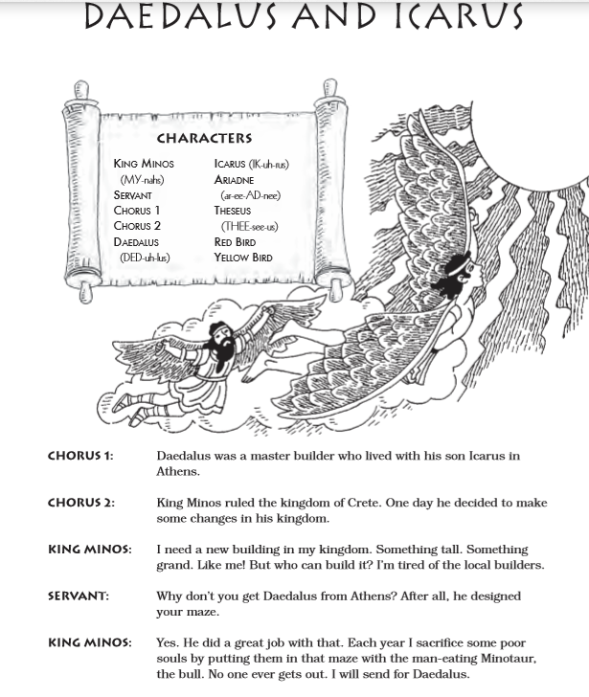

If you have any questions regarding your child’s learning, please send an email to:
learning2@datchetstmarysacademy.co.uk we will look into your query and respond as soon as possible.

