Learning From Home
Year 3
Week 4 (week beginning 11th May)

Please find below details of your child’s learning from home tasks for this week.

 | Learning Focus | Links to useful websites, resources and videos to support with the learning focus | Tasks to complete
Phonics/ Spelling | We are learning to spell words in which the /ʌ/ sound is spelt ou. | Spellingframe.co.uk  Click on year 3/4  Rule 8 (suffix -ly): View words  Then do spelling tiles  Then test when ready.
Reading | We are learning to identify words which capture our interest in our reading, and use strategies to work the meanings of new words. | Use Twinkl Home Learning Hub.  Click on 7-9 age range. Choose activities for 20/4/20. Then go down to Guided Reading session [How to Skin A Bear] and watch and read on Youtube. Do the comprehension activities as you go. You should find this book easier as we shared much of it in class, but we did not read all chapters or do any of the comprehension activities. Further chapters are available on each of the following days of that week (e.g. 21/4, 22/4)  Alternatively, read a suitable book using Oxford Owls on the school VLE.
Writing | We are learning to write instructions. | At the bottom of this sheet is a template for making a mask of the mythical monster, Medusa. She has snakes for hair and anyone who looks her in the eyes is turned to stone. Look up the myth if you want to know more!  A good set of instructions should have:  - A title which tells you what the instructions are for  - An introduction to persuade the reader to follow the instructions  - A ‘what you need’ list of materials and tools  - Step by step information about what to do and in what order  - Simple words  - ‘Bossy’ (imperative) verbs  - Diagrams (with labels) to help you follow the instructions  - Numbers or time connectives (e.g. next, then, finally)  - A closing line or paragraph with any further information  - Warnings/ safety advice in a separate box | Use the template to make the mask and then write a set of instructions to tell others how to make a Medusa mask. Refer to the ‘A good set of instructions should have’ checklist to help you.  Read you text to someone else to check that it makes sense and that you have used all the capital letters and full stops you need.
Maths | We are learning to place fractions on a number line and to find fractions of a set of objects.  Doodle Maths daily | Use the website: https://whiterosemaths.com/homelearning/  Other websites which you may find useful are:  https://uk.ixl.com/math/year-3/fractions-of-number-lines  https://www.math-aids.com/Fractions/  https://primarymathsresources.com/free-fractions-worksheets.html | Go to the White Rose website and choose Year 3. Select Week 2. Use the daily video lessons to revise, or learn more about, fractions. Complete the worksheet provided. There is one lesson for every day or the week. Answers are provided. If you need more practice or more challenge, look at the other websites for some more worksheets.
Project linked to foundation subject(s) | Groocy Greeks:  History  Art | https://kids.kiddle.co/Ancient_Olympic_Games  In Wk4 Home schooling file you will find a PowerPoint which contains information and questions to answer.  Have a think about modern day Olympics.  https://www.olympic.org/sports  The link above will take you to the Olympic website which lists all the sports in the summer and winter Olympics.  https://www.bbc.co.uk/bitesize/topics/z87tn39/articles/z36j7ty  The link above will take you to bbc bitesize- Where did the Olympics begin?  Have a look at the photo pack of Greek vases. What sport do you think each vase shows?  In the file find the activity sheet comparing the ancient and modern Olympic games.  Complete the venn diagram modern/ancient Olympics.  In the week 4 file you can find a template of a Greek vase.  Use the internet to magpie some ancient Greece designs.  https://www.youtube.com/watch?v=5wIc6Y4cSr4  You can use the link above. It gives you a demonstration on how to draw a vase.  https://www.bbc.co.uk/bitesize/topics/z87tn39/articles/zgpdjxs  This link will take you to BBC bitesize- Ancient Greek Culture.  You can create your own design or draw a scene showing one of the Olympic events. | To compare the ancient and modern Olympics.  To draw and design a Greek vase.  If you can have fun and re-enact the Olympic games.

Other useful websites, games, resources and videos:

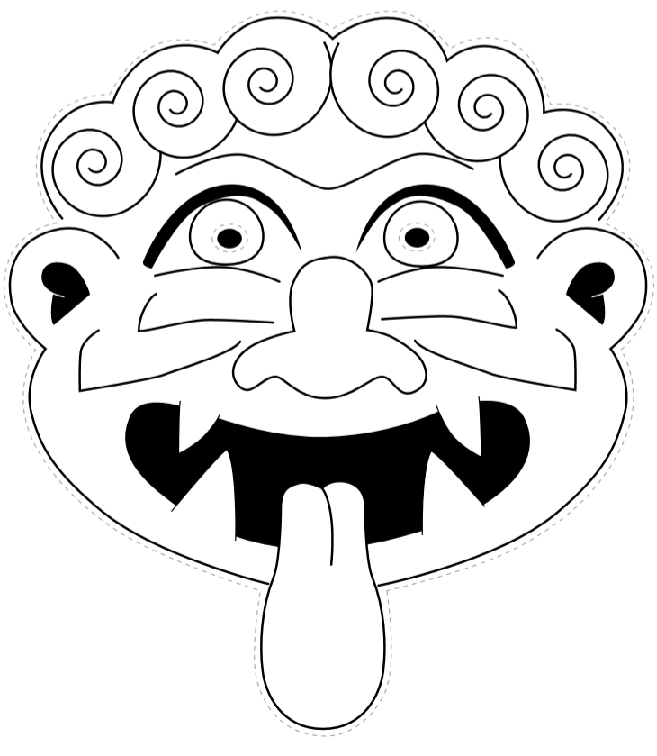
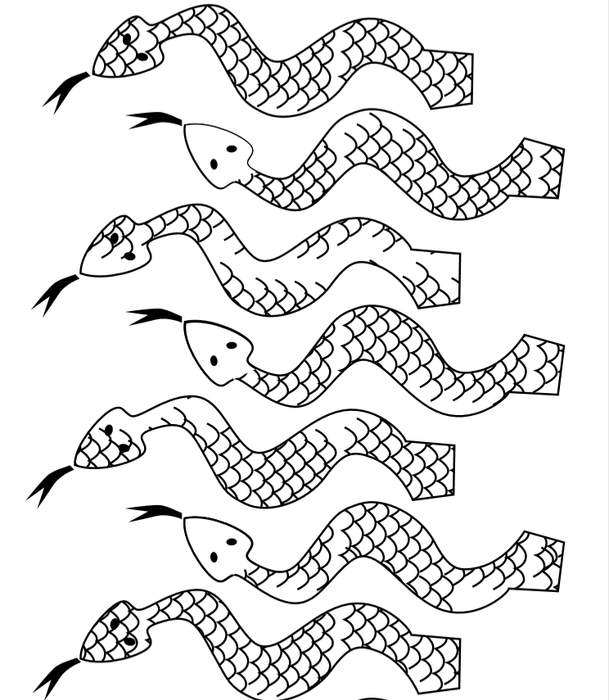
If you have any questions regarding your child’s learning, please send an email to:
learning2@datchetstmarysacademy.co.uk we will look into your query and respond as soon as possible.

