Learning From Home
Year 3
Week 7 (week beginning 8th June)

Please find below details of your child’s learning from home tasks for this week.

 | Learning Focus | Links to useful websites, resources and videos to support with the learning focus | Tasks to complete
Phonics/ Spelling | We are learning to spell words ending with  -ous. | Spellingframe.co.uk  Click on year 3/4  Rule 11: View words  Then do spelling tiles and free game.  Then test when ready.
Reading | We are learning to develop our reading skills. | Use Twinkl Home Learning Hub.  Click on 7-9 age range. Choose activities for 18/5/20. Then go down to Guided Reading session [The Creakers, Prologue] and download the pack. Work throught the PowerPoint presentation, answering the questions as you go. Further extracts and activities are available on each of the following days of that week (e.g. 19/5, 20/5)  Alternatively, read a suitable book using Oxford Owls on the school VLE.
Writing | We are learning to write a senses poem. | You will remember that we have started our new topic of ‘Blue Planet’. At the bottom of this sheet, you will find an example of a senses poem [If I Had Wings] about being a bird. This poem is about the five senses: sight, hearing, taste, touch and smell.  A good senses poem should:  - describe things you can see, hear, smell, taste and touch/ feel  - be written in stanzas (verses)  - include some items that are strange, exotic and magical  - use powerful verbs (e.g. sniff)and precise describing words (e.g. peppered)  - use a simile [as _as] (e.g. as hot as peppered curry)  - be written with neat handwriting | Using this poem as a model, write your own senses poem about being a creature. See the example to help you. You can start each stanza with ‘If I had wings’ or you can adapt your poem to another creature e.g. ‘If I had hooves’, or ‘If I had fins’. Refer to the ‘A good senses poem should’ checklist to help you.  Do not just write down the first idea that comes in to your head. Spend some time thinking about whether you can find a more precise or more powerful word.
Maths | We are learning to add and subtract money. We are learning to convert pounds and pence. We are learning to multiply and divide by 3.  Doodle Maths daily | Use the website: https://whiterosemaths.com/homelearning/  Other websites which you may find useful are:  https://uk.ixl.com/math/year-3/equivalent-amounts-of-money-up-to-1-pound  https://uk.ixl.com/math/year-3/exchanging-coins  https://uk.ixl.com/math/year-3/add-and-subtract-money-word-problems-up-to-5-pounds  https://uk.ixl.com/math/year-3/multiply-by-3  https://uk.ixl.com/math/year-3/divide-by-3  https://www.math-aids.com/Fact_Family/Multiplication_Division.html  https://www.math-aids.com/Money/  https://primarymathsresources.com/free-factors-and-multiples-worksheets.html  https://worksheetgenius.com/multiplication_worksheets.php | Go to the White Rose website and choose Year 3. Select Summer Term, Week 3. Use the daily video lessons to revise, or learn more about, working with money. Complete the worksheet provided. Day 4 moves on to using 3x table facts. There is one lesson or challenge for every day of the week. Answers are provided. If you need more practice or more challenge, look at the other websites for some more worksheets.
Project linked to foundation subject(s) | Science-Forces and Magnets.  Idenitfying forces acting on objects. | Please follow the PowerPoint Pushes and Pulls. Find in home learning resources.  The first question we need to think about is- What is a force? I have found some online resources to help you answer this question.  https://www.bbc.co.uk/bitesize/topics/zvpp34j  BBC Bitesize, Pushes and Pulls.  https://www.bbc.co.uk/bitesize/clips/zch4wxs 7  Find some clips to watch.  If you have access to Youtube there are a few clips on forces. (Remember to stay safe on YouTube).  https://www.youtube.com/watch?v=XAJUzs46nJQ  https://www.bbc.co.uk/bitesize/clips/zkw8q6f The link for slide 4 on PowerPoint. Identify any pusing and pulling in this clip.  Can you try and act out a few pushing and pulling actions. Can you find anymore around the home?  Find the activity sheet in the home learning resources. Pushing and pulling forces.  Another activity can be found in the home learning resources. Pushes and pulls home learning tasks.  (All topic work set by Miss Andrews). | Research forces- some links for help.  Complete activity sheet.  Complete activity sheet.  Extra activities to do around the house:  Can you sort your toys into groups of push and pull force.

Other useful websites, games, resources and videos:

If you have any questions regarding your child’s learning, please send an email to:
learning2@datchetstmarysacademy.co.uk we will look into your query and respond as soon as possible.

‘If I Had Wings’ poem

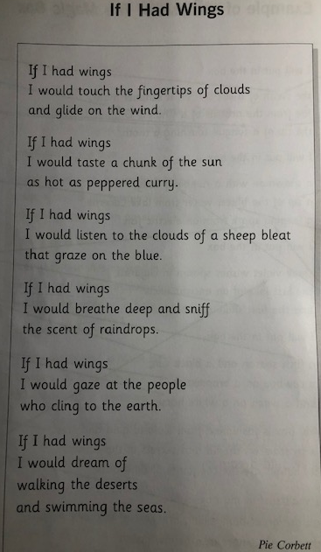

Opening stanza of a senses poem modelled on ‘If I Had Wings’

If I had fins
I would touch the turbulent tides of the Atlantic Ocean
and wash-up on shores of powder soft sand.

