Colour in the cubes to show the some of the bonds to 10.
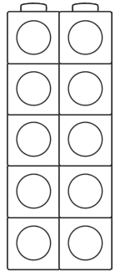
__ + __ = 10
2 + 8 = 10

__ + __ = 10
__ + __ = 10

__ + __ = 10
__ + __ = 10

__ + __ = 10
__ + __ = 10

__ + __ = 10
__ + __ = 10

__ + __ = 10
__ + __ = 10

