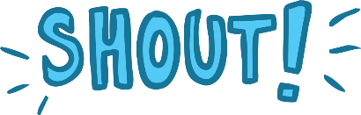
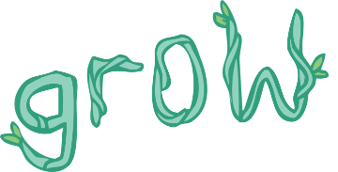
Calligrams
A calligram is a word or piece of writing which is written to look like what the word means.
Can you underline any words in these sentences that might make good calligrams?

- In the Autumn, the days gets shorter, the nights get longer and leaves fall off the trees.

- In the Winter, the snow falls and we light blazing hot fires to keep us warm.

Have a go at turning some of these Great Fire of London words into your own calligrams:

windy | night | shouted | fire | boiling
blazing | water | river | disaster | bakery

Challenge:
Think of your favourite animal. Can you create 2 calligrams to match? For example for crocodile you could use the words ‘long’ and ‘snappy’ to make your calligrams.

