The Human Body


To name, identify and label the parts of the human body.
Look at the labels of the body parts. Can you add these body parts to the outline below?

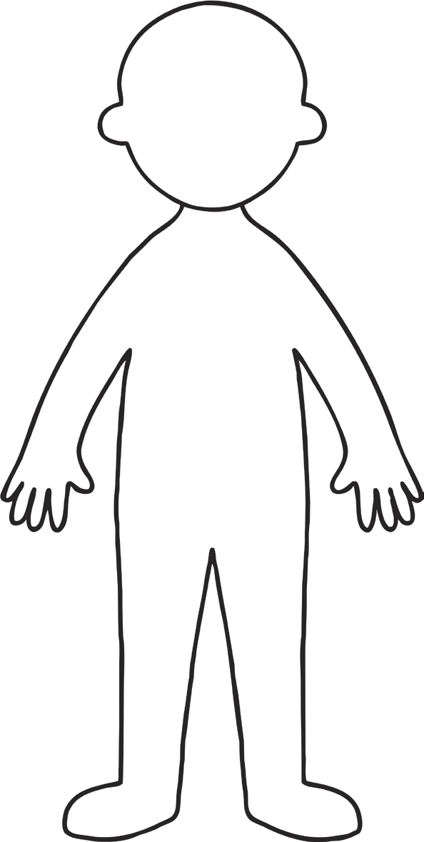

Cut out the labels and add them to your completed human
head
arm
leg
mouth
teeth
hand
nose
ear
foot
eye
finger
toe
face
knee
elbow
neck
hair
chest
ankle
wrist
stomach
shoulder


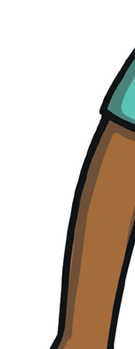
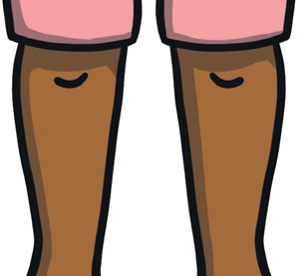
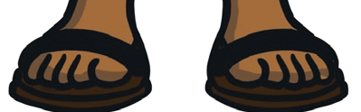
arms
legs
feet
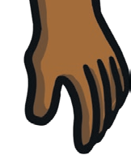
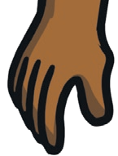
Write a sentence to explain what we use these body parts for.
hands

_____________________________________________________________

_____________________________________________________________

_______________________________________________________________

