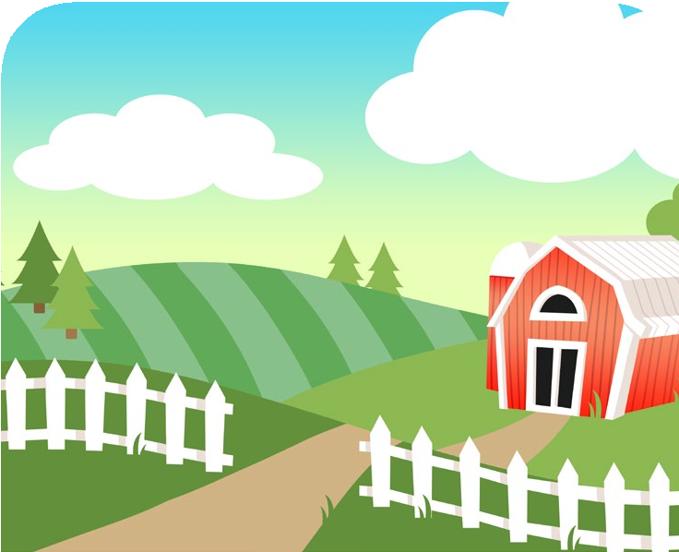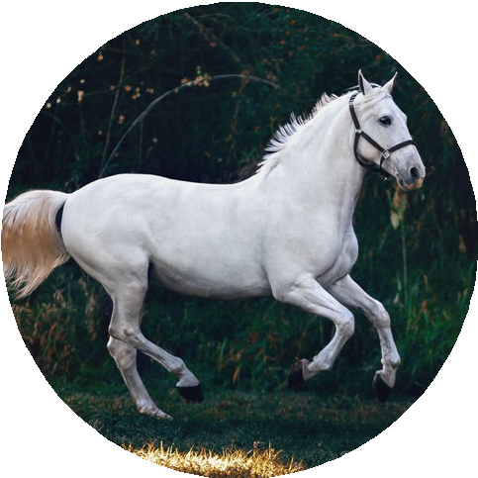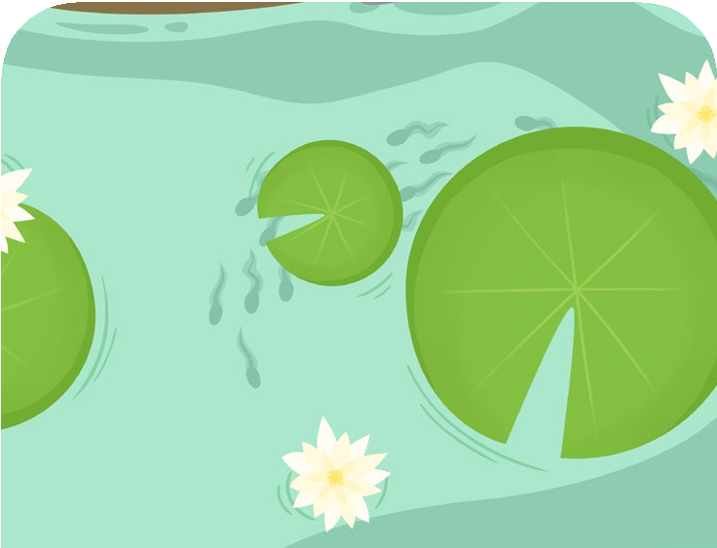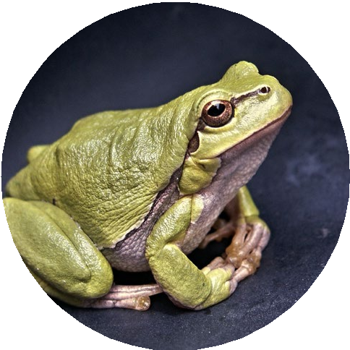
horse
Features: covered in hair, four legs
Diet: grass, hay, fruit and
vegetables
twinkl.com
frog
Features: moist, smooth skin, a long sticky tongue
Diet: insects, such as moths
and flies
twinkl.com

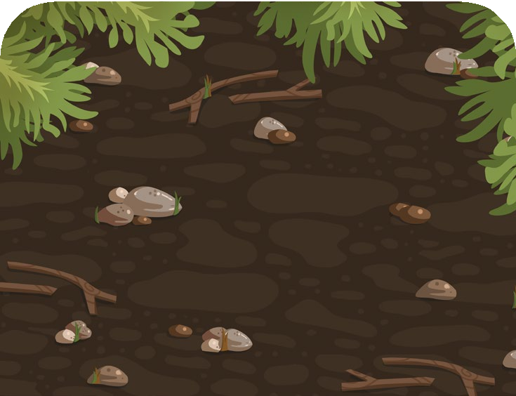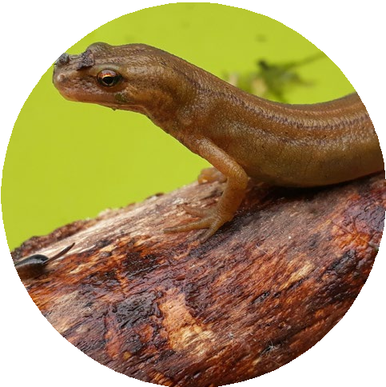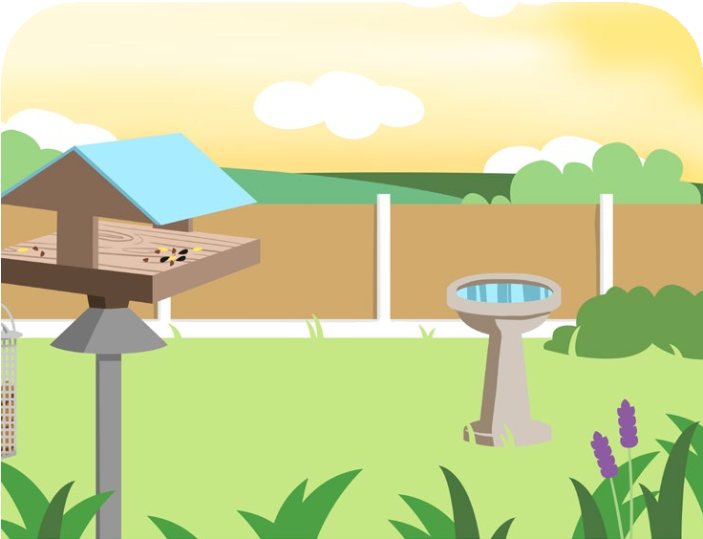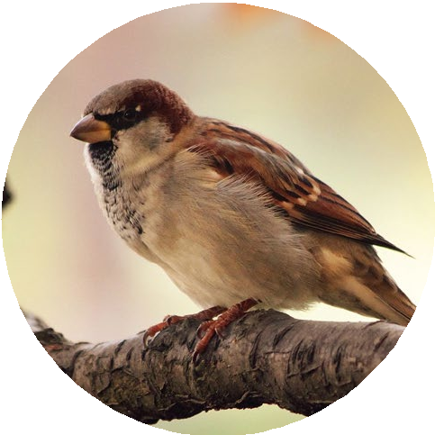
newt
Features: moist skin, four legs
Diet: slugs, worms, tadpoles
twinkl.com
house sparrow
Features: feathers, two legs, a beak
Diet: seeds and insects
twinkl.com

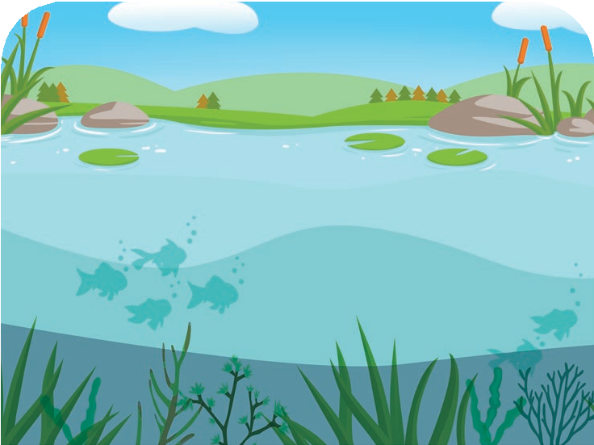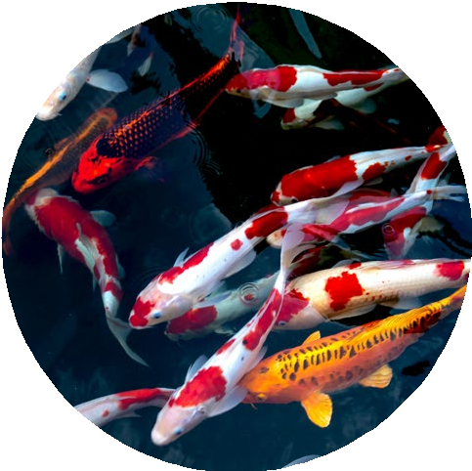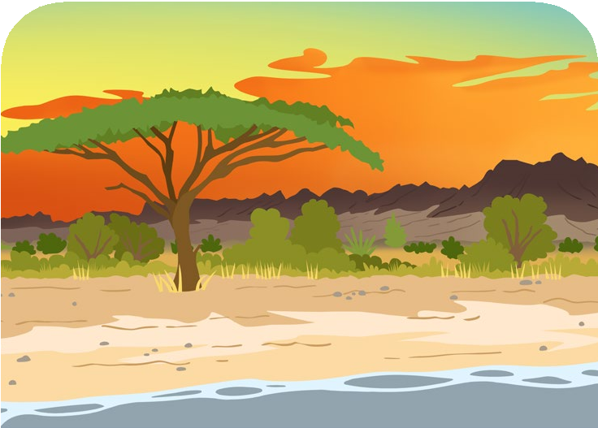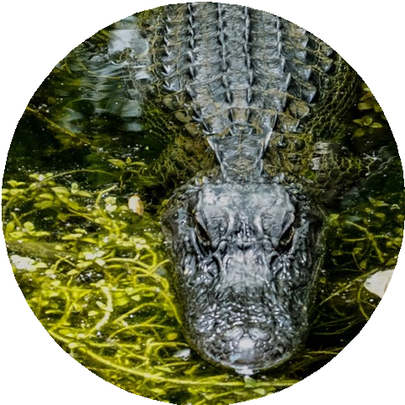
koi
Features: scaly skin, fins and gills
Diet: water plants and
insects
twinkl.com
crocodile
Features: scaly skin, sharp teeth
Diet: fish, frogs and birds
twinkl.com

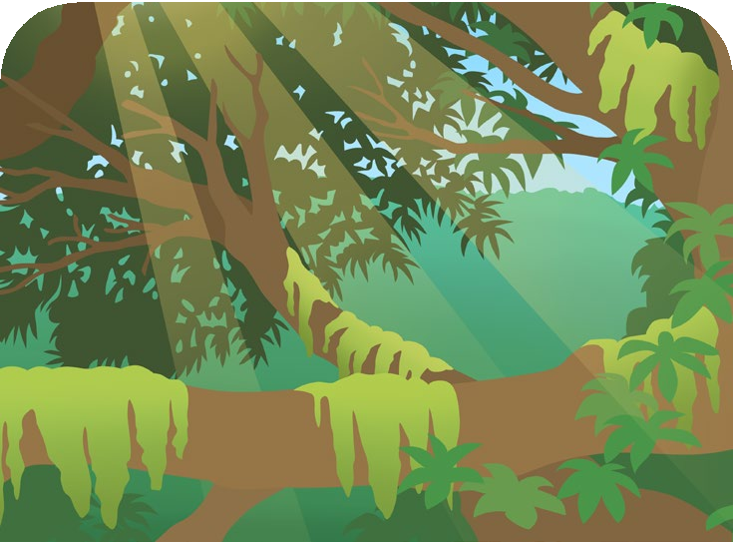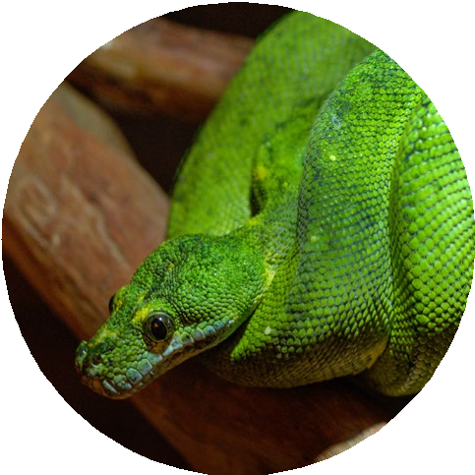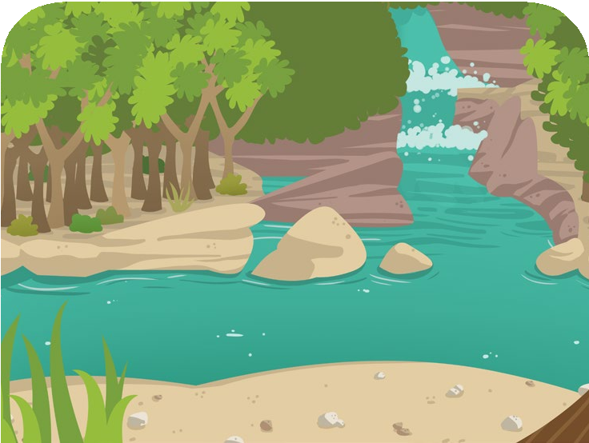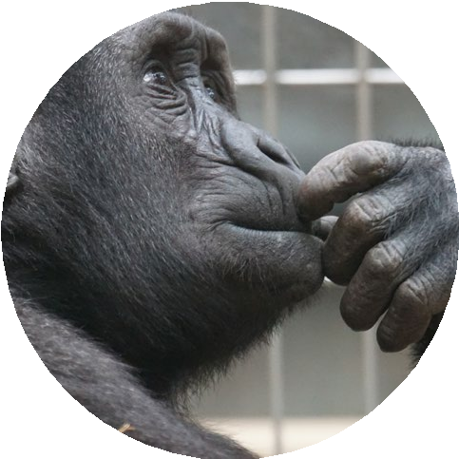
snake
Features: scaly skin, no legs
Diet: mice, voles, frogs and other small animals

twinkl.com
chimpanzee
Features: covered in hair, two legs
Diet: mice, fruit, vegetables, bark and insects

twinkl.com

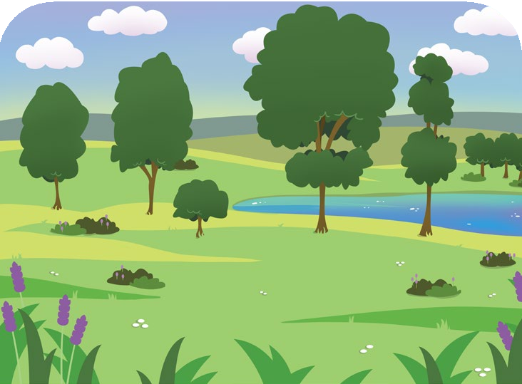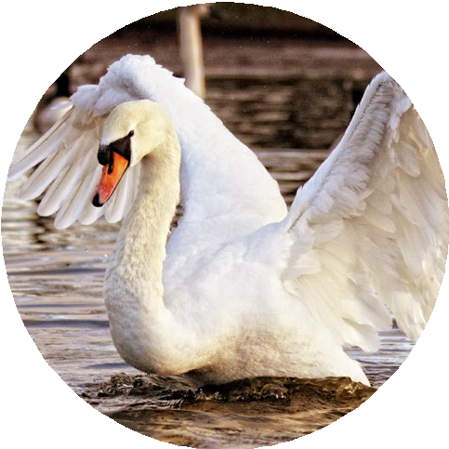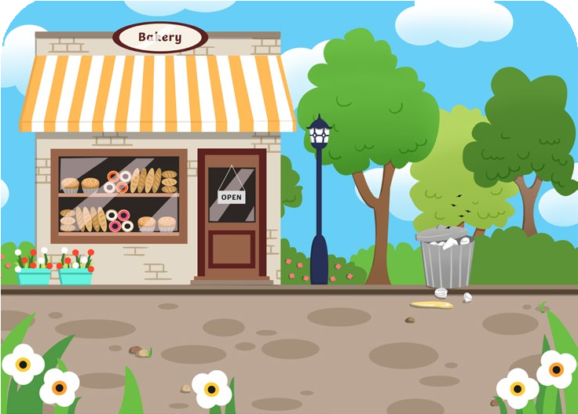
swan
Features: feathers, two legs, a beak
Diet: plants, flowers, insects
twinkl.com
cat
Features: covered in hair, four legs, sharp claws
Diet: mice, voles, birds and
other small animals
twinkl.com

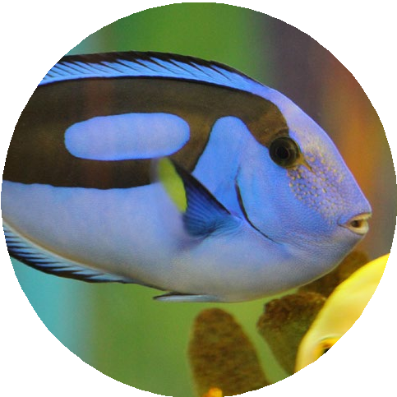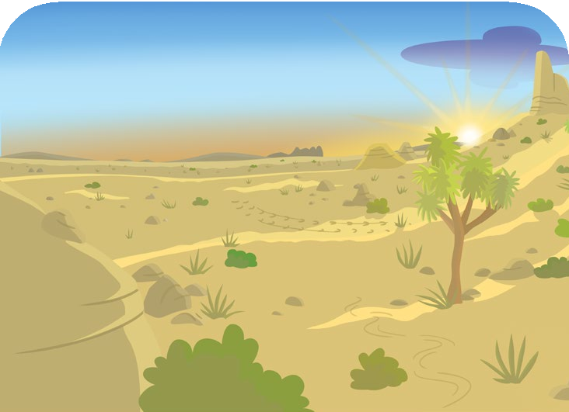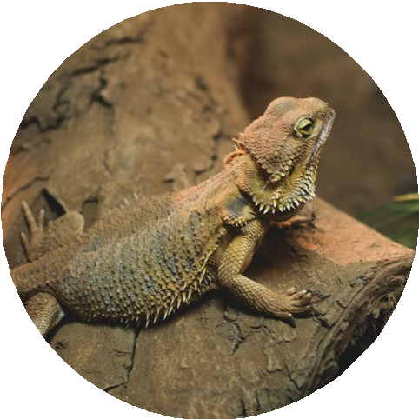
blue tang
Features: gills, scaly skin, fins, live in water
Diet: water plants, such as
algae
twinkl.com
bearded dragon
Features: scaly skin, four legs
Diet: fruit, plants and
insects
twinkl.com

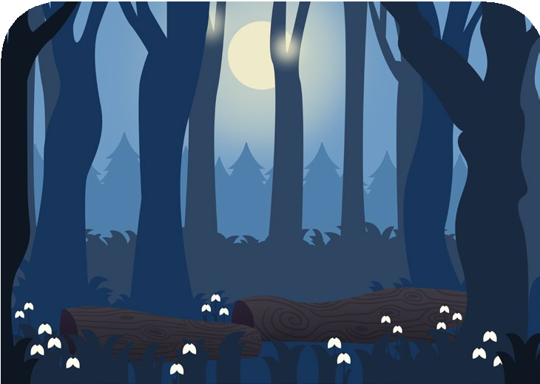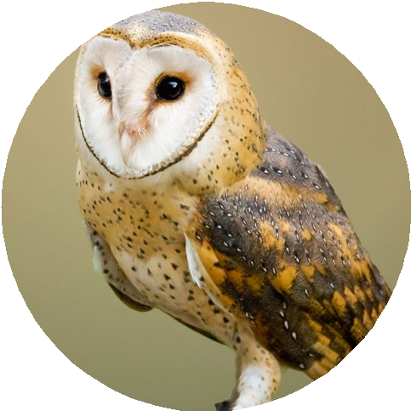
human
Features: hair, two legs
Diet: fruit, vegetables, dairy, meat, grain and nuts

twinkl.com
barn owl
Features: feathers, two legs, a beak, sharp talons (claws)
Diet: mice, voles, shrews,
frogs
twinkl.com

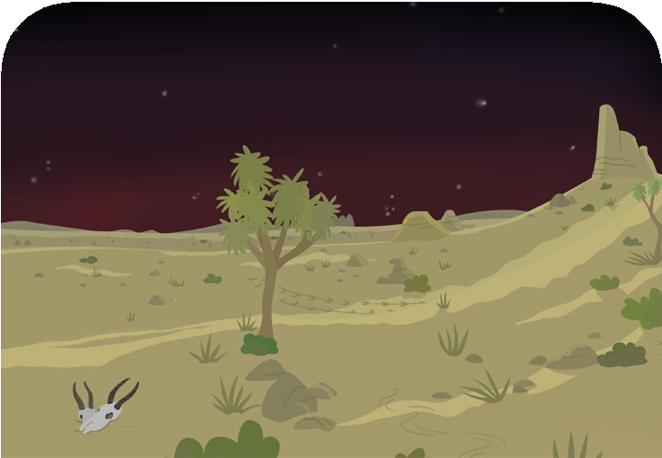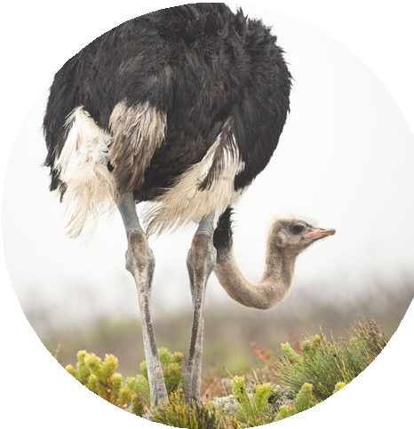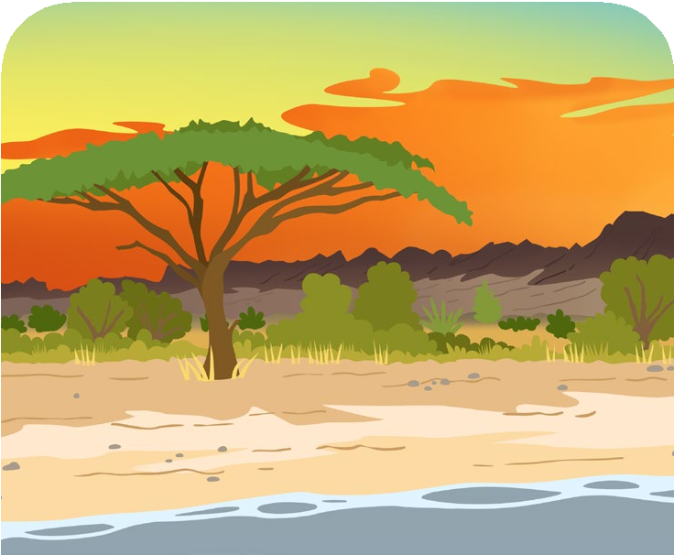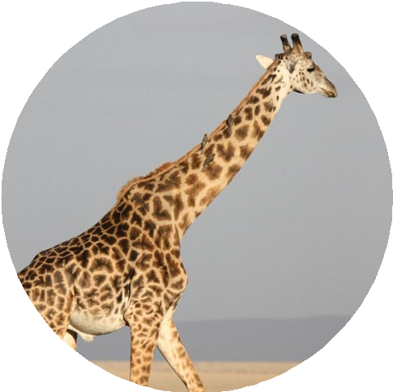
ostrich
Features: feathers, a beak, two legs
Diet: plants and insects
twinkl.com
giraffe
Features: covered in hair, four legs
Diet: grass, leaves, twigs and
plants
twinkl.com

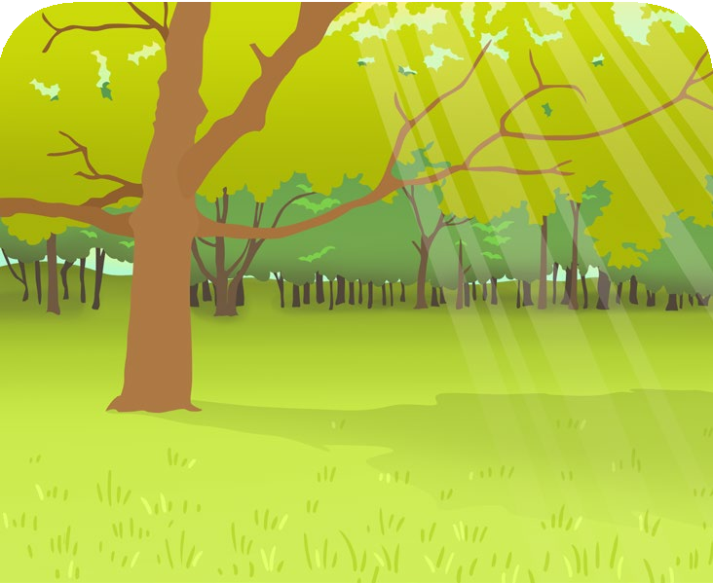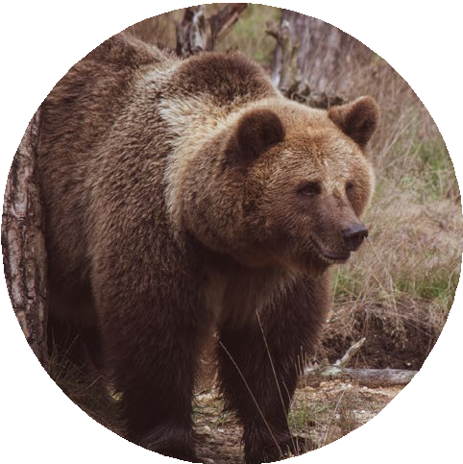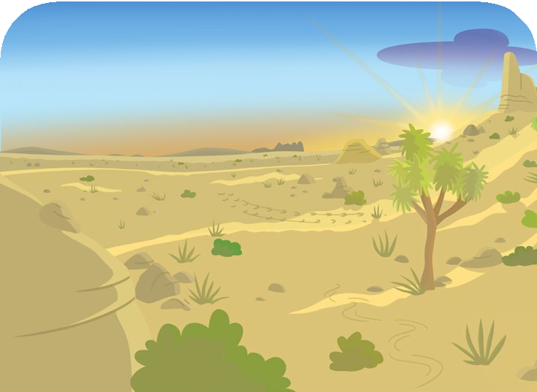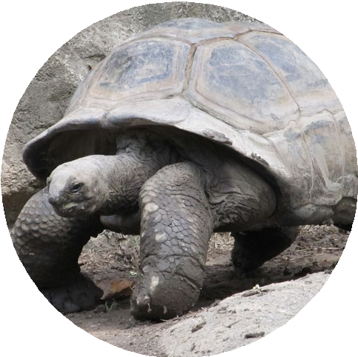
brown bear
Features: covered in hair, four legs, sharp claws
Diet: grass, plants, berries
and insects
twinkl.com
tortoise
Features: scaly skin, four legs
Diet: grass, leaves and
plants
twinkl.com

