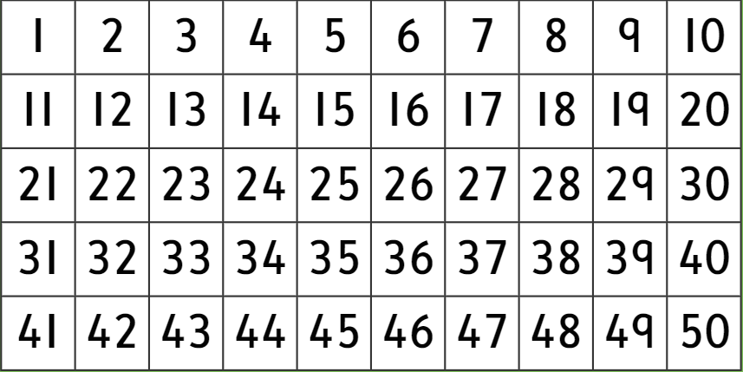
Colour in the multiples of 2

Colour in the multiples of 5

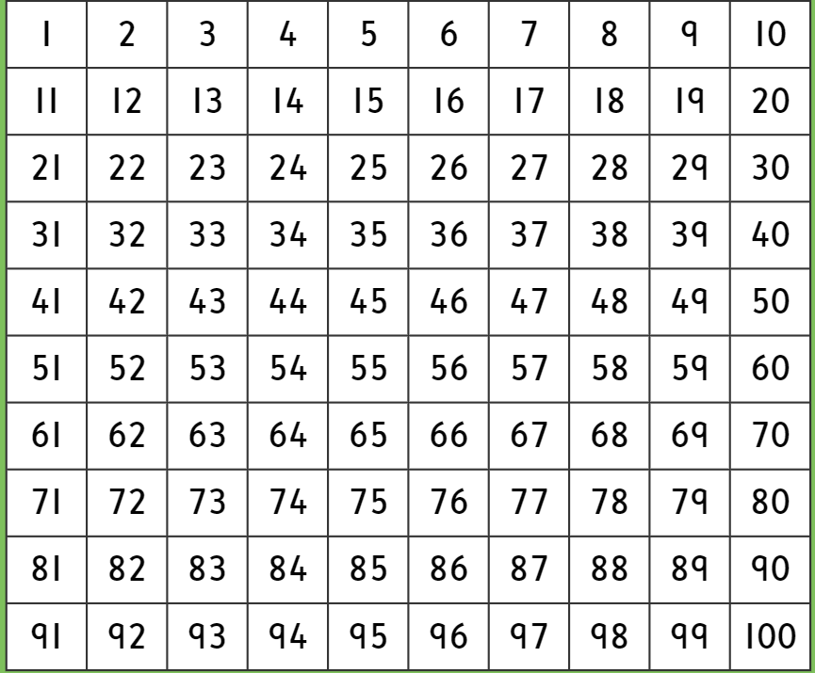
Colour in the multiples of 10

