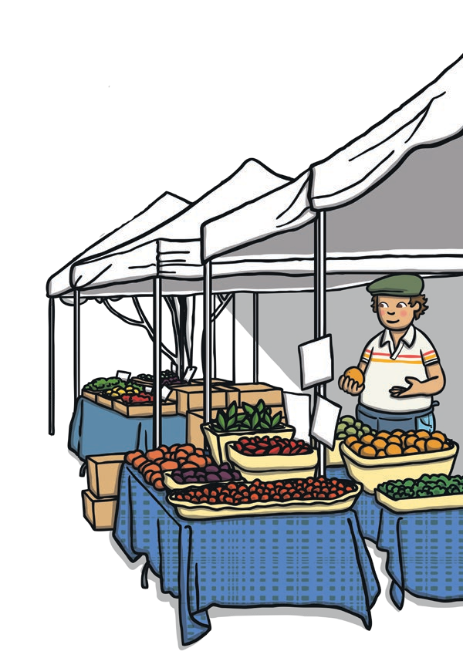Name________________ Date___________

My Shopping List

Learning Objective: To write a list. To understand how a list looks
different to sentences.

