Name___________________________ Date_________________
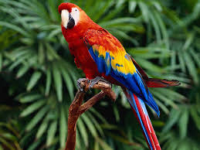
Captions

____________________________________________________________________________________________________________________________________________________________




