Exploring Winter with Our Senses
Hear
Taste
Feel
visit twinkl.com
Use your five senses to explore winter.
See



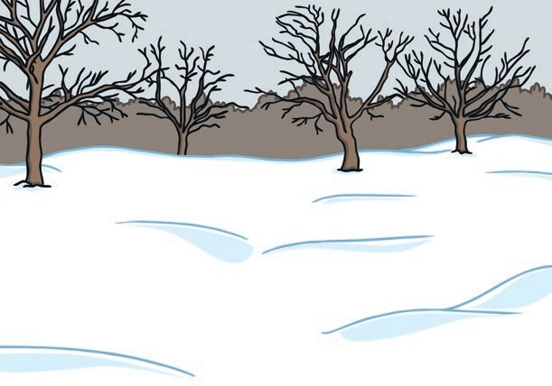




Smell

