Topic | Learning objective | Teaching points /teachers voice | Task to complete
English | LO I can begin to write my suspense story | We are going to begin to write our suspense stories today.  Please watch the PowerPoint in the folder.  Press the play button to hear me talking to you.   | Use your planning frame and writing targets to begin to write out your suspense story.  Please pay attention to those things on the writing targets that you we highlighted that you need to work on this time.  You need to take your time on this – I would only expect you to have written to the end of the Build up today if you are trying to show off your writing skills to us.  You can check each paragraph that you have written to make sure it is as good as it can be.

Spelling | LO To spell cious, tious words | Spelling Frame  Year 5/6 Rule 37  JF Please note: your spellings are on Spelling Frame for you. | Go onto spelling frame daily  You will have a spelling test as part of Friday’s English lesson
Maths  SEE BELOW IF You are in Mrs Matharu’s Maths group | LO To express decimals as fractions | DOODLE MATHS DAILY FOR 15 Minutes  Main  We are going to continue to work on decimals today and link it to our fractions work.  This is a bit of revision from work we did in the Autumn  https://vimeo.com/490693175  You might find that drawing a place value chart helps you to understand the valueof a decimal number more easily:  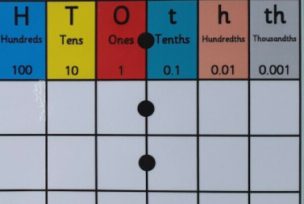 | Main  All of Miss Gilbert’s and Mrs Phillips’s Maths class do the worksheet:  Year 6 Home learning Maths Main Thursday  And mark your own work using the answers  Extension:  Then do the questions in Year 6 Homeschool Learning Maths Extension Thursday  Please mark your own work when you have finished.
Maths  Mrs Matharu’s Group | LO I can read and interpret tables.  I understand how to compare and calculate difference using charts | - Today you are going to use previous learning to calculate sums and differences when reading tables and charts.  Watch - https://vimeo.com/432265829 | Complete work sheet labelled Mrs Matharu’s group 25.2.21 Complete all questions on the worksheet.  Don’t forget to do your doodle maths and Doodle timetables!
Topic  French | LO To understand the French words for stationery  I can show that I understanding the meaning of a sentence by saying whether it is true or false. | Read through the Powerpoint, clicking on the sound clips.   | Choose your challenge:  Challenge 1  Challenge 2

If you have any questions about today’s learning activities set then please email the class email these are viewed from 9.00 until 4.00 daily.

