Topic | Learning objective | Teaching points /teachers voice | Task to complete
English | LO To develop reading for pleasure skills | Today we are going to relax a little with our English and find out about book reviews.  This builds on our comprehension yesterday when I told you that one of my favourite books was the Weirdstone of Brisingamen by Alan Garner (it was a bit scary!)  We are going to use an Oak National Academy lesson to help us.  Please watch  https://classroom.thenational.academy/lessons/to-develop-reading-for-pleasure-through-book-recommendations-68u3cr | Pause the video and do the tasks as the teacher (Ms Madden) tells you to.  Be prepared with your writing book and pen or pencil.
Spelling | LO  To spell homophones | Spelling Frame rule 52  JF Please note: your spellings are built from root words. All of the root words do not end with a double consonant  So drum becomes drumming, drummed.  The rule is when there is a vowel before the final consonate, you have to double the consonant when adding -ed, or -ing. | Go onto spelling frame daily  You will have a spelling test as part of Friday’s English lesson
Maths  SEE BELOW IF You are in Mrs Matharu’s Maths group | LO To find the whole (fractions) | DOODLE MATHS DAILY FOR 15 Minutes  This is the final day of our fractions work.  We are finding the whole  https://vimeo.com/480708847 | All to do Homeschool Learning Maths Thursday sheet  Mark your work using answers.  Extension  Write a tricky fraction problem from all of your new fraction knowledge.  Send it in to us.
Mrs Matharu’s Maths group | LO To complete a termly assessment | - Today you are going to answer test questions on work you have covered this term.  - Have a look at https://www.bbc.co.uk/bitesize/topics/z4nsgk7/articles/zwbndxs  https://www.bbc.co.uk/bitesize/topics/zhdwxnb/articles/z9n4k7h | Complete maths question labelled – Mrs Matharu’s group 11.2.21
Topic  ICT | LO To understand how to stay life while playing games online. | Watch the powerpoint, clicking on any sound buttons.  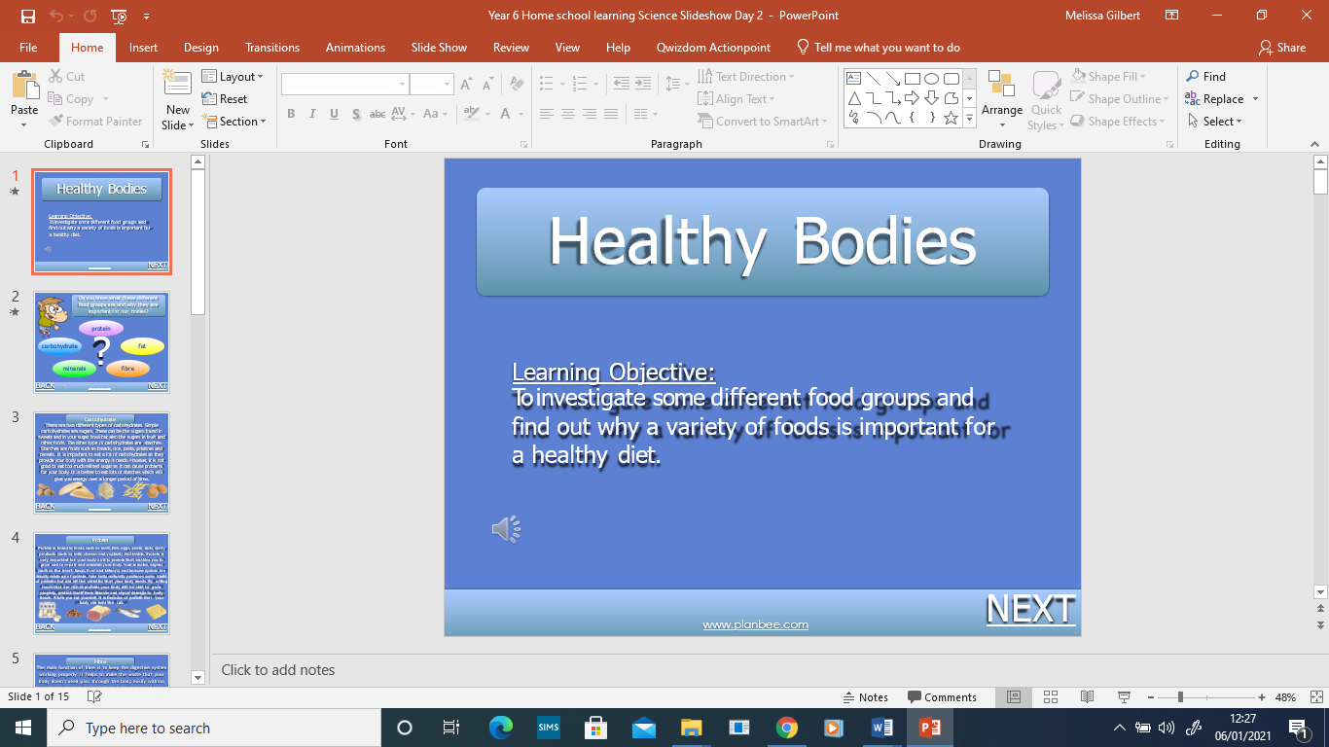  Check out the thinkuknow game: https://www.thinkuknow.co.uk/8_10/ | Create your top 10 tips for staying safe while online gaming.

If you have any questions about today’s learning activities set then please email the class email these are viewed from 9.00 until 4.00 daily.

