Q1.
Tick (✓) the two cards that show the same weight.
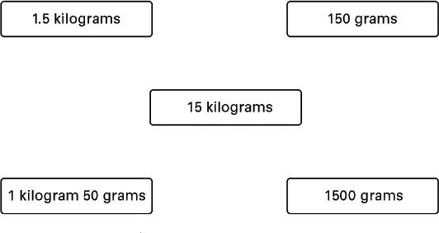
1 mark
Q2.
Conversions
Fill in the gaps to show what the units measure.
The first one is done for you.

centimetres measure ___length___
kilograms measure ___________
litres measure ___________
square metres measure ___________

2 marks

Q3.
Length
Arrange these masses in order of size.
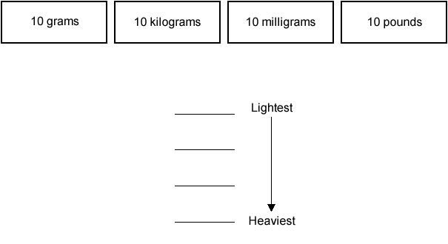
1 mark
Q4.
Put these amounts of money in order.
£7 £1.75
68p 243p
________ ________ ________ ________
1 mark

Q5. Match each length to the correct box on the right.
One has been done for you.
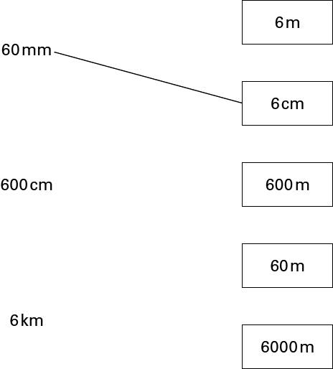
1 mark

Q6.
(a) Fill in the gaps using units of length.
The first one is done for you.
There are 10 mm in one cm
There are 100 _________ in one __________
1 mark
There are 1000 _________ in one _________
(b) Fill in the gaps using units of mass.
There are 1000 _________ in one _________
1 mark
Q7.
Units
(a) Steve says there are 1000 centimetres in one metre.
Is he correct?

Yes | 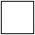 | No
Explain your answer.
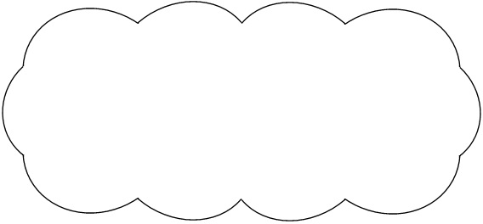
1 mark
(b) How many millimetres are in one centimetre?

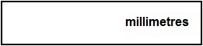
1 mark
Q8.
Estimates
Which value completes each sentence? Tick (✓) the correct box.
The first one is done for you.

The length of a banana is about …
2 cm  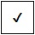 20 cm  200 cm  2000 cm | 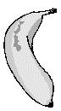

A can of drink holds about …
0.3 litres  3 litres  30 litres  300 litres | 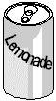
1 mark

The weight of an apple is about …
1 gram  10 grams  100 grams  1000 grams | 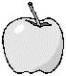
1 mark
Q9.
Long jump
Peter took part in a long jump competition.
He had three jumps.
The arrows on the scale show how far he jumped each time.
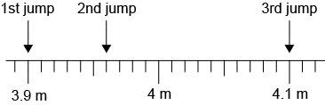
(a) How far did Peter jump on his 2nd jump?
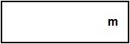
1 mark
(b) Peter jumped further on his 3rd jump than on his 1st jump.
How much further?
Write your answer in metres.
1 mark
Now write your answer in centimetres.
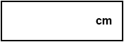
1 mark

