Topic | Learning objective | Teaching points /teachers voice | Task to complete
English | LO To answers comprehension questions carefully | Watch the Powerpoint Year 6 Home school Learning English Comprehension  Click on  to run the slide show.  You might want to print off the text:  Year 6 Home School Learning English Comprehension Main  MRS MATHARU’s group Read the story on the sheet: Mrs Matharu’s English Group Comprehension | Main  Year 6 Home School Learning English Comprehension sheet and questions at the end.  When you have answered the questions, write your own.  MRS MATHARU’S GROUP  Sheet: Mrs Matharu’s English Group Comprehension  Read the story and answer the questions.
Spelling | LO  To spell homophones | Spelling Frame rule 52  JF Please note: your spellings are built from root words. All of the root words do not end with a double consonant  So drum becomes drumming, drummed.  The rule is when there is a vowel before the final consonate, you have to double the consonant when adding -ed, or -ing. | Go onto spelling frame daily  You will have a spelling test as part of Friday’s English lesson
Maths  SEE BELOW IF You are in Mrs Matharu’s Maths group | LO To find fractions of an amount. | DOODLE MATHS DAILY FOR 15 Minutes  We are doing some fraction problem solving today.  Please watch https://vimeo.com/480708541 | All to do Homeschool Learning Maths Thursday sheet  Mark your work using answers  Extension: Another fractions problem from NRich.  Try this problem.  https://nrich.maths.org/peachestoday  The solution is on the page.
Mrs Matharu’s Maths group | LO To be able to understand imperial units and know the relationship between them | Today we continuing are looking at imperial units (units of measurement) and how to convert them.  Watch https://www.bbc.co.uk/bitesize/topics/z4nsgk7/articles/zwbndxs  Miles, feet and inches are old units of length. These are known as imperial units of length but are not now commonly used in maths.  - There are 12 inches in a foot.  - An inch is roughly equal to 2.5 centimetres.  - A foot is roughly equal to 30 centimetres.  A mile is roughly equal to 1.5 kilometres | Complete work sheet labelled Mrs Matharu’s group 10.2.21 Complete questions 1-4 on the worksheet.  Remember converting either involves dividing or times.  Have a look in your kitchen and find items that are measured in: kilograms (kg), grams(g), pints, litres (l), millilitres (ml), pound (lb)  Take the quiz on https://www.bbc.co.uk/bitesize/topics/z4nsgk7/articles/zwbndxs
Topic  ICT | LO To understand what copyright is. | Watch the powerpoint, clicking on the sounds.  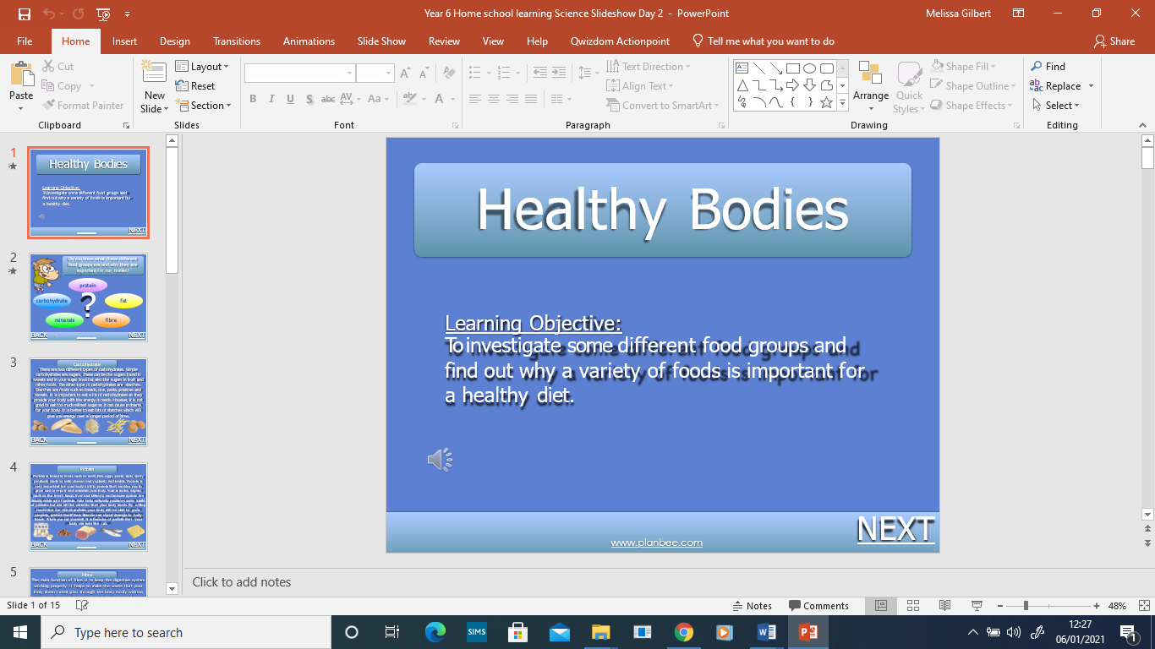 | Write your own scenario and have someone at home decide if it is the right or wrong thing to do.

If you have any questions about today’s learning activities set then please email the class email these are viewed from 9.00 until 4.00 daily.

