Topic | Learning objective | Teaching points /teachers voice | Task to complete
Assembly |  | Please watch our virtual assembly in the Video Resource Centre.  It is right at the bottom of the page. The one on the left with Miss Green. (Assembly week commencing 8th February).
English | LO To edit to improve my newspaper report | Please Watch the PowerPoint:  Year 6 Homeschool Learning English Report Writing Tuesday  Click on Play the Powerpoint from the slide show button so that you can hear me talking.    Re-watch the video and pause it where you need to, to help you improve your plan  https://www.youtube.com/watch?v=oWcmTQ1tWbI | You are going to edit to improve your work  You need to have printed off the Writing Targets discussion sheet from yesterday.  Use these steps to help you  1. Read over your own work to make sure it makes sense. (Check verbs agree - we were, we are, I was, they were).  2. Read for punctuation.  3. Read for spellings.  4. Improve with adjectives/adverbs/ complex sentences.  5. Use the checklist.  6. Underline in pink any words you have magpied.  7. Improve what you have not already done.
Spelling | LO To spell homophones | Spelling Frame  Year 5/6 Rule 52  JF Please note: your spellings are built from root words. All of the root words do not end with a double consonant  So drum becomes drumming, drummed.  The rule is when there is a vowel before the final consonate, you have to double the consonant when adding -ed, or -ing. | Go onto spelling frame daily  You will have a spelling test as part of Friday’s English lesson
Maths  SEE BELOW IF You are in Mrs Matharu’s Maths group | LO To apply the four rules (BODMAS) to fractions | DOODLE MATHS DAILY FOR 15 Minutes  Main  We are going to apply the four rules (BODMAS)to our fractions work today.  Please watch this video  https://vimeo.com/480708159  Remember BODMAS means you calculation B Brackets first, then O Operations (squaurd, cubed). Then D division. The M Multiplication. Then A Addition. Then S Subtraction.  (We did BODMAS work in week 2 of the Spring term if you want to remind yourself of it). | Main  All of Miss Gilbert’s and Mrs Phillips’s Maths class do the worksheet:  Year 6 Home learning Maths Monday  And mark your own work using the answers  Extension then try this from N Rich. It is an online special game of countdown with fractions. You need to be on a computer/tablet to solve the problems.  https://nrich.maths.org/6564  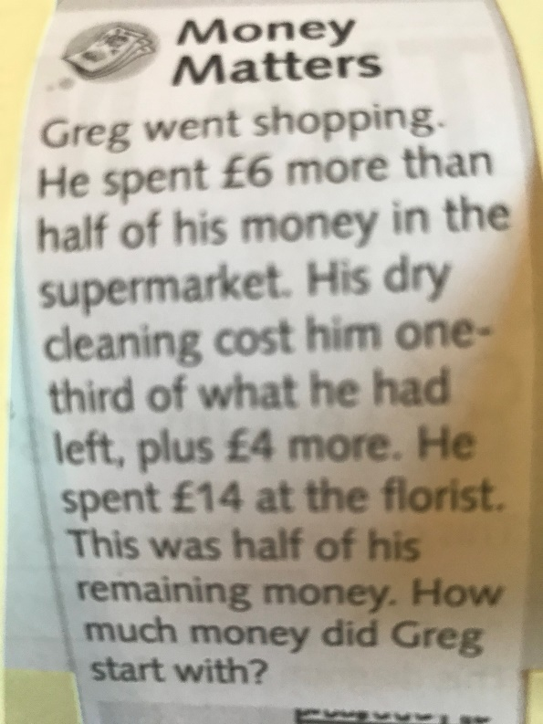
Maths  Mrs Matharu’s Group | LO To be able to understand metric units and know the relationship between them. | Today we continuing with metric units (units of measurement) and how to convert them.  Watch again  https://www.bbc.co.uk/bitesize/topics/z4nsgk7/articles/zqf4cwx  The metric system is used to measure the length, weight or volume of an object. Length is measured in millimetres (mm), centimetres (cm), metres (m) or kilometres (km).  - 1 cm = 10 mm  - 1 m = 100 cm  - 1 km = 1000 m  - 1 cm is about the width of a staple  1 m is about the width of a single bed | Complete work sheet labelled Mrs Matharu’s group 9.2.21 Complete all questions on the worksheet.  Remember  If you are converting mm to cm you divide by 10  If you are converting cm to mm you times by 10  If you are converting m into cm you times 100  If you are converting cm into m you divide by 100
Topic  ICT | LO To understand what cyber bullying is. | Cyberbullying effects all of us including adults, watch the video below of Cher Lloyd talking about the effect cyberbullying.  https://www.bbc.co.uk/newsround/16902835  Watch the powerpoint  Then watch this video http://www.digizen.org/resources/cyberbullying/films/uk/lfit-film.aspx | Imagine a friend of yours is being cyberbullied, write some advice for them telling them what to do.

If you have any questions about today’s learning activities set then please email the class email these are viewed from 9.00 until 4.00 daily.

