Topic | Learning objective | Teaching points /teachers voice | Task to complete
English | LO To make notes on planning frame | Today we are continuing with our newspaper report writing. You are going to pretend to be sports journalists.  On Monday we watched the BBC trailers for the 2014 Olympics in Sochi – The Dreadful Menace.  Today I want us to see if some of the athletes defeated the Dreadful Menace or if the Dreadful Menace defeated them.  Watch this video of the final of the Men’s Snowboard Cross event from the 2014 Olympics  https://www.youtube.com/watch?v=oWcmTQ1tWbI  You will need to pause the video at points to write down the names of the competitors.  Also replaying the video will help you to plan a really good report of what happened. | Use the planning frame  You are choosing whether you are writing a good, great or exceptional discursive piece.  Chose the correct planning sheet for you.  Think of all of the great work on Monday – did the athletes defeat the dark menace of the mountain? Did the mountain defeat the athletes?  What great descriptive language could you take from Monday’s poem?
Spelling | LO To spell homophones | Spelling Frame  Year 5/6 Rule 51 | Go onto spelling frame daily  You will have a spelling test as part of Friday’s English lesson
Maths  SEE BELOW IF You are in Mrs Matharu’s Maths group | LO To divide fractions by integers | DOODLE MATHS DAILY FOR 15 Minutes  Main  We are continuing our fractions work today.  Please watch this video  https://vimeo.com/476254074 | Main  All of Miss Gilbert’s and Mrs Phillips’s Maths class do the worksheet:  Year 6 Home learning Maths Thursday  And mark your own work using the answers  Extension then do the question in the folder labelled:  Year 6 Homeschool learning Maths extension
Maths  Mrs Matharu’s Group | LO To be able to add and subtract fractions with different denominators. | Today is our final lesson on fractions. Today you are going to add and subtract fractions with different denominators (number on the bottom of a fraction).  Watch -https://www.youtube.com/watch?v=T3sI7bm2CLA  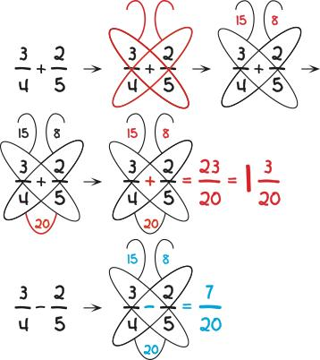  Butterfly Fractions  - To add or subtract fractions the butterfly way,  - Write the fractions side-by-side as usual and draw two wings along the diagonals made by the numerator of one fraction and the denominator of the other fraction and draw an antenna on each wing.  - As suggested by the wings, that look like a multiplication sign, multiply the numbers in each wing and put the product in the antenna for the wing.  - Think or say: “This poor butterfly needs a body.” To give it a body, connect the bottom parts of the wings with a body-like loop and multiply the two denominators it connects, putting the product inside the body.  - Add or subtract the numbers in the antennae in keeping with what is being done to the fractions and put the result over the number in the body.  - If necessary, reduce or simplify the result.  The butterflies above for 3/4 + 2/5 and 3/4 – 2/5 illustrate the procedure. The only difference in subtracting the fractions versus adding them is in the last step where the numbers in the antennae are subtracted instead of added. | Use the butterfly method to solve the following questions on sheet named Mrs Matharu’s group 4.02.21.  If you need help go through the sequence of instructions in the column on the left.  Make sure you mark it. How did you do?  If you have time play-https://www.bbc.co.uk/bitesize/topics/zhdwxnb/articles/zyrj7ty
Topic  RE | LO To explore the Christian idea of agape, unconditional love and eternal life. | Read through the PowerPoint, clicking on the sound clips.  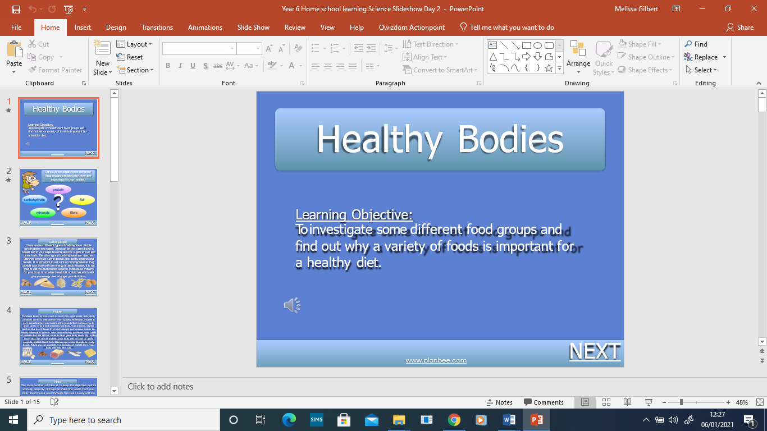 | Can a non-Christian go to heaven? Write why or why not.

If you have any questions about today’s learning activities set then please email the class email these are viewed from 9.00 until 4.00 daily.

