Maths extension questions Thursday
Q1.
Complete the number sentences.
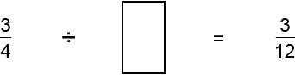
1 mark
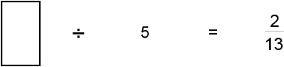
1 mark

2 mark
Q2.

Place these numbers in order of size, starting with the smallest.

0.19 |  | 0.9 |  | 0.091 |  | 0.109
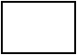
smallest |  |  |  |  |  | largest
1 mark
Place these fractions in order of size, starting with the smallest.

smallest |  |  |  |  |  | largest

Q3.

The diagram shows a shaded triangle inside a larger triangle.

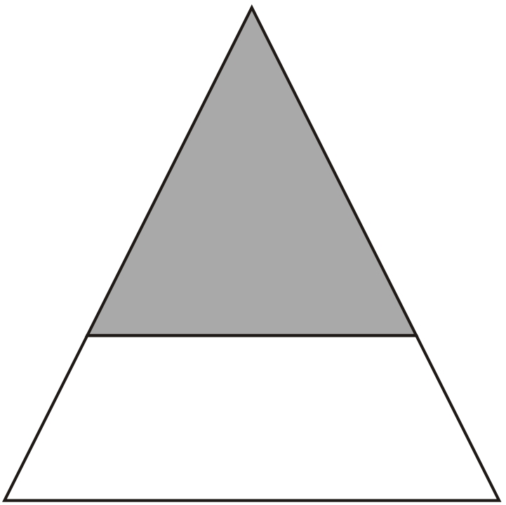
The area of the shaded triangle is 52 cm².
The area of the shaded triangle is of the area of the larger triangle.
Calculate the area of the larger triangle.

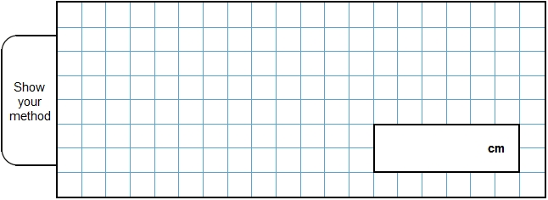
2 mark
1 mark

Mark schemes
Q1.
3
1
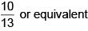
1
[2]

Q2.
(a)
All four numbers in their correct places.
1
(b)
All four numbers in their correct places.
1
[2]

Q3.
Award TWO marks for the correct answer of 117.
If the answer is incorrect, award ONE mark for evidence of an appropriate method,
eg
52 ÷ 4 = 13 AND 9 × 13
OR = 0.444 AND 52 ÷ 0.444
Calculation need not be completed for the award of the mark.
Up to 2
[2]

[

