Topic | Learning objective | Teaching points /teachers voice | Task to complete
English | LO To make notes | Today we are continuing with finding out about newspaper report writing.  Please watch this video from Oak National Academy  https://classroom.thenational.academy/lessons/to-gather-evidence-for-a-newspaper-report-6mvk6d | Pause the video and do the tasks as the teacher (Ms Chu) tells you to.  Be prepared with your writing book and pen or pencil.
Spelling | LO To spell homophones | Spelling Frame  Year 5/6 Rule 51 | Go onto spelling frame daily  You will have a spelling test as part of Friday’s English lesson
Maths  SEE BELOW IF You are in Mrs Matharu’s Maths group | LO To multiply fractions by fractions | DOODLE MATHS DAILY FOR 15 Minutes  Main  We are continuing our fractions work today.  Please watch this video  https://vimeo.com/476253821 | Main  All of Miss Gilbert’s and Mrs Phillips’s Maths class do the worksheet:  Year 6 Home learning Maths Wednesday  And mark your own work using the answers  Extension then do the question from Maths Herald  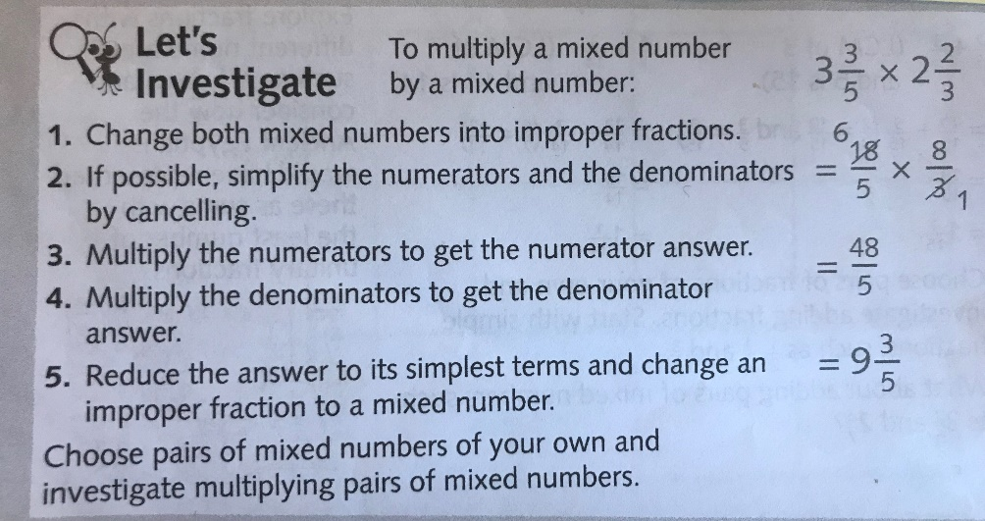
Maths  Mrs Matharu’s Group | LO To be able to add with different denominators. | In today’s lesson you are going to continue adding fractions with different denominators (number on the bottom of a fraction).  Watch https://vimeo.com/505801286  The video uses the bar method which some children like as it is so visual. I would show you the butterfly method in school which is explained below.  To add two fractions-  - First, you multiply the denominators – that becomes your new denominator  - Then, you multiply the numerators and denominators diagonally and add – that becomes your new numerator  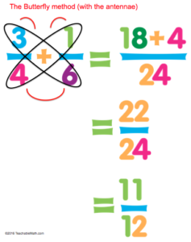 | Complete work sheet labelled Mrs Matharu’s group 3.2.21 Complete all questions on the worksheet.  Watch -https://www.youtube.com/watch?v=T3sI7bm2CLA  to understand the butterfly method. You will be using this tomorrow.
Topic  RE | LO To explore the Christian idea of agape, unconditional love and eternal life. | Read through the Powerpoint, clicking on the sound clips.  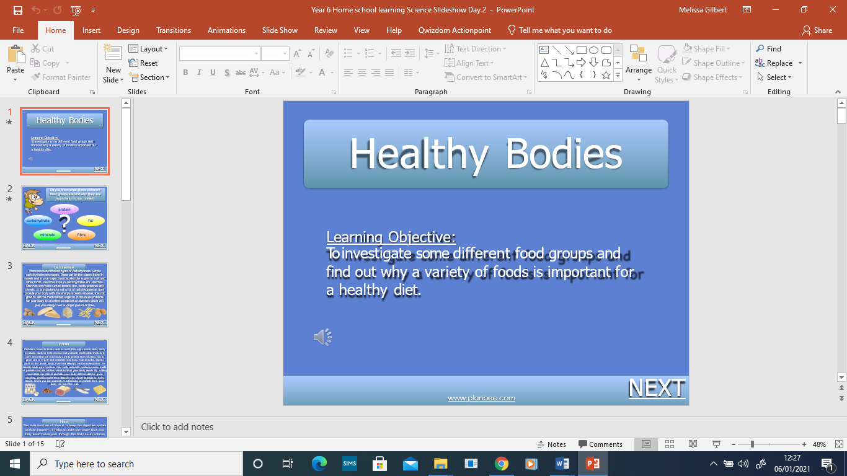  Watch this video: https://www.truetube.co.uk/film/christian-funeral | Draw what you think heaven looks like.

If you have any questions about today’s learning activities set then please email the class email these are viewed from 9.00 until 4.00 daily.

