Topic | Learning objective | Teaching points /teachers voice | Task to complete
Assembly |  | Please watch our virtual assembly in the Video Resource Centre.  It is right at the bottom of the page (and the first one by the Buckeridge family).
English | LO To understand the features of a newspaper reports | Today we are continuing going to find out about the features of a newspaper report.  We are going to use an Oak National Academy lesson to help us.  Please watch  https://classroom.thenational.academy/lessons/to-analyse-the-features-of-a-newspaper-report-chj6cc | Pause the video and do the tasks as the teacher (Ms Chu) tells you to.  Be prepared with your writing book and pen or pencil.
Spelling | LO To spell homophones | Spelling Frame  Year 5/6 Rule 51 | Go onto spelling frame daily  You will have a spelling test as part of Friday’s English lesson
Maths  SEE BELOW IF You are in Mrs Matharu’s Maths group | LO To multiply fractions by integers | DOODLE MATHS DAILY FOR 15 Minutes  Main  We are continuing our fractions work today.  Please watch this video  https://vimeo.com/475426110 | Main  All of Miss Gilbert’s and Mrs Phillips’s Maths class do the worksheet:  Year 6 Home learning Maths Tuesday  And mark your own work using the answers  Extension then do the question in the folder labelled:  Year 6 Homeschool learning Maths extension Tuesday
Maths  Mrs Matharu’s Group | LO To Be able to add within 1 with different denominators | In today’s lesson you are adding fractions with different denominators (number on the bottom of a fraction).  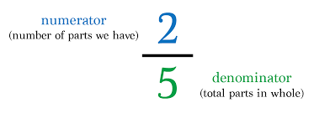  Watch https://vimeo.com/503393745  Make sure you answer the questions in the video and pause when asked to do so. | Complete work sheet labelled Mrs Matharu’s group 2.2.21 Complete all questions on the worksheet.  Consolidate learning-  https://www.bbc.co.uk/bitesize/articles/z42vgwx  Can you do the quiz?
Topic  French | LO To use the pronouns il and elle. | Read through the Powerpoint, clicking on the sound clips.  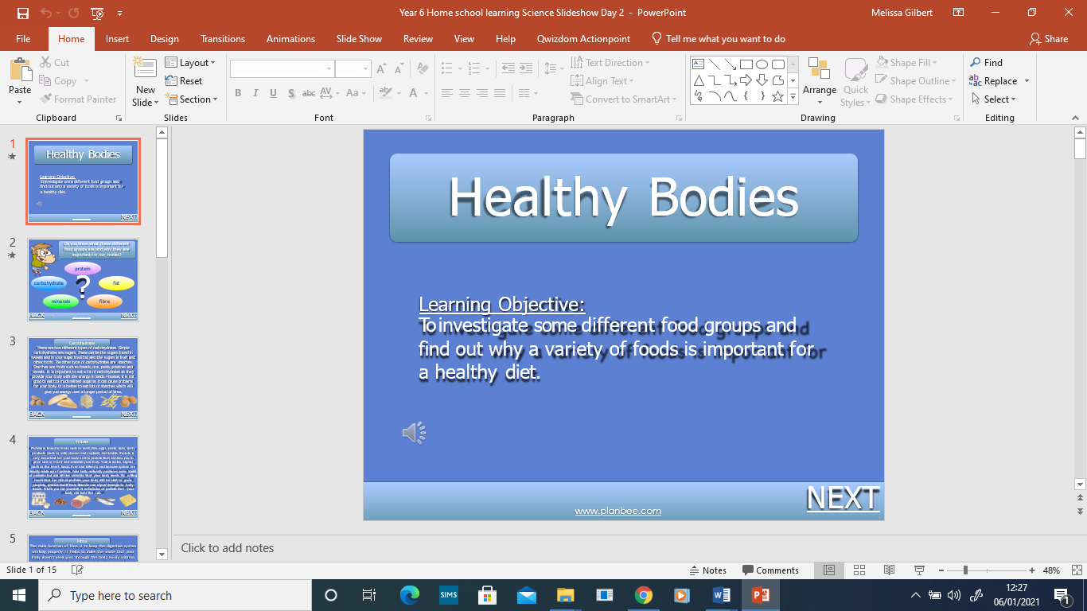 | Re-write the sentence at the top of the sheet, choosing the correct gender. Look at the pictures to see who is where and write the word in French (use the word bank to help you).

If you have any questions about today’s learning activities set then please email the class email these are viewed from 9.00 until 4.00 daily.

