Topic | Learning objective | Teaching points /teachers voice | Task to complete
English | LO To understand a poem | We are going to do more English linked to our mountains topic  You will be going between the instructions on the PowerPoint and the film  Powerpoint: Year 6 Homeschool Learning English Day 1  Click on the button to run the PowerPoint    Please watch this film  https://www.youtube.com/watch?v=4b9Ji7DvsjU  or if you are in school use  https://www.literacyshed.com/the-sports-shed.html  or the link your teacher has. | I want you to work through the tasks on the PowerPoint.  Then use either Challenge 1 and 2 sheet  Or  Challenge 3 sheet  To answer questions about the poem
Spelling | LO To spell homophones | Spelling Frame  Year 5/6 Rule 51  JF Please note: your spellings are built from root words. All of the root words do not end with a double consonant  So drum becomes drumming, drummed.  The rule is when there is a vowel before the final consonate, you have to double the consonant when adding -ed, or -ing. | Go onto spelling frame daily  You will have a spelling test as part of Friday’s English lesson
Maths  SEE BELOW IF You are in Mrs Matharu’s Maths group | LO To add and subtract fractions | DOODLE MATHS DAILY FOR 15 Minutes  Main  We are going to continue to work on fractions this week.  This is building on the fractions work we did in the autumn term .  Please watch this video  https://vimeo.com/475425864  Remember I have shown you the butterfly method for adding and subtracting fractions when the denominators are different. If you need to use the Buterfly method, here is a reminder:  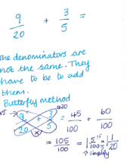 | Main  All of Miss Gilbert’s and Mrs Phillips’s Maths class do the worksheet:  Year 6 Home learning Maths Monday  And mark your own work using the answers  Extension then try this from The Maths Herald  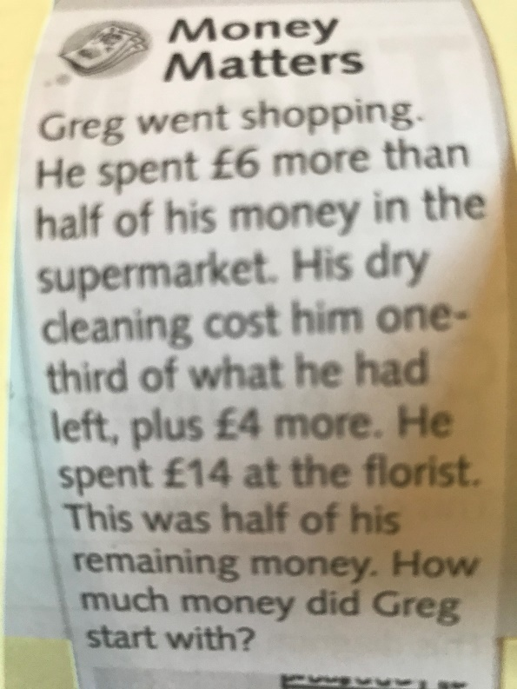
Maths  Mrs Matharu’s Group | LO To Be able to add and subtract fractions with the same denominator. | This week we are going to continue our work on fractions. Today’s lesson is a revision session on adding and subtracting fractions with the same denominator (number on the bottom of a fraction). Remember we did this in the autumn term.  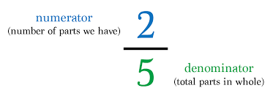  Watch https://vimeo.com/503132995  Make sure you answer the questions in the video and pause when asked to do so. | Complete work sheet labelled Mrs Matharu’s group 1.2.21 Complete all questions on the worksheet.  Consolidate learning-https://www.bbc.co.uk/bitesize/topics/zhdwxnb/articles/z9n4k7h  We will be looking at adding and subtracting fractions with different denominators later on this week. There are some bbc clips on the above website that you might find useful.
Topic  French | LO To understand emotions in French | Read through the Powerpoint, clicking on the sound clips.  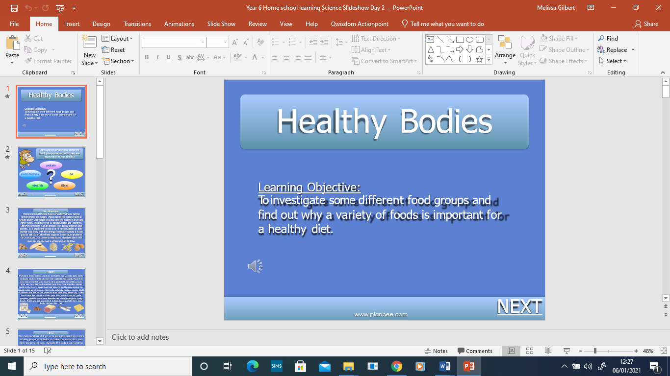 | Match the emotions to the French word.

If you have any questions about today’s learning activities set then please email the class email these are viewed from 9.00 until 4.00 daily.

