Topic | Learning objective | Teaching points /teachers voice | Task to complete
English | LO To edit to improve my work | Please Watch the PowerPoint:  Year 6 Homeschool Learning English Discursive 4  Click on Play the Powerpoint from the slide show button so that you can hear me talking.   | You are going to edit to improve your work  You need to have printed off the Writing Targets discussion sheet from yesterday.  Use these steps to help you  1. Read over your own work.  2. Make sure it makes sense. (Check verbs agree - we were, we are, I was, they were).  3. Read for punctuation.  4. Read for spellings.  5. Improve with adjectives/adverbs/ complex sentences.  6. Use the checklist.  7. Improve what you have not already done.
Spelling | LO To spell homophones | Spelling Frame  Year 5/6 Rule 50 | Go onto spelling frame daily  You will have a spelling test as part of Friday’s English lesson
Maths  SEE BELOW IF You are in Mrs Matharu’s Maths group | LO To subtract fractions | DOODLE MATHS DAILY FOR 15 Minutes  Main  We are going to work on fractions this week.  Please watch this video  https://vimeo.com/475425649  Remember I have shown you the butterfly method for adding and subtracting fractions when the denominators are different. If you need to use the Butterfly method, here is a reminder:  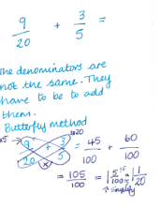 | Main  All of Miss Gilbert’s and Mrs Phillips’s Maths class do the worksheet:  Year 6 Homelearning Maths Work Thursday  And mark your own work using the answers  Extension then do the:  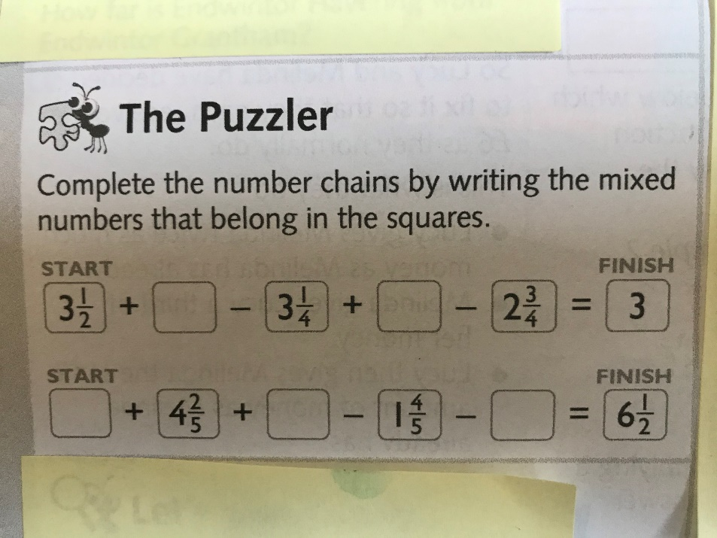
Maths  Mrs Matharu’s Group | LO To Be able to compare and order fractions less than 1 | Today we are going compare and order fractions less than 1.  Watch https://vimeo.com/500362215  The fraction wall will help you  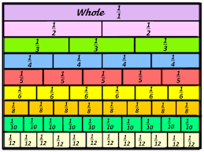  Make sure you answer the questions in the video and pause when asked to do so. | Complete work sheet labelled Mrs Matharu’s group 28.1.21 Complete all questions on the worksheet.  If you get stuck cut strips of paper the same length and shade in the fractions to answer the questions.  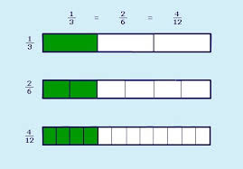  Consolidate learning  Watch-  https://www.bbc.co.uk/bitesize/articles/zkfyhcw  The videos part a and b will help with your understanding. As an extension do the activity sheets on this website.
Topic  Art | To recreate Hokusai’s Mount Fuji using painting. | Read through the Powerpoint, clicking on the sound clips if you need a reminder.  Look at the last slide.  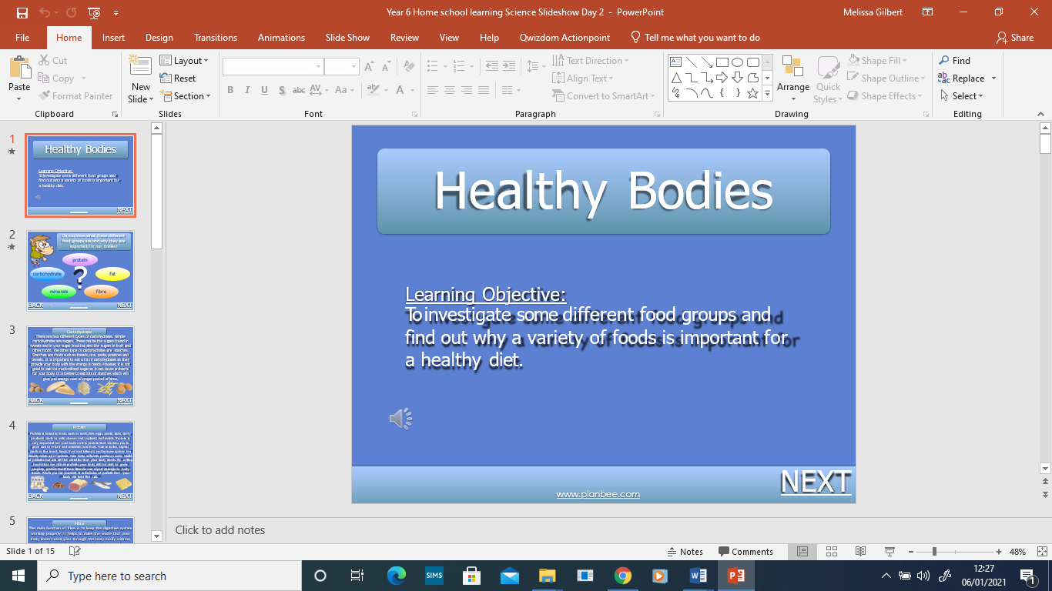 | Paint Hokusai’s ‘Mount Fuji’, following the success criteria.
If you have any questions about today’s learning activities set then please email the class email these are viewed from 9.00 until 4.00 daily.

