Topic | Learning objective | Teaching points /teachers voice | Task to complete
Assembly |  | Please watch our assembly in the Video Resource Centre | You are going to use your plan that you did yesterday to write your letter to Miss Green about allowing us to go on a trip to Mount Everest.
English | LO To write a discursive text | We are continuing with our discursive writing today.  Watch the PowerPoint  Year 6 Homeschool Learning English Discursive 3  Click on Play the Powerpoint from the slide show button so that you can hear me talking.   | You are going to use your plan that you did yesterday to write your persuasive letter to Miss Green about allowing us to go on a trip to Mount Everest.  Success Criteria  Use plan from yesterday  Make arguments powerful  Use reasons  Balanced conclusion  Use the Discursive writing checklist to guide your writing (it is in the work folder for today)  Use a question as the title  Audience : Miss Gilbert and Mrs Phillips  Purposed: To persuade us to organise a trip to Mount Everest for Year 6
Spelling | LO To spell homophones | Spelling Frame  Year 5/6 Rule 50 | Go onto spelling frame daily  You will have a spelling test as part of Friday’s English lesson
Maths  SEE BELOW IF You are in Mrs Matharu’s Maths group | LO To add fractions | DOODLE MATHS DAILY FOR 15 Minutes  Main  We are going to work on fractions this week.  Please watch this video  https://vimeo.com/471389642  Remember I have shown you the butterfly method for adding and subtracting fractions when the denominators are different. If you need to use the Butterfly method, here is a reminder:  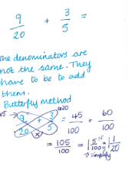 | Main  All of Miss Gilbert’s and Mrs Phillips’s Maths class do the worksheet:  Year 6 Homelearning Maths Work Wednesday  And mark your own work using the answers  Extension then do the following problem: (Hint drawing a picture might help you to solve this)  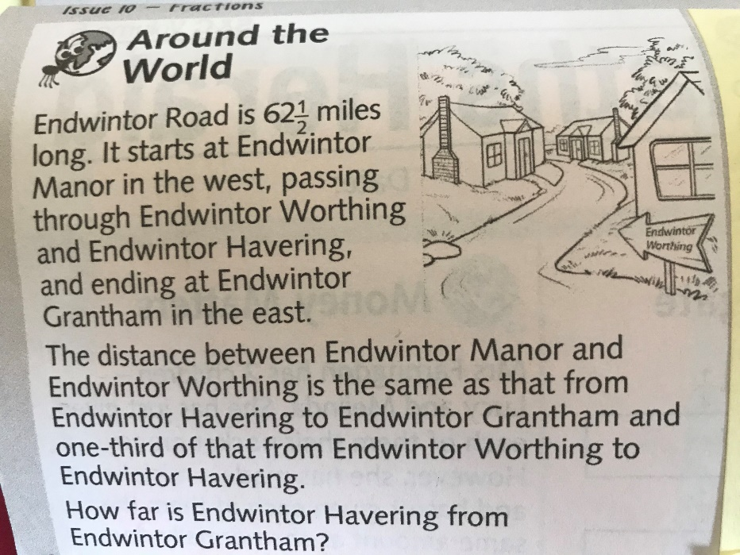
Maths  Mrs Matharu’s Group | LO To Understand equivalent fractions | Today we are going to continue our work on equivalent fractions.  The fraction wall will help you  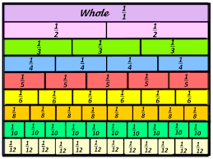  We used this when we did work on equivalent fractions.  Watch https://vimeo.com/498327611  Make sure you answer the questions in the video and pause when asked to do so. | Complete work sheet labelled Mrs Matharu’s group 27.1.21 Complete questions 1-6 the worksheet.  Remember whatever you do to the top number (numerator) you must do the same to the bottom number (denominator) of the fraction.  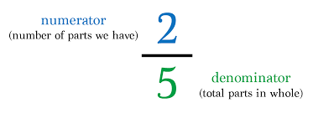  Have a look at some of the fraction games on-  https://www.topmarks.co.uk/Search.aspx?q=equivalent%20fractions
Topic  Art | To recreate Hokusai’s Mount Fuji using sketching. | Read through the Powerpoint, clicking on the sound clips.  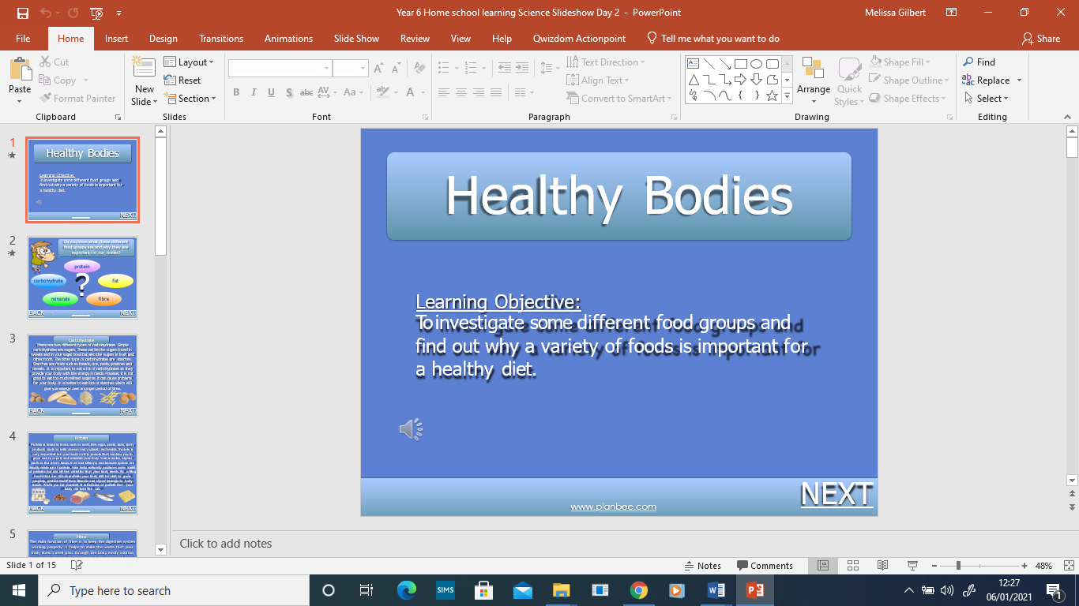 | Sketch Hokusai’s ‘Mount Fuji’, following the success criteria.

If you have any questions about today’s learning activities set then please email the class email these are viewed from 9.00 until 4.00 daily.

