Topic | Learning objective | Teaching points /teachers voice | Task to complete
Assembly |  | Please watch our assembly in the Video Resource Centre
English | LO To plan a discursive text | Today we are continuing with our discursive writing.  Please watch the PowerPoint Year 6 Homeschool Learning English Discursive 2.  Click on Play the PowerPoint from the slide show button so that you can hear me talking.   | Use the planning frame  You are choosing whether you are writing a good, great or exceptional discursive piece.  Chose the correct planning sheet for you.
Spelling | LO To spell homophones | Spelling Frame  Year 5/6 Rule 50 | Go onto spelling frame daily  You will have a spelling test as part of Friday’s English lesson
Maths  SEE BELOW IF You are in Mrs Matharu’s Maths group | LO To add and subtract fractions (2) | DOODLE MATHS DAILY FOR 15 Minutes  Main  We are going to work on fractions this week. This is building on the fractions work we did in the autumn term .  Please watch this video  https://vimeo.com/471344877  Remember I have shown you the butterfly method for adding and subtracting fractions when the denominators are different. If you need to use the Butterfly method, here is a reminder:  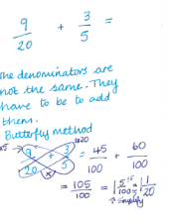 | Main  All of Miss Gilbert’s and Mrs Phillips’s Maths class do the worksheet:  Year 6 Home learning Maths Monday  And mark your own work using the answers  Extension then do the question in the folder labelled:  Year 6 Homeschool learning Maths extension Tuesday
Maths  Mrs Matharu’s Group | To Understand equivalent fractions | Do you remember the fraction wall we used last time we were doing fractions?  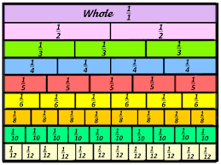  We used this when we did work on equivalent fractions.  Watch https://vimeo.com/498327458  Make sure you answer the questions in the video and pause when asked to do so. | Complete work sheet labelled Mrs Matharu’s group 26.1.21 Complete all the worksheet.  Have a look at some of the fraction games on-  https://www.topmarks.co.uk/Search.aspx?q=equivalent%20fractions
Topic  RE | LO To comprehend the Christian belief in unconditional and eternal love. | Watch this video: https://www.truetube.co.uk/film/christian-marriage  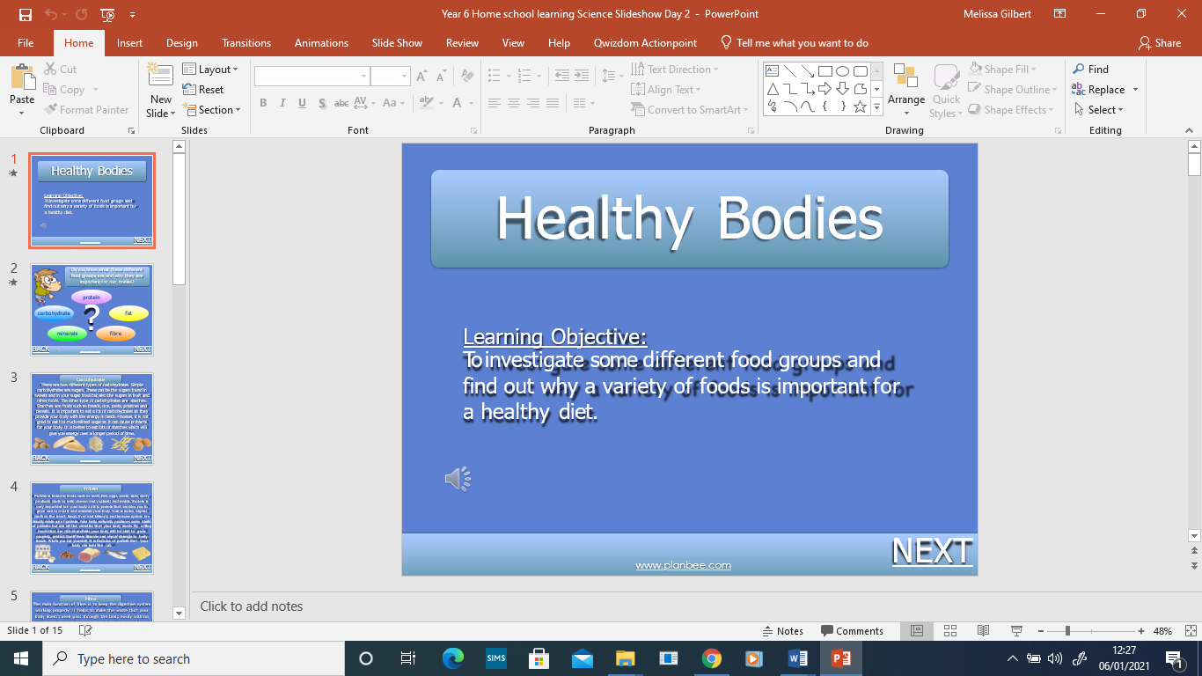  Read through the Powerpoint, clicking on the sound clips. | Write your own wedding vows, they do not have to be romantic. You could write them to a family member or a pet.
If you have any questions about today’s learning activities set then please email the class email these are viewed from 9.00 until 4.00 daily.

