Challenge 1.
LO: To find out about the offspring of a variety of different animals.
SC:
- I know that all animals, including humans, have offspring that grow into adults?
- I can match a variety of adult animals to their offspring?
• I know that growth from offspring to adult is a gradual process?

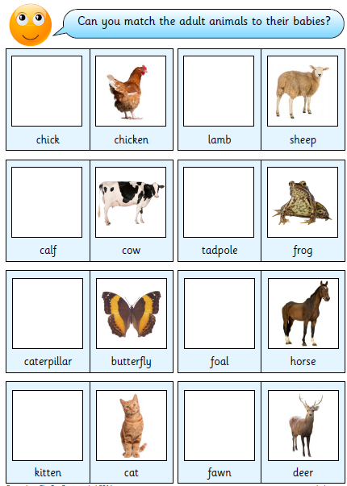

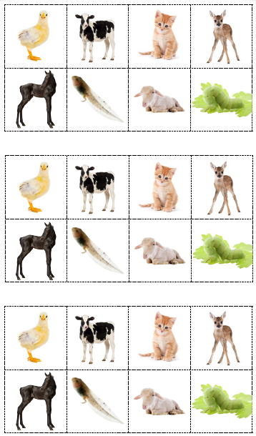

Challenge 2.
LO: To find out about the offspring of a variety of different animals.
SC:
- I know that all animals, including humans, have offspring that grow into adults?
- I can match a variety of adult animals to their offspring?
• I know that growth from offspring to adult is a gradual process?

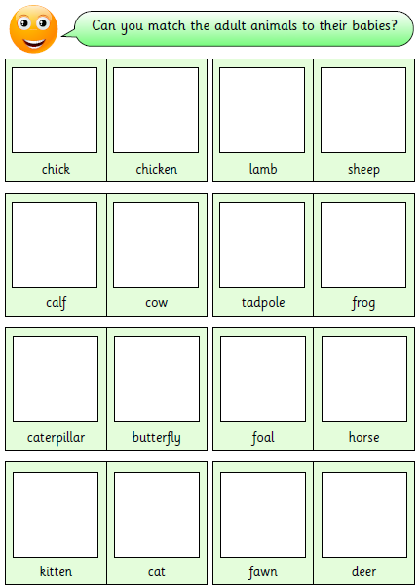

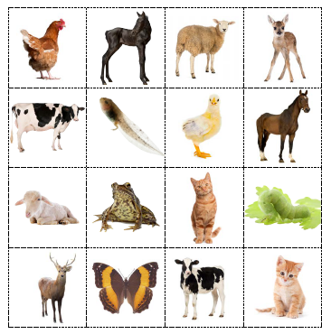

Challenge 3.
LO: To find out about the offspring of a variety of different animals.
SC:
- I know that all animals, including humans, have offspring that grow into adults?
- I can match a variety of adult animals to their offspring?
• I know that growth from offspring to adult is a gradual process?


