Topic | Learning objective | Teaching points /teachers voice | Task to complete
English | LO To learn the features of discursive writing text | We are continuing with linking to our Topic of Mountains in our English work.  This week we are going to look at discursive writing.  Watch the PowerPoint  Year 6 Homeschool Learning English 1 Discursive  Click on Play the Powerpoint from the slide show button so that you can hear me talking.   | I want you to look through the text on either the word document  (Should Goldilocks be gaoled?) or on pages 5 and 6 of the PowerPoint.  Identify how the title is written  What is the purpose of the first paragraph?  What is the purpose of the second paragraph?  What is the purpose of the final paragraph?  Are there any special words used to build the arguments?  Magpie words
Spelling | LO To spell homophones | Spelling Frame  Year 5/6 Rule 50 | Go onto spelling frame daily  You will have a spelling test as part of Friday’s English lesson
Maths  SEE BELOW IF You are in Mrs Matharu’s Maths group | LO To add and subtract fractions | DOODLE MATHS DAILY FOR 15 Minutes  Main  We are going to work on fractions this week. This is building on the fractions work we did in the autumn term .  Please watch this video  https://vimeo.com/470094960  Remember I have shown you the butterfly method for adding and subtracting fractions when the denominators are different. If you need to use the Buterfly method, here is a reminder:  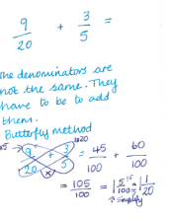 | Main  All of Miss Gilbert’s and Mrs Phillips’s Maths class do the worksheet:  Year 6 Home learning Maths Monday  And mark your own work using the answers  Extension then do the: Extentension sheet in today’s folder:  Year 6 Homeschool learning Maths Monday extension sheet
Maths  Mrs Matharu’s Group | LO To Know what a fraction is | This week we are going to be learning about fractions. Today’s lesson is a revision on what is a fraction.  Watch https://vimeo.com/498327271  Make sure you answer the questions in the video and pause when asked to do so. | Complete work sheet labelled Mrs Matharu’s group 25.1.21 Questions 1-6  Watch https://www.bbc.co.uk/bitesize/clips/zvvgkqt  This will help with tomorrow’s lesson.
Topic  RE | To understand different beliefs on eternity | Read through the Powerpoint, clicking on the sound clips.  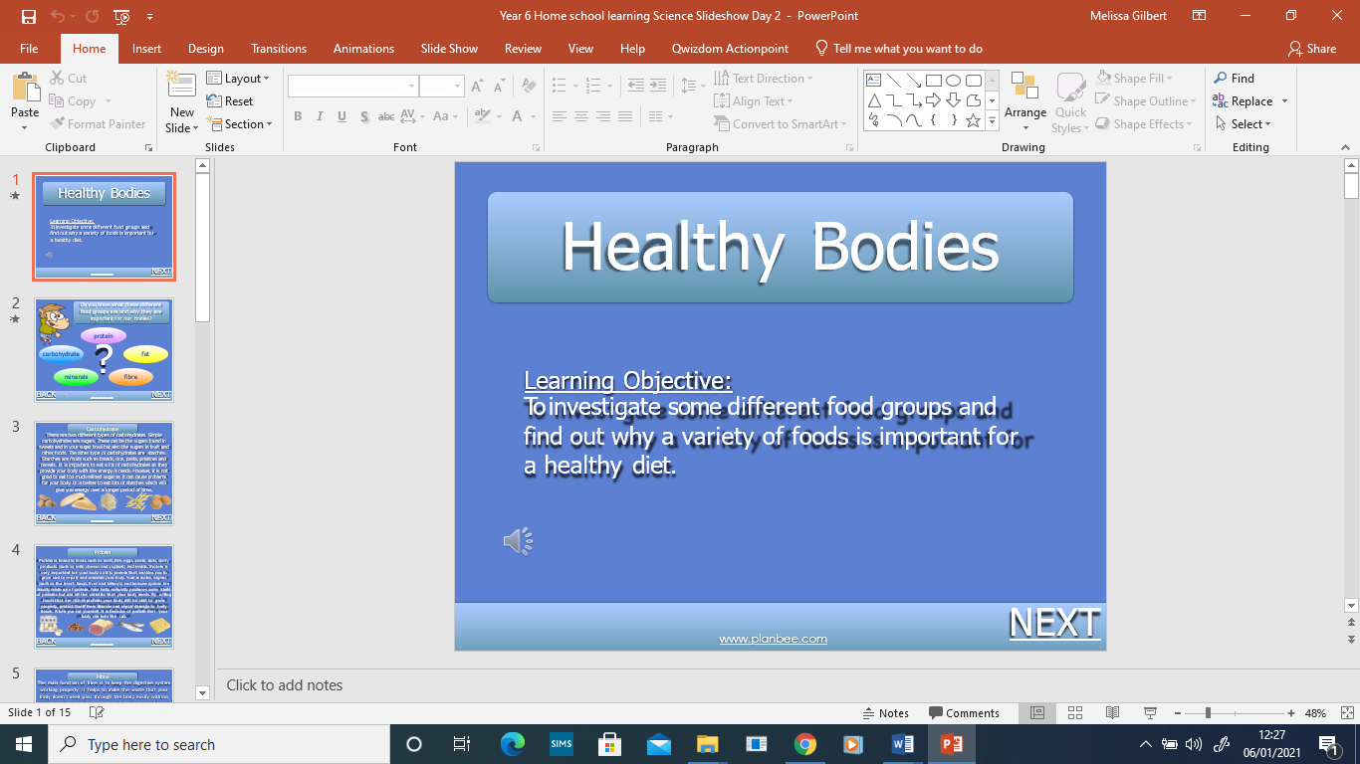 | Draw something that you think is eternal and write why you think that.

If you have any questions about today’s learning activities set then please email the class email these are viewed from 9.00 until 4.00 daily.

