Homeschool learning Algebra check January 2021
Q1.
A theme park sells tickets online.
Each ticket costs £24
There is a £3 charge for buying tickets.
Which of these shows how to calculate the total cost, in pounds?

 | Tick one.
number of tickets × 3 + 24 | 
number of tickets × 24 + 3
number of tickets + 3 × 24
number of tickets + 24 × 3
1 mark
Q2.
Dev says,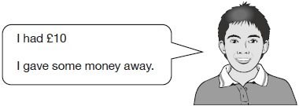
Which expression shows how much money Dev has left?
a is the amount of money, in pounds, that Dev gave away.
Tick one.
10 + a
10 ÷ a
a – 10
10 – a
a × 10
1 mark
Q3.

Here is a rule for the time it takes to cook a chicken.

Cooking time = 20 minutes plus an extra
40 minutes for each kilogram
How many minutes will it take to cook a 3 kg chicken?
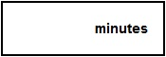
1 mark
What is the mass of a chicken that takes 100 minutes to cook?
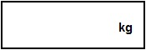
1 mark
Q4.

Each shape stands for a number.
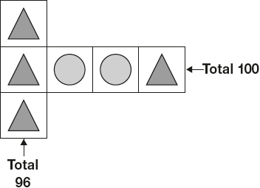
Work out the value of each shape.

1 mark

1 mark
Q5.

A shop sells fruit.
Chen buys 2 apples and 3 bananas.  He pays £2.35 | 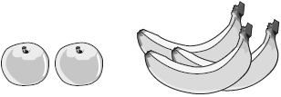

Megan buys 2 apples and 1 banana.  She pays £1.25 | 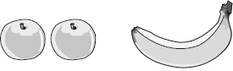

How much does one banana cost?

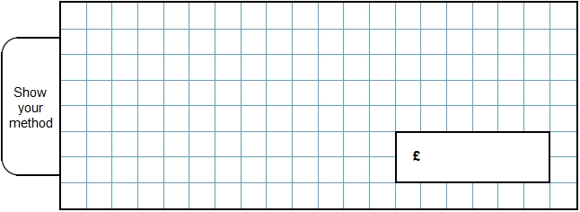
2 marks
Q6.

Maria bakes cakes and sells them in bags.
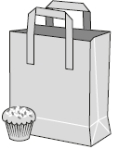
She uses this formula to work out how much to charge
for one bag of cakes.

Cost = number of cakes × 20p + 15p for the bag
How much will a bag of 12 cakes cost?
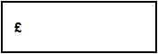
1 mark
Olivia buys a bag of cakes for £5.15
Use the formula to calculate how many cakes are in the bag.

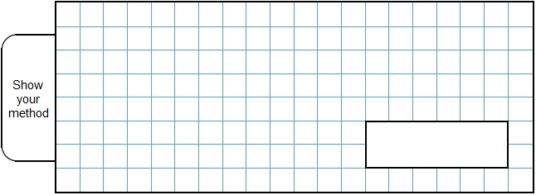
2 marks

Mark schemes
Q1.
Second box only ticked correctly, as shown:

number of tickets × 3 + 24
number of tickets × 24 + 3 | 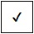
number of tickets + 3 × 24
number of tickets + 24 × 3
Accept alternative unambiguous positive indication of the correct answer, e.g. Y.
[1]
Q2.
Award ONE mark for the correct box ticked, as shown:
Tick one.
10 + a
10 ÷ a
a – 10
10 − a
a × 10
Accept alternative unambiguous positive indication of the correct answer, e.g. Y.
[1]
Q3.

(a) 140
The answer is a time interval
1
(b) 2
1
[2]
Q4.

(a) = 32
1
(b) = 18
If the answers to and are incorrect, award ONE mark if
+ = 50 unless = 25
1
[2]
Q5.
Award TWO marks for the correct answer of 55p OR £0.55
If the answer is incorrect, award ONE mark for evidence of appropriate working, eg
■ £2.35 – £1.25 = £1.10
£1.10 ÷ 2 = wrong answer
Accept for ONE mark £55 OR £55p OR 0.55p as evidence of appropriate working.
Working must be carried through to reach an answer for the award of ONE mark.
Up to 2
U1
[2]
Q6.
(a) £2.55
1
(b) Award TWO marks for the correct answer of 25
If the answer is incorrect, award ONE mark for evidence of an appropriate method, e.g:
• £5.15 − 15p = £5
£5 ÷ 20p
OR
• £5.15 − 15p = £5
5 × 5
Answer need not be obtained for the award of ONE mark.
Commentary: The 2014 national curriculum specifies that pupils should use simple formulae (6A2).
Up to 2
[3]

