Thursday extension work
Q1.
x + 2y = 20
x and y are whole numbers less than 10
What could x and y be?

x = | 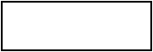
y =
1 mark
Q2.
Amina is making designs with two different shapes.
She gives each shape a value.
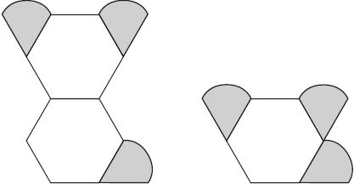
Total value is 147 Total value is 111
Calculate the value of each shape.
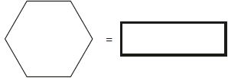
1 mark
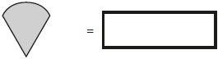
1 mark
Q3.
A shop prints designs on T-shirts.
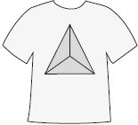
They use this formula to work out the price for printing a design.

price = 60p × number of colours + £1.25
What is the price for printing a design that has 3 colours in it?
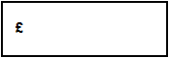
1 mark
Amina has £5 to spend on printing a design.
What is the greatest number of colours she can have in the design?
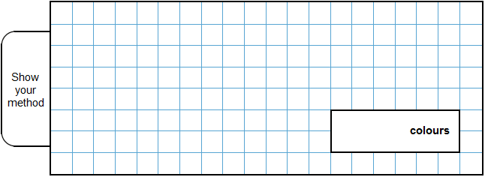
2 marks

Q4.

Solve this equation to find the value of y.
8(y + 12) = 100

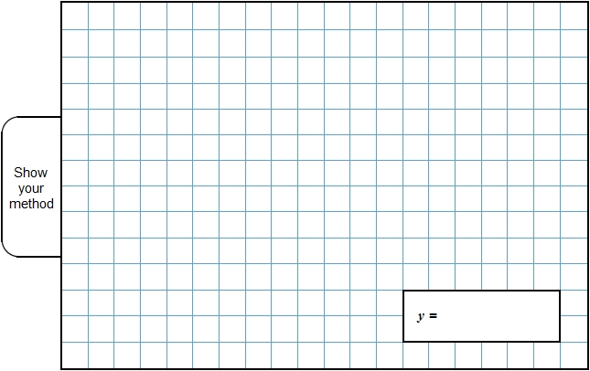
2 marks
Q5.

Here is a sequence of shapes.
Each time a square is added to a shape,
two more circles are added.

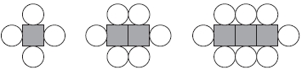
number of squares, s 1 2 3
number of circles, c 4 6 8

The sequence of shapes continues.
The formula for the sequence is c = 2s + 2

Calculate the number of circles when the
number of squares in a shape is 150.
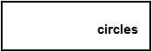
1 mark
How many squares are there in a shape that has 100 circles?

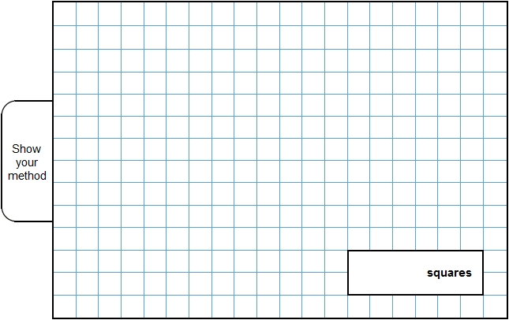
2 marks

Mark schemes
Q1.
Award ONE mark for any pair of whole numbers less than 10 that satisfy the equation, i.e.
x = 8 AND y = 6
OR
x = 6 AND y = 7
OR
x = 4 AND y = 8
OR
x = 2 AND y = 9
[1]
Q2.
(a) 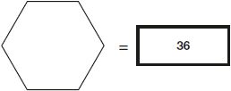
1
(b) 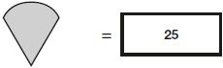
Award ONE mark for an answer of
• (147 – 2 × answer for box 1) ÷ 3
OR
• (111 – answer for box 1) ÷ 3
Any follow-through fraction or decimal answer must be expressed as an exact value.
1
[2]
Q3.
(a) £3.05
Refer to the additional guidance on marking answers involving money.
1
(b) Award TWO marks for the correct answer of 6
If the answer is incorrect, award ONE mark for evidence of an appropriate method, e.g.
• £5 − £1.25 = £3.75
£3.75 ÷ 60p = 6.25
7 colours (rounded incorrectly)
OR
• £5 − £1.25 = £4.75 (error)
475 ÷ 60 =
OR
• 6 × 60 = 360
£3.60 + £1.25 = £4.85
7 colours (rounded incorrectly)
Answer need not be obtained for the award of ONE mark.
Up to 2m
[3]
Q4.
or equivalent
! Algebra
Accept equivalent fractions or decimals
2
or
Shows or implies a correct first step of algebraic manipulation that
either reduces the number of terms or collects variables on one
side of the equation and numbers on the other or correctly
removes the brackets, eg:
• 8y + 96 = 100
• y + 12 = 100 ÷ 8
• 8y = 4
OR
Shows or implies a complete correct method, eg:
• 100 ÷ 8 = 12 (error)
12 – 12 = 0
• 25 × 4 = 100
12.5 × 8 = 100
12.5 – 12
1
Do not accept a first step of algebraic manipulation
which has a conceptual error, eg:
• y + 12 = 100
• y + 96 = 100
• 8y + 12 = 100
! Correct embedded solutions
Award 1m for a response which shows , or
equivalent, as the embedded solution to their working
[2]
Q5.
(a) 302
1
(b) 49
2
or
Shows or implies a correct first step of algebraic manipulation that
either reduces the number of terms or collects variables on one
side of the equation and numbers on the other, eg:
• 2s = 100 − 2
• s = 98 ÷ 2
! Correct embedded solutions
Award 1 for a response which shows
49 as the embedded solution to their working
OR
Shows or implies a complete correct method, eg:
• (100 – 2) ÷ 2
1
[3]

