Topic | Learning objective | Teaching points /teachers voice | Task to complete
English | LO To plan a persuasive letter | We are continuing with our persuasive writing unit.  Watch PowerPoint Year 6 Homeschool Learning English Day 3  Click on Play the PowerPoint from the slide show button so that you can hear me talking.   | You are going to plan your persuasive letter to Miss Green about allowing us to go on a trip to Mount Everest.  Just like in class use the planning frame that is right for your writing  Good Planning sheet  Great Planning sheet  Or  Exceptional Planning sheet  PLEASE DO NOT WRITE THE LETTER OUT
Spelling | LO To spell homophones | Spelling Frame  Year 5/6  Rule 49  . | Go onto spelling frame daily  You will have a spelling test as part of Friday’s English lesson
Maths  SEE BELOW IF You are in Mrs Matharu’s Maths group | LO To find pairs of values that could satisfy an equation | DOODLE MATHS DAILY FOR 15 Minutes  Main  We are building up our algebra knowledge today.  Watch the White Rose Maths video  Type or copy this link into your web browser  https://vimeo.com/428002579 | Main  All of Miss Gilbert’s and Mrs Phillips’s Maths class do the worksheet:  Year 6 Homelearning Maths Wednesday  And mark your own work using the answers  Extension: Try this 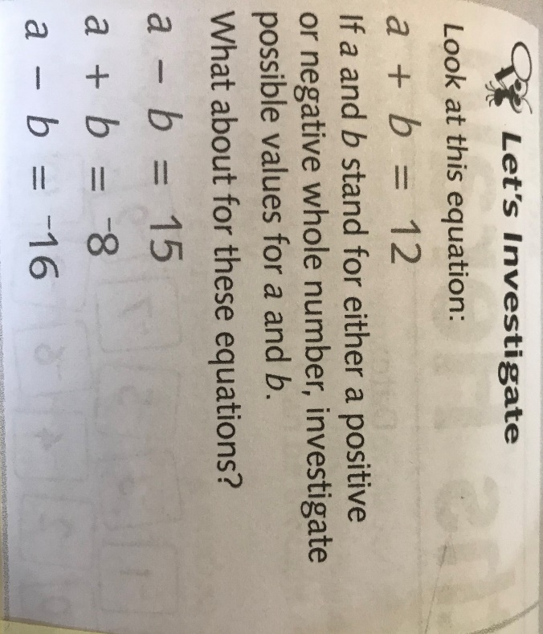
Maths  Mrs Matharu’s Group | LO To solve simple division 1 step word problems with remainders. | Today we are continuing with division. This time you are going to solve simple division word problems with remainders.  How to solve word problems  - Read the word problem aloud.  Forty-six pieces of apple are shared equally among 9 children. How many pieces of apple do each receive?  - Highlight the mathematical function (+, -, x or ÷) you will need to use to solve the problem. This might be a word.  Forty-six pieces of apple are shared equally among 9 children. How many pieces of apple do each receive?  - Underline the numbers in the problem  Forty-six pieces of apple are shared equally among 9 children. How many pieces of apple do each receive?  - Write the calculation you need to do to solve the problem.  46÷9=  - Solve it  Show your workings out. | Watch https://www.bbc.co.uk/bitesize/clips/zdpfgk7  It will make you laugh!  Now do the sheet labelled Mrs Matharu’s Maths 20.01,21  Don’t forget to do your Doodle maths.
Topic  Science | LO To investigate the effects of tobacco, alcohol and other drugs. | Read through the Powerpoint, clicking on the sound clips.  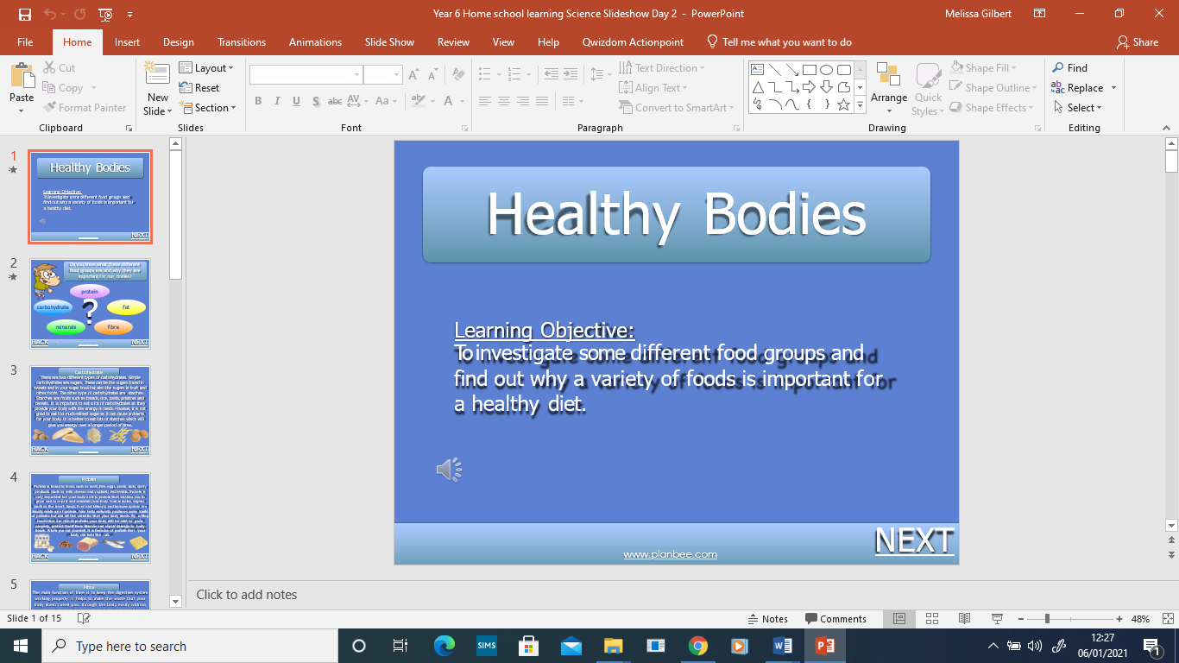 | Create a poster warning people of the effects of drugs.

If you have any questions about today’s learning activities set then please email the class email these are viewed from 9.00 until 4.00 daily.

