Topic | Learning objective | Teaching points /teachers voice | Task to complete
Assembly |  | Please watch our assembly in the Video Resource Centre
English | LO To learn the features of persuasive writing text | We are continuing with linking to our Topic of Mountains in our English work.  This week we are going to use Oak National Academy to help us with persuasive writing  Use Oak Learning Academy:  https://classroom.thenational.academy/lessons/to-understand-the-features-of-a-persuasive-letter-74tk4d  Click play and let Mr Brown teach you!  Just follow his instructions and then do Task 2. | Task 1  Make a list of the features of a formal lesson.  Task 2  If you are at home: think of something you could persuade someone to do and try to use the persuasive skill of flattery to get them to do that.  Write down your brilliant persuasive idea.  If you are in Keyworker school: think of something you could persuade someone to do and use the persuasive skill of flattery to get them to do that.  Write down your brilliant persuasive idea.
Spelling | LO To spell homophones | Spelling Frame  Year 5/6 Rule 49 | Go onto spelling frame daily  You will have a spelling test as part of Friday’s English lesson
Maths  SEE BELOW IF You are in Mrs Matharu’s Maths group | LO To understand formulae in algebra | DOODLE MATHS DAILY FOR 15 Minutes  Main  We are going to continue our work on algebra this week.  Please watch this video  https://vimeo.com/500489558 | Main  All of Miss Gilbert’s and Mrs Phillips’s Maths class do the worksheet:  Year 6 Homelearning Maths Sheet Day 1  And mark your own work using the answers  Extension then do the: Stretch and Challenge Let’s Investigate in the learning folder
Maths  Mrs Matharu’s Group | LO TO learn to use the bus stop method when dividing larger numbers.  Be able to divide 3-digit numbers with a 1-digit number and no remainders. | Today we are going to learn how to use our knowledge of times tables to solve division questions. We are going to use the bus stop method.  Watch this: https://www.youtube.com/watch?v=Zw80VcCMdpM  Example  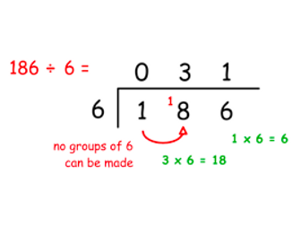  It really helps to write the donkey work next to the calculation. E.g.  6  12  18  24  30  36  42 | Complete the challenges below. You must set out each question using the bus stop method as shown in the example. DO NOT JUST WRITE THE ANSWERS.  Challenge 1  468÷2 = d. 655÷5=  429÷3= e. 560÷4=  592÷4= f. 684÷2=  Challenge 2  Write your 6 times table before solving the questions below as it will help you.  - 684÷6= d. 708÷6=  - 678÷6= e. 558÷6=  - 642÷6=  Consolidate division  Play- http://www.math-play.com/Division-Millionaire/division-millionaire-game_html5.html  Or https://www.topmarks.co.uk/maths-games/hit-the-button choose division facts and mixed tables to challenge yourself.
Topic  Science | To investigate what happens to the heart when we exercise and why. | Read through the Powerpoint, clicking on the sound clips.  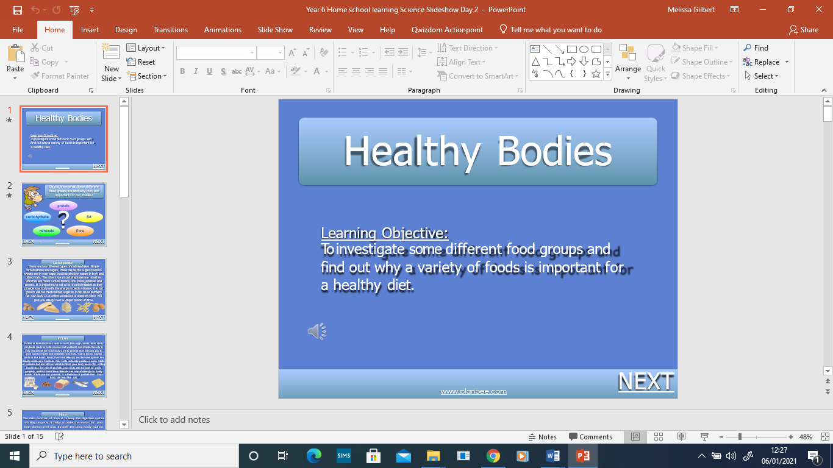 | Choose your challenge:  Challenge 1  Challenge 2  Challenge 3  If you would like an extra challenge please complete the extension.

If you have any questions about today’s learning activities set then please email the class email these are viewed from 9.00 until 4.00 daily.

