Topic | Learning objective | Teaching points /teachers voice | Task to complete
Assembly |  | Please watch our assembly in the Video Resource Centre (or use this link.  https://datchet-st-marys-cofe-primary-school.primarysite.media/media/collective-worship-assembly
English | LO To generate points to use in a persuasive letter | We are continuing with our persuasive writing unit.  Use Oak Learning Academy:  https://classroom.thenational.academy/lessons/to-generate-points-to-use-in-our-persuasive-letter-6muk2d?activity=video&step=1 | Task 1  Within the video lesson: make points as to why school uniform is a good thing.  Task 2  Within the video lesson: generate points and evidence for each of the chosen points
Spelling | LO To spell homophones | Spelling Frame  Year 5/6  Rule 49 | Go onto spelling frame daily  You will have a spelling test as part of Friday’s English lesson
Maths  SEE BELOW IF You are in Mrs Matharu’s Maths group | LO To solve simple one step equations | DOODLE MATHS DAILY FOR 15 Minutes  Main  We are going to use White Rose Maths videos and worksheets to help us understand more algebra this week.  Type or copy this link into your web browser  https://vimeo.com/428002477 | Main  All of Miss Gilbert’s and Mrs Phillips’s Maths class do the worksheet:  Year 6 Homelearning Maths Sheet Day 2  And mark your own work using the answers  Extension  Then do the Extension Maths questions in Daily Work folder.
Maths  Mrs Matharu’s Group | LO To use the bus stop method when dividing larger numbers.  Be able to divide 3-digit numbers with a 1-digit number with remainders. | Today we are continuing to divide numbers using the bus stop method.  Watch  https://www.youtube.com/watch?v=Pw4waV_jsPU  This video shows you how to do the bus stop method with remainders and how to set out your work correctly.  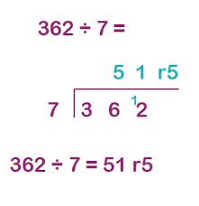 Write x7 table to help  7  14  21  28  35  42  49  56  63  70 | Complete the challenges below. You must set out each question using the bus stop method as shown in the example. DO NOT JUST WRITE THE ANSWERS.  Challenge 1  465÷2 = d. 258÷5=  495÷4= e. 387÷6=  198÷5= f. 870÷9=  Challenge 2  Write your 7 times table before solving the questions below as it will help you.  - 684÷7= d. 708÷7=  - 379÷7= e. 558÷7=  - 642÷7=  Consolidate division  Play- https://www.arcademics.com/games/demolition

Topic  Geography Mountains | To investigate how muscles move the skeleton and how muscle activity requires increased blood flow. | Read through the PowerPoint, clicking on the sound clips.  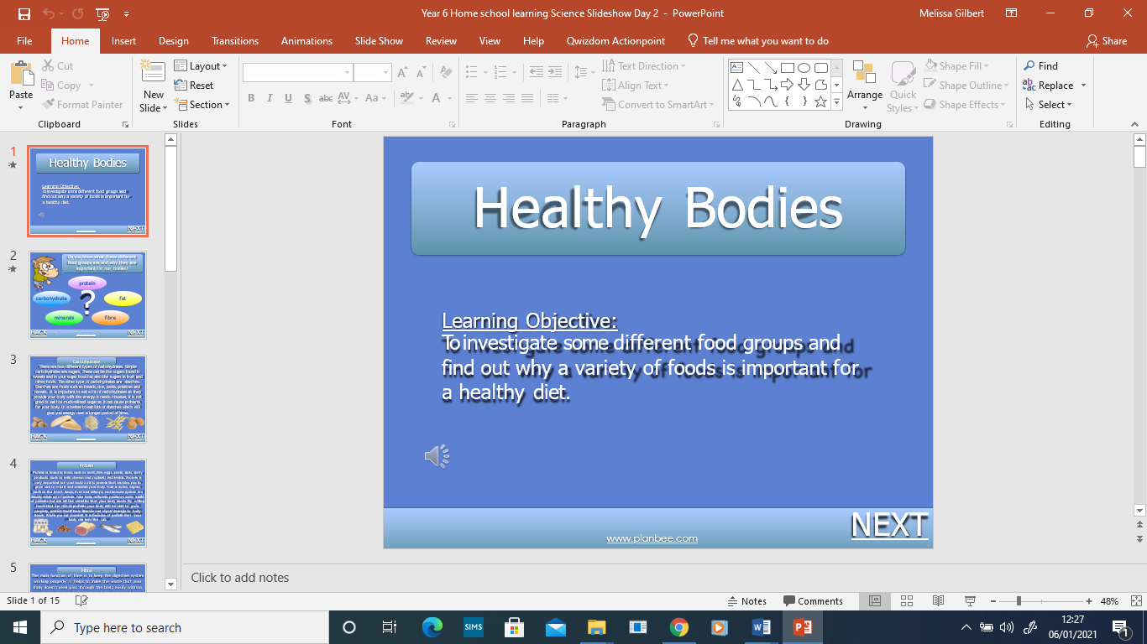  Watch this video: https://www.bbc.co.uk/teach/class-clips-video/science-ks2-how-do-muscles-and-bones-work/zfgtscw  Watch this video to see how backstroke uses our muscles: https://www.youtube.com/watch?v=zpCByHvKmUM&feature=youtu.be | Choose your challenge:  Challenge 1  Challenge 2  Challenge 3

If you have any questions about today’s learning activities set then please email the class email these are viewed from 9.00 until 4.00 daily.

