Q1.

Solve this equation.
7y + 12 = 5y + 40

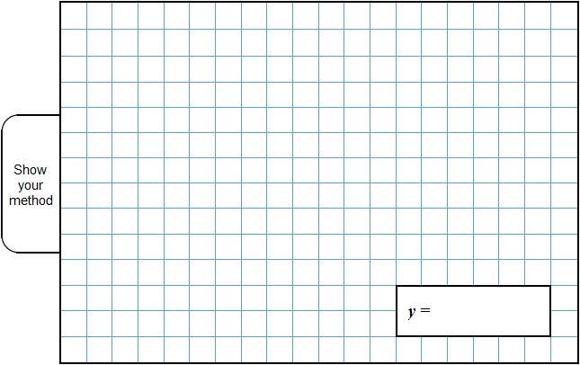
2 marks
Q2.

Solve this equation to find the value of y.
8(y + 12) = 100

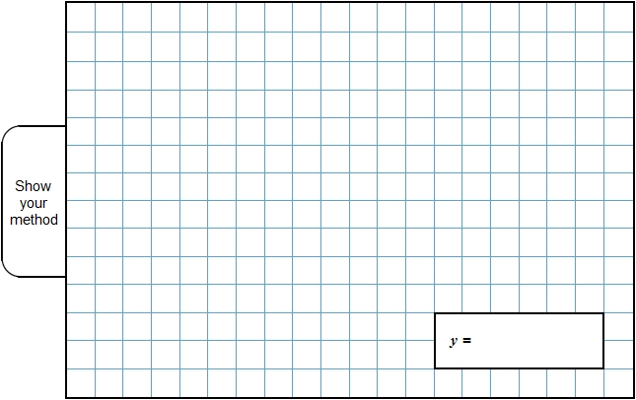
2 marks
Q3.

Find the value of y in the equation.
8 + y = 7 + 5y

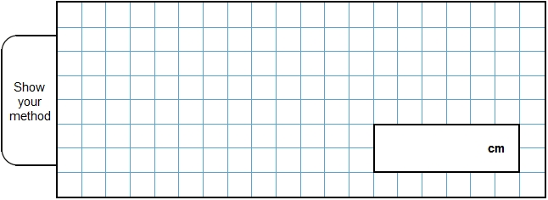
2 mark

Mark schemes
Q1.
14
! Algebra
See guidance
2
or
Shows or implies a correct first step of algebraic manipulation that either reduces the number of terms or collects variables on one side of the equation and numbers on the other, eg:
• 2y + 12 = 40
• 7y = 5y + 28
• 7y − 5y = 40 − 12
• 2y = 28
• 28 ÷ 2
! Condone correct embedded solutions
Award 1 mark, for a response which shows 14 as the embedded solution to their working, eg:
• 7y + 12 = 5y + 40
(7 × 14) + 12 = (5 × 14) + 40
110 = 110
1
[2]
Q2.
or equivalent
! Algebra
Accept equivalent fractions or decimals
2
or
Shows or implies a correct first step of algebraic manipulation that
either reduces the number of terms or collects variables on one
side of the equation and numbers on the other or correctly
removes the brackets, eg:
• 8y + 96 = 100
• y + 12 = 100 ÷ 8
• 8y = 4
OR
Shows or implies a complete correct method, eg:
• 100 ÷ 8 = 12 (error)
12 – 12 = 0
• 25 × 4 = 100
12.5 × 8 = 100
12.5 – 12
1
Do not accept a first step of algebraic manipulation
which has a conceptual error, eg:
• y + 12 = 100
• y + 96 = 100
• 8y + 12 = 100
! Correct embedded solutions
Award 1m for a response which shows , or
equivalent, as the embedded solution to their working
[2]
Q3.
Award TWO marks for the correct answer of 0.25 OR ¼
If the answer is incorrect, award ONE mark for evidence of an appropriate method, eg algebraic manipulation to reach
4y = 1 OR – 4y = –1
OR trial and improvement showing at least two convergent attempts OR trials with two values that differ by less than1 and which straddle the correct value.
Accept equivalent fractions.
Up to 2
[2]

