Topic | Learning objective | Teaching points /teachers voice | Task to complete
English | LO to be able to make notes on a short film. | We are linking to our Topic of Mountains in our English work.  Please watch this short film: The Ridge  Type or copy this link into your web browser  https://vimeo.com/125896742 | Make notes on the film to help you imagine you are the bike rider for writing you will do tomorrow.  What can you see?  What can you hear?  What can you smell?  How do you feel?  What is special about your bike?
Maths | LO Use negative numbers and calculate intervals across zero  Mrs Matharu’s group:  LO I can read, write, order and compare up to 6-digit numbers | Main  We are going to use White Rose Maths videos and worksheets to help us understand negative numbers.  Type or copy this link into your web browser  https://vimeo.com/454667428  Mrs Matharu’s group  Type or copy this link into your web browser  Watch : https://vimeo.com/452564518 | Main  All Miss Gilbert’s and Mrs Phillips’s Maths class do this:  Work through the video and answer the questions as they come up.  Extension then do this: Stretch and Challenge Let’s Investigate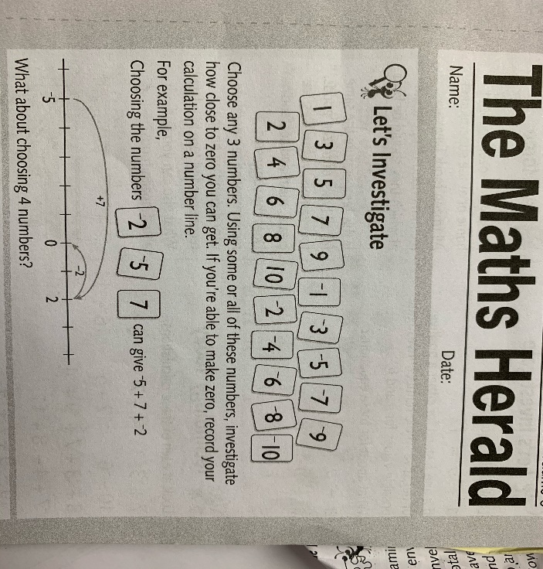  Mrs Matharu’s group  Use Home School Learning Maths Day 1  Complete challenges 1 and 2 on p4  Attached sheet: Mrs Matharu’s group 6 January  Game to check learning: Who wants to be a Hundredaire?  http://www.math-play.com/Place-Value-Millionaire/place-value-millionaire-game_html5.html  Let me know if you win!  I hope you enjoyed this lesson.
Topic  Geography Mountains | LO To find out facts about Mount Everest | Please look at the Powerpoint t Mount Everest 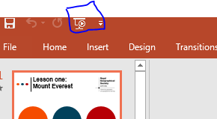  Please click on the Slide show at the top of the slides then you will hear me talking to you (I have shown you what it looks like by my wiggly box above) | After looking through the Powerpoint, I would like you to create a factfile about Mount Everest, using word document Everest Fact File  You will need to go onto the Internet to find out facts. Use your searching skills to find out more.

If you have any questions about today’s learning activities set then please email the class email these are viewed from 9.00 until 4.00 daily.

