Topic | Learning objective | Teaching points /teachers voice | Task to complete
English | LO To write a diary entry | You can rewatch the film from yesterday. The Ridge  https://vimeo.com/125896742  Have your notes from yesterday:  Think about the main parts from ‘the Ridge’ that you are going to include, think about how you would be feeling. How can you make your writing as descriptive as possible? What can you see, hear, feel, taste and smell? Can you think of any exciting vocabulary that you can use in your diary entry? Think of some WOW words!  Remember to start your diary entry with ‘Dear Diary,’ | Write a diary entry as if you are the person on your bike on The Ridge  Use the Writing Targets to help you write to the best of your ability : Home School Learning English Day 2
Maths | LO To calculate intervals across zero  LO Mrs Matharu’s group  Count forwards and backwards in steps of 10, 100 and 1000  Round any number up to 1 000 000 to the nearest 10, 100 and 1000 | Main  We are going to use another White Rose Maths video and worksheets to help us understand negative numbers more  Use this video link to understand - https://vimeo.com/454667567  Mrs Matharu’s group  Watch this video  https://vimeo.com/454666928 | Main  Download and complete the worksheet in  Home School Learning Maths Day 2 negative numbers  I would like all of you to do this  Then check your answers.  Extension:  Try Technology today activity (you will need a calculator)  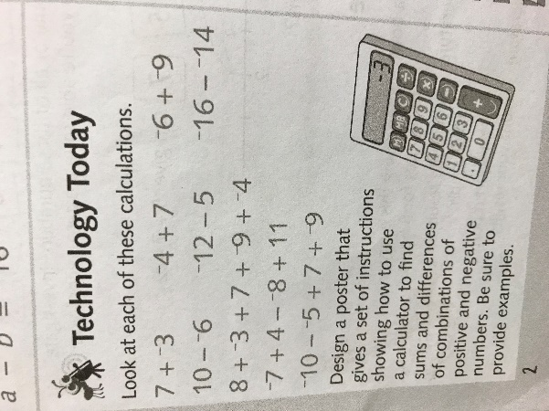  Mrs Matharu’s group  Complete challenges 1 and 2 on p6 and 7 on Home School Learning Maths Day 2 Mrs Matharu’s group  Game to check learning:  Do the quiz on - https://www.bbc.co.uk/bitesize/articles/zjf492p  I hope you enjoyed this lesson.
Topic | LO I can use an OS map to answer questions about Mount Snowdon | In the folder Year 6 Home Schooling 7 January 2021 Watch the PowerPoint slides in Slide Show mode like yesterday.  I talk you through the slides. | Use the OS (Ordnance Survey) map in the file Home School Learning Topic Day 2  Answer the questions on the worksheet Home School Learning Topic Day 2 Mapping Snowdon worksheet  The questions in Section 3 on Scale are there for an extra challenge.  Then you can check your answers using the answer sheet.

If you have any questions about today’s learning activities set then please email the class email these are viewed from 9.00 until 4.00 daily.

