Topic | Learning objective | Teaching points /teachers voice | Task to complete
English | LO to edit and improve a diary entry | We are continuing with linking to our Topic of Mountains in our English work.  Please read your diary entry from Friday to improve it. | Use this editing checklist (you have used it before)  It is your opportunity to upskill your work.  Editing success criteria  1. Read for does it make sense ____  2. Read for punctuation__  3. Read for spelling ____  4. Read to improve ____  5. Underline in pink words or phrases from a "good book" ___  6. Fill in checklist that was sent out on Friday ___
Spelling | LO To spell homohones | Spelling Frame  These are the spellings you were set before Christmas. | Go onto spelling frame daily  You will have a spelling test as part of Friday’s English lesson
Maths  SEE BELOW IF You are in Mrs Matharu’s Maths group | LO To understand and use BODMAS | DOODLE MATHS DAILY FOR 15 Minutes  Main  We are going to use White Rose Maths videos and worksheets to help us understand BODMAS (the order to do number operations)  Type or copy this link into your web browser  https://vimeo.com/465421787 | Main  All of Miss Gilbert’s and Mrs Phillips’s Maths class do the worksheet:  Year 6 Homelearning Maths Sheet Day 1  And mark your own work using the answers  Extension then do this: Stretch and Challenge The Puzzler:  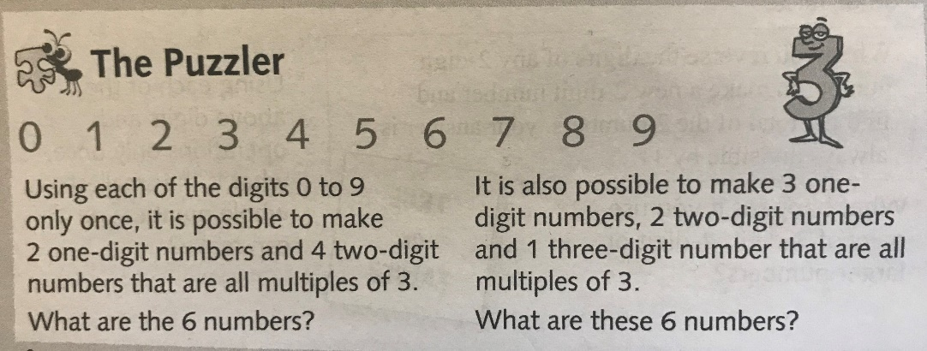
Maths  Mrs Matharu’s Group | To be able to count backwards through 0 with negative numbers.  Be able to interpret negative numbers in context | DOODLE MATHS DAILY FOR 15 Minutes  Plus  Do you know what negative numbers are? This time of year, you often hear about negative numbers when the temperature drops.  Watch : https://vimeo.com/457420739  It might help to draw a number line like this when working out questions.  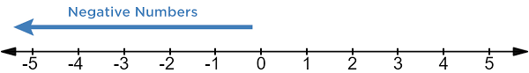 | Do challenges 1 & 2. If you feel confident with negative numbers try challenge 3.  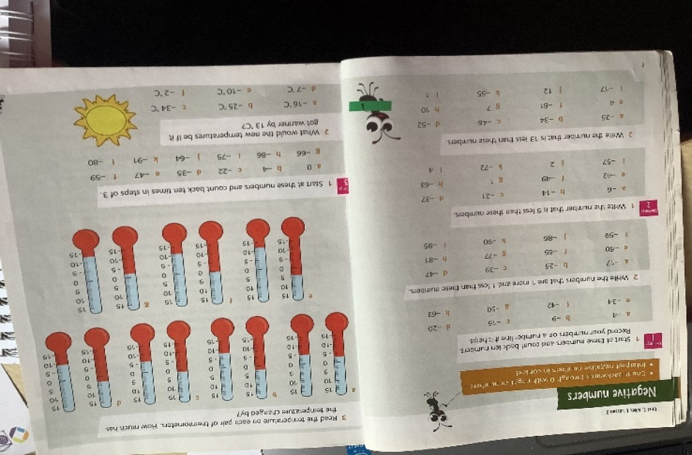  Consolidate learning:  Try the quiz on here: https://www.bbc.co.uk/bitesize/topics/znwj6sg/articles/zxthnbk
Topic  Geography Mountains | LO To find out facts about Mount Everest | Please look at the Powerpoint Formation of mountains.  Please click on the Slide show at the top of the slides then you will hear me talking to you (I have shown you what it looks like by my wiggly box below)  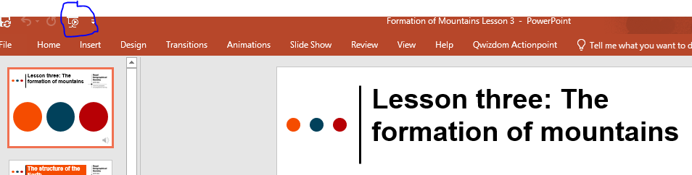 | After looking through the Powerpoint, I would like you to complete the worksheets Formation of Mountains worksheets.

If you have any questions about today’s learning activities set then please email the class email these are viewed from 9.00 until 4.00 daily.

