Topic | Learning objective | Teaching points /teachers voice | Task to complete
English | LO To write a mountain poem | Please watch the Powerpoint in the Day 2 file:  Year 6 Home School Learning English Day 2 Mountain Poem  Play the Powerpoint from the slide show button so that you can hear me talking.   | Make notes as you watch the film.  Write a poem about Mount Everest.  Aim for the Writing that you aim for in class using the checklist to help you make the poem the best it can be. Year 6 Home School Learning English Day 2 checklist
Spelling | LO  To spell homophones | Spelling Frame  These are the spellings you were set before Christmas. | Go onto spelling frame daily  You will have a spelling test as part of Friday’s English lesson
Maths  SEE BELOW IF You are in Mrs Matharu’s Maths group | LO To work out a one step rule | DOODLE MATHS DAILY FOR 15 Minutes  Plus  We are going to be learning about algebra. You already know some algebra  For example 4 + * = 10  What is the * worth? 6  Watch this video  https://vimeo.com/425603587 | ALL to work through the worksheet  Home School Learning Maths Tuesday  Use the answer sheet to check your work.  Extension:
Maths  Mrs Matharu’s Group | Subtract whole numbers with 5 digits using formal written method | This lesson is revisiting work on column subtraction. You already know how to do this so this is a revision lesson.  Watch: https://www.bbc.co.uk/bitesize/topics/zy2mn39/articles/zc78srd  Remember the importance of setting out your columns correctly and putting the largest number first.  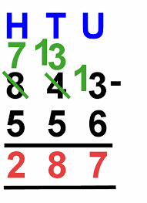 | Busy Ants p14 Challenge 1 and 2.  If you are getting these correct try challenge 3.  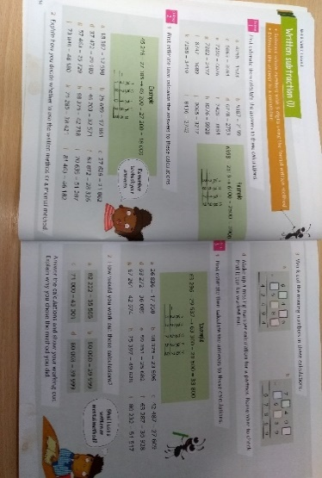
Topic | To find out how scientific ideas about food and diets were tested in the past and how this has contributed to our knowledge of a balanced diet. | Read through the Powerpoint, clicking on the sound clips.  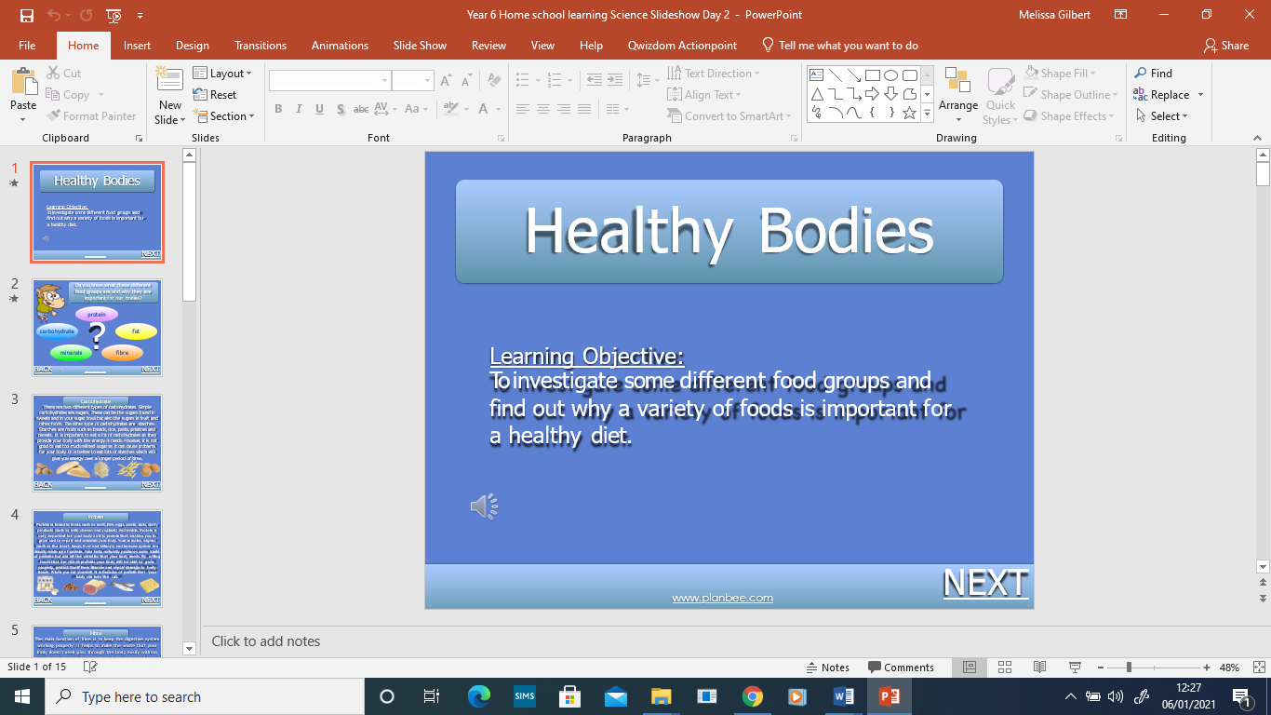 | Choose your challenge:  Challenge 1 – Worksheet 1A  Challenge 2 – Worksheet 1B  Challenge 3 – Worksheet 1C

If you have any questions about today’s learning activities set then please email the class email these are viewed from 9.00 until 4.00 daily.

