Topic | Learning objective | Teaching points /teachers voice | Task to complete
English | LO To write a poem about extreme mountain biking | Watch the Powerpoint Year 6 Homeschool Learning English Day 3 Mountain bike poems.  Click on  to run the slide show.  Within it you will also need to rewatch the short film: The Ridge  https://vimeo.com/125896742 | Write a poem inspired by The Ridge  You can use the structure of the poem Bro Time With My Bike to magpie and then put in words and ideas from The Ridge  Or you can use your own ideas to write a poem.  Use the Year 6 Homeschool Learning English Day 3 checklist to self-assess and improve your work like you would in class.
Spelling | LO  To spell homophones | Spelling Frame  These are the spellings you were set before Christmas. | Go onto spelling frame daily  You will have a spelling test as part of Friday’s English lesson
Maths  SEE BELOW IF You are in Mrs Matharu’s Maths group | LO To use algebraic expresssions | DOODLE MATHS DAILY FOR 15 Minutes  We are doing more algebra today  Watch https://vimeo.com/425603866  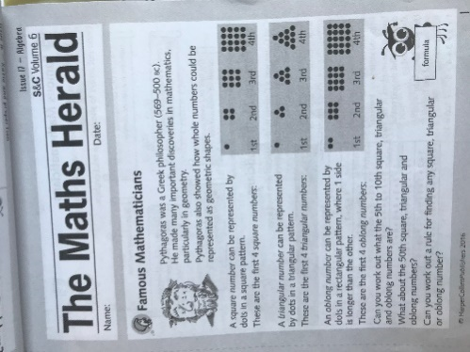 | All to do Homeschool Learning Maths Wednesday sheet  Mark your work using answers  Extension: See left
Mrs Matharu’s Maths group | LO To subtract whole numbers with 5 and 6 digits using formal written method | Well done if you completed yesterday’s lesson. Did you get up to challenge 3?  Today you are going to use your knowledge of column subtraction using up to 6 digits. This can be tricky and careless mistakes can be made so be careful.  Watch: https://m.youtube.com/watch?v=qyH6cPu23SI  Remember the importance of setting out your columns correctly and putting the largest number first.  Here are some fun ICT games to improve your subtraction speed.  https://www.ictgames.com/mobilePage/verticalSub/  https://primarygamesarena.com/Topics/Subtraction# | Busy Ants p16/17 Challenge 1 – do the first 5 only  Challenge 2 1a-e and 2a-e  Check with a calculator to see if they are all correct. If not, what common errors have you made?  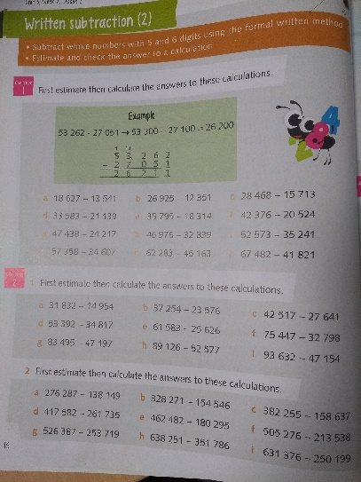
Topic | To investigate some different food groups and find out why a variety of foods is important for a healthy diet. | Read through the powerpoint, clicking on the sound clips.  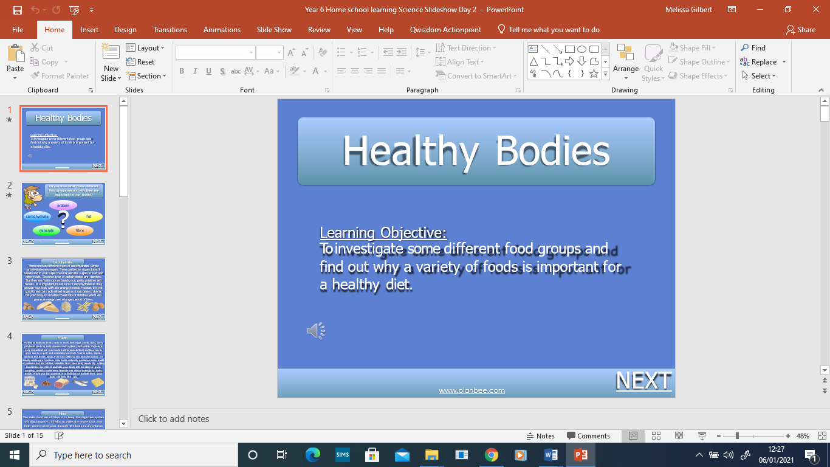 | Choose your challenge:  Challenge 1 – Worksheet 2A  Challenge 2 – Worksheet 2B  Challenge 3 – Worksheet 2C

If you have any questions about today’s learning activities set then please email the class email these are viewed from 9.00 until 4.00 daily.

