Topic | Learning objective | Teaching points /teachers voice | Task to complete
English | LO To answers comprehension questions carefully | Watch the Powerpoint Year 6 Home school Learning English Day 4 Comprehension  Click on  to run the slide show.  You might want to print off the text:  Year 6 Home School Learning English Thursday Comprehension  MRS MATHARU’s group Read the story on the sheet: Mrs Mathary’s English Group Comprehension | Main  Year 6 Home School Learning English Thursday Comprehension sheet and questions at the end.  When you have answered the questions, write your own.  MRS MATHARU’S GROUP  Sheet: Mrs Matharu’s English Group Comprehension  Read the story and answer the questions.
Spelling | LO  To spell homophones | Spelling Frame  These are the spellings you were set before Christmas. | Go onto spelling frame daily  You will have a spelling test as part of Friday’s English lesson
Maths  SEE BELOW IF You are in Mrs Matharu’s Maths group | LO To use simple formula | DOODLE MATHS DAILY FOR 15 Minutes  We are doing more algebra today  Please watch https://vimeo.com/425603939  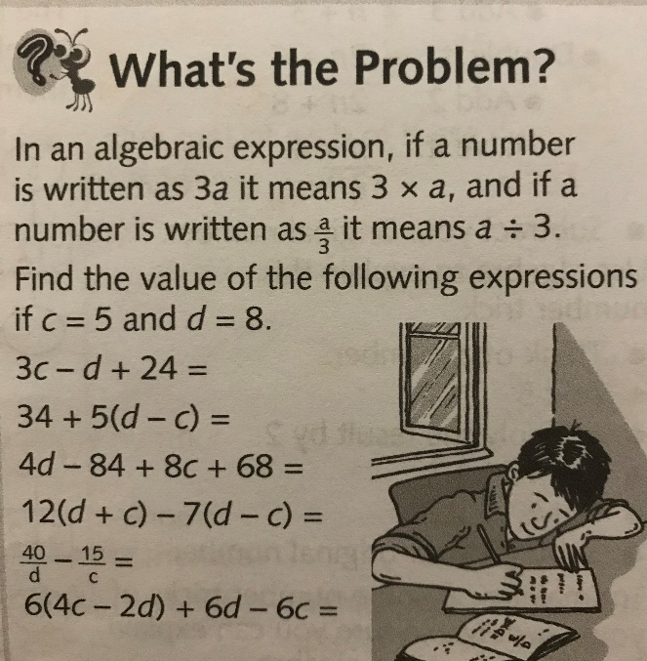 | All to do Homeschool Learning Maths Thursday sheet  Mark your work using answers  Extension: See left
Mrs Matharu’s Maths group | Add and subtract decimals to 2 places using the formal written method | In this lesson you will use your previous learning to add and subtract decimals to two decimal places (123.45). 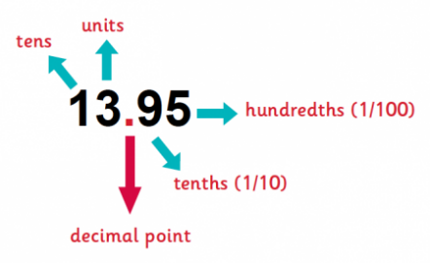  Remember to set your calculations out in the correct columns and line up the decimal places.  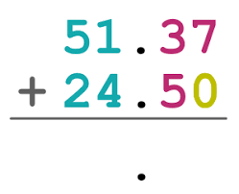 | Download/look at Word document Mrs Matharu’s group Maths in the files on the Class Pages  Busy Ants p18 Challenge 1 – Section 1 a-e  Section 2 a-e  Challenge 2-Section 1 a-e  Be careful – look at the signs. Are you adding or subtracting?  We have finished our revision unit on adding and subtracting using columns. Well done.  Have a go at this-https://www.sheppardsoftware.com/math/subtraction/fruit-splat-game/  What level can you get up to?  Mrs Matharu
Topic | To find out how nutrients and water are transported in the human body | Watch this video by copying the link into your web browser:  https://www.bbc.co.uk/teach/class-clips-video/science-ks2-how-our-circulatory-system-keeps-us-alive/zhf76v4  Read through the powerpoint, clicking on the sound clips.  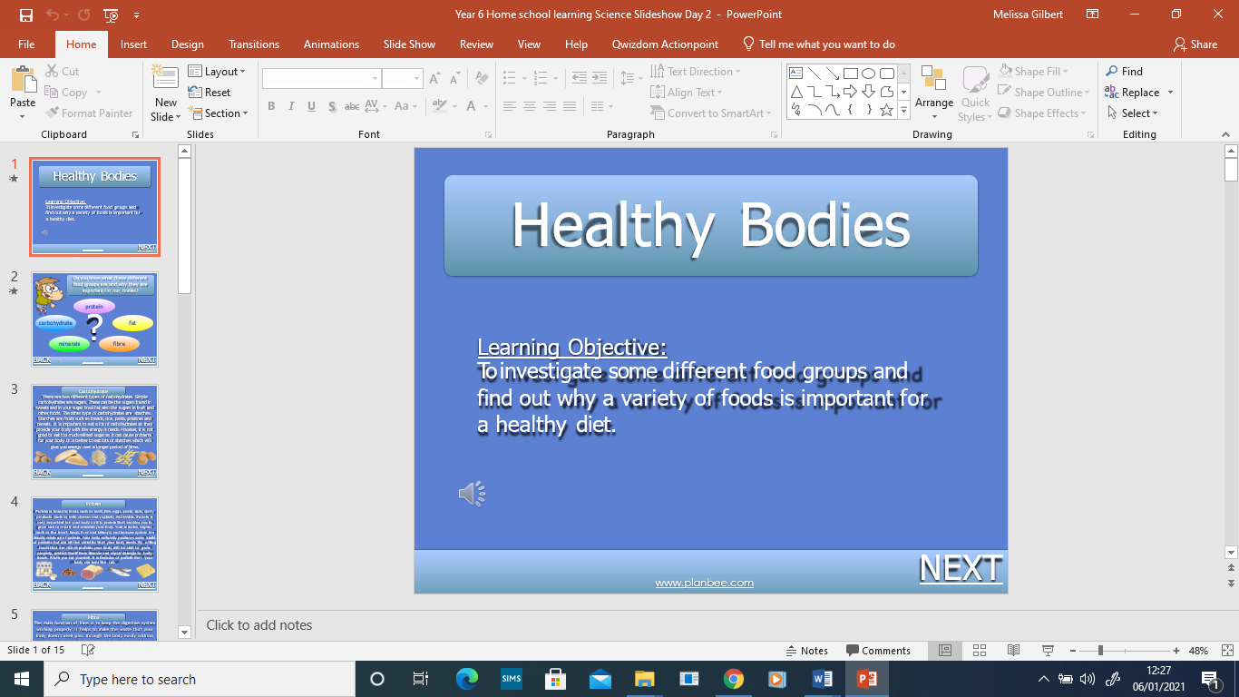 | All: Print or draw the human circulatory system, label your system using the labels provided to help you.  Extension: Worksheet 3A

If you have any questions about today’s learning activities set then please email the class email these are viewed from 9.00 until 4.00 daily.

